|  |  |  |
| --- | --- | --- |
|  |  | |
|  | SESAR Solution PJ07.02 SPR-INTEROP/OSED  for V2 - Part I  User Driven Prioritisation Process | |
|  | Deliverable ID: |  |
|  | Dissemination Level: |  |
|  | Project Acronym: |  |
|  | Grant: |  |
|  | Call: |  |
|  | Topic: |  |
|  | Consortium Coordinator: |  |
|  | Edition Date: |  |
|  | Edition: |  |
|  | Template Edition: |  |

|  |
| --- |
| INDUSTRIAL RESEARCH |



|  |  |  |
| --- | --- | --- |
| Authoring & Approval | | |
| Authors of the document | | |
| Name /Beneficiary | Position/Title | Date |
| Laurent Guichard /EUROCONTROL | PJ07-02 Team Member | 20/09/2019 |

|  |  |  |  |  |  |
| --- | --- | --- | --- | --- | --- |
| Reviewers internal to the project | | | | | |
| Name /Beneficiary | | Position/Title | | Date | |
| Nadine PILON /EUROCONTROL | PJ07-02 Solution Leader | | 09/2019 | |
| Katherine CLIFF /Think Research Ltd on behalf of EUROCONTROL | PJ07-02 Validation Lead | | 07/2019 | |
| Leo VAN DER HOORN /EUROCONTROL | PJ07-02 Team Member | | 07/2019 | |
| Laurent CROUZARD /EUROCONTROL | PJ07-02 Team Member | | 07/2019 | |
| Karin LEHISTE /EUROCONTROL | PJ07-02 Team Member | |  | |
| Ella PINSKA CHAUVIN /Think Research Ltd on behalf of EUROCONTROL | PJ07-02 Human Performance expert | | 01/07/2019 | |
| Renee PELCHEN-MEDWED /EUROCONTROL | PJ07-02 Human Performance expert | |  | |
| Laurent TABERNIER /EUROCONTROL | PJ07-02 performance expert | |  | |
| Hugo MANSO TORRES /EUROCONTROL | PJ07-02 safety expert | |  | |
| Marco GIBELLINI /EUROCONTROL | PJ07-02 CBA expert | |  | |
| Kirsteen PURVES /EUROCONTROL | PJ07-02 CBA expert | |  | |
| Mehtap KARAARSLAN /EUROCONTROL | PJ07-02 system expert | |  | |
| Jacqueline COQUEL /Air France | Airspace User Representative | | 14/06/2019 | |
| Russel OLIVIER /HOP | Airspace User Representative | |  | |
| Alon LAVI /IATA | Airspace User Representative | | 03/06/2019 | |
| Mats LINDHOLM /IATA | Airspace User Representative | |  | |
| Dmitrijs BUIKO /Air Baltic | Airspace User Representative | | 21/06/2019 | |
| Estelle BANGHAVON /Transavia | Airspace User Representative | | 14/06/2019 | |
| Matthias STAVROULIS /Transavia | Airspace User Representative | | 14/06/2019 | |
| Andre RUNGGER /Swiss | Airspace User Representative | | 14/06/2019 | |
| Nick Rhodes /Consultant | Airspace User Representative | | 07-08/2019 | |
| Joseph Abo-Roman /AIRBUS | Technical Partner | |  | |
| Daniel Chiesa /AIRBUS | Technical Partner | | 19/09/2019 | |
| Frederic Rousseau /ATOS | Technical Partner | |  | |
| Daniel Muller /THALES | Technical Partner | |  | |
| Diana Jimeno Cuenca /INDRA | Technical Partner | |  | |
| Stella SALDANA /EUROCONTROL | PJ09-03 Solution lead | |  | |

|  |  |  |
| --- | --- | --- |
| Approved for submission to the SJU By - Representatives of beneficiaries involved in the project | | |
| Name/Beneficiary | Position/Title | Date |
| Franck BALLERINI | Head of Unit Network Research and Development |  |

|  |  |  |
| --- | --- | --- |
| Rejected By - Representatives of beneficiaries involved in the project | | |
| Name/Beneficiary | Position/Title | Date |
|  |  |  |

|  |  |  |  |  |
| --- | --- | --- | --- | --- |
| Document History | | | | |
| Edition | Date | Status | Author | Justification |
| 00.00.01 | 20 Sept 2017 | Initial Draft | L. Guichard | Creation of the Document |
| 00.02.00 | 28 Feb 2018 | Draft | L. Guichard | Integrate internal review |
| 00.02.01 | 08 Mar 2018 | Draft | S. Ruiz, L. Guichard | Update APRIO and LVUC (ch3.3.2.7 ch3.3.2.8 Appendix B) |
| 00.03.00 | 24 May 2019 | Draft | L. Guichard | Update from Validation and workshops, add Requirements, IER and traceability |
| 00.03.01 | 30 Aug 2019 | Draft | L. Guichard | Update from review |
| 00.03.02 | 20 Sep 2019 | Final | L. Guichard | Update from final review |
| 00.03.03 | 15 Oct 2019 | Final | L. Guichard | Updated from SJU review |

Copyright Statement

© – 2019 – PJ07 Consortium

All rights reserved. Licensed to the SESAR Joint Undertaking under conditions.

This OSED is part of a project that has received funding from the SESAR Joint Undertaking under grant agreement No 733020 under European Union’s Horizon 2020 research and innovation programme.



Abstract

The current edition of this document describes, in detail, the operational environment (§3.2) and the operating methods (§3.3) of the new concepts of PJ07 Solution 2 UDPP.

The User Driven Prioritisation Process (UDPP) is built to give flexibility to Airspace Users (AUs), i.e., the ability of the Air Traffic Management (ATM) system to accommodate AUs’ changing business priorities in particular when delay occurs. Increased flexibility could result in a more cost-efficient delay management during congested situations, with substantial reductions of operational and cost impacts for AUs. Equity (in the sense that one AU’s prioritisation does not negatively affect another’s) is the main constraint for UDPP.

Table of Contents

Abstract 4

1 Executive Summary 12

2 Introduction 14

2.1 Purpose of the document 14

2.2 Scope 14

2.3 Intended readership 15

2.4 Background 16

2.5 Structure of the document 16

2.6 Glossary of terms 17

2.7 List of Acronyms 20

3 Operational Service and Environment Definition 25

3.1 SESAR PJ07 Solution 02: a summary 25

3.1.1 Deviations with respect to the SESAR Solution(s) definition 28

3.2 Detailed Operational Environment 28

3.2.1 Operational Characteristics 28

3.2.2 Roles and Responsibilities 28

3.2.3 Technical Characteristics 31

3.2.4 Applicable standards and regulations 31

3.3 Detailed Operating Method 31

3.3.1 Previous Operating Method 31

3.3.2 New SESAR Operating Method 33

3.3.2.1 From Delay management to Cost Management and Improve Passenger Experience 33

3.3.2.1.1 Reactionary delay management 34

3.3.2.1.2 AU event oriented management 35

3.3.2.1.3 AU Cost management 35

3.3.2.2 The UDPP delegation and UDPP measure 37

3.3.2.3 The UDPP prioritization 38

3.3.2.3.1 Introduction of the UDPP features. 39

3.3.2.3.2 Equity in UDPP 40

3.3.2.3.3 UDPP FDR feature 40

3.3.2.3.4 UDPP SFP feature 42

3.3.2.3.5 UDPP Margins feature 43

3.3.2.3.6 Margins on Protected flights 44

3.3.2.3.7 FDR, SFP and Margin are mixed in the same priority value approach 44

3.3.2.3.8 AU inputs: different ways of thinking 45

3.3.2.3.9 UDPP features timeline 46

3.3.2.3.10 UDPP mapping on ATM 47

3.3.2.4 Time parameters and timeline 48

3.3.2.4.1 Time reference and Arrival Schedule time 48

3.3.2.4.2 UDPP Cut-off time: UDPP measure close time 49

3.3.2.4.3 UDPP Time for freezing flights input 50

3.3.2.4.4 UDPP max anticipation schedule delay 50

3.3.2.4.5 Summary of UDPP Time events on timeline 50

3.3.2.4.6 UDPP over ATM actors timeline 51

3.3.2.5 Concept view of interactions between ATM actors 52

3.3.2.6 Time management: UDPP priorities, AU Preferences and DCB STAMs 53

3.3.2.7 UDPP investigation: Absolut priority (E-OCVM V1) 54

3.3.2.8 UDPP investigation: Low Volume Users in Constraint (E-OCVM V1) 54

3.3.2.9 Use Cases 57

3.3.3 Differences between new and previous Operating Methods 62

4 Safety, Performance and Interoperability Requirements (SPR-INTEROP) 63

4.1 UDPP enablers form other projects 63

4.2 Operational Requirements 63

4.3 SPR 73

4.3.1 Safety Requirements for UDPP 73

4.3.2 Performance Requirements for UDPP 73

4.4 INTEROP 79

5 References and Applicable Documents 82

5.1 Reference Documents 83

Appendix A Cost and Benefit Mechanisms 85

1 Stakeholders identification and Expectations 86

2 Benefits mechanisms 87

3 Costs mechanisms 90

Appendix B UDPP algorithms description 92

1 Introduction 93

2 Definitions 94

3 General UDPP algorithm view 97

4 Global and AU algorithm parameters 99

4.1 Global Airport Parameters (applied to all AUs): 99

4.2 Parameters Specific to each AU (defined by AU and can be dynamically changed) 99

5 UDPP Algorithms 101

5.1 The CASA-like time calculation on constrained resources 101

5.2 The AU local flight management: local ranking models + time assignment 103

5.2.1 The Local Ranking models 104

5.2.1.1 The “Priority only” model 104

5.2.1.2 The “Priority and Margin” model 105

5.2.1.2.1 Step 1 - Manage Protected flights (Pflight) (with Margins or not) 107

5.2.1.2.2 Step 2 - Manage Margin flights 109

5.2.1.2.3 Step 3 - Manage the Default Baseline flights (dBflights) 109

5.2.1.2.4 Step 4 - Manage the priority value flights (Nflights) 110

5.2.1.2.5 Step 5 - Manage the Suspended flights 110

5.2.1.3 Dynamic Management of Time Not Before and Time Not After 110

5.2.1.4 Generic functions to manage flight position 111

5.2.1.4.1 Function - Manage Time Solution 111

5.2.1.4.2 Function - Manage Solution Earlier 112

5.2.1.4.3 Function – Move Flight Earlier 112

5.2.2 Local Flight Time Assignment 112

5.3 The Merge function 113

Appendix C Flexible Credits for Low Volume Users in Constraint (FCL) – E-OCVM V1 116

1 FCL design criteria 117

2 FCL rules to preserve equity under high flexibility conditions 118

3 Assumptions and principles of the mechanism 119

4 Initial proposal benefits and limitations 121

5 Body of evidence 122

5.1 Techniques used for the generation of evidence 122

5.2 Analysis of the concept through the User Delay Optimisation Model (UDOM) 124

5.3 Data analysis for the characterisation of LVUCs and hotspots 125

5.4 Case studies and Simulations 133

5.4.1 Description of the traffic scenario 133

5.4.2 Description of the cost model and parameters assumed 135

5.4.3 Case study 1: All the AUs using the FCL system 136

5.4.4 Case study 2: LVUCs with up to 3 flights in the UDPP measure (single UDPP measure optimisation) 139

5.4.5 Case study 3: LVUCs with up to 3 flights in the UDPP measure (multiple UDPP measure optimisation) 142

5.4.6 Case study 4: LVUCs with up to 4 flights in the UDPP measure (multiple UDPP measure optimisation) 144

5.4.7 Case study 5: All AUs with 6 flights or less can use FCL but only for prioritising up to 3 flights (multiple UDPP measure optimisation) 144

5.4.8 Case study 6: All AUs with 6 flights or less can use FCL but MNIT = 6 (multiple UDPP measure optimisation) 145

6 Limitations of the Research and Identification of Future Work 147

6.1 Mathematical representation of the utility or delay cost functions for flights 147

6.2 User delay-cost optimisation model (UDOM) 148

6.3 FCL exchange rate between credits and minutes of delay 149

6.4 FCL merging rules 149

6.5 Proof of equity based on fast-time simulations 149

6.6 Uncertainty and dynamicity of the UDPP measure severity 150

6.7 Other potential concept improvements and case studies 150

7 Conclusions and Recommendations 152

7.1 Conclusions 152

7.2 Recommendations 153

The SPR/INTEROP-OSED Template includes the following parts:

* ***SPR/INTEROP-OSED Template – Part I (this volume)***
* SPR/INTEROP-OSED Template – Part II Safety Assessment Report (SAR)
* SPR/INTEROP – OSED Template – Part III Security Assessment Report (SeAR)
* SPR/INTEROP – OSED Template – Part IV Human Performance Assessment Report (HPAR)
* SPR/INTEROP – OSED Template – Part V Performance Assessment Report (PAR)

List of Tables

Table 1: PJ07 Solution 02 Maturity levels table 15

Table 2: Glossary of terms 20

Table 3: List of acronyms 24

Table 4: SESAR Solution 07-02 Scope and related OI steps 26

Table 5: Link to CONOPS 28

Table 6: UDPP Actors Roles and Responsibilities for each Process 31

Table 7: UDPP features on timeline 48

Table 8: Difference between new and previous Operating Method 62

Table 9: REQuirement capture layout 72

Table 10: Stakeholder’s expectations 86

Table 11: Discounted CBA results (per stakeholder and overall) 90

Table 12: Description of a statically typical hotspot 127

Table 13: Distribution of flights and delay per AU 135

Table 14: Cost thresholds examples assumed in the simulations 136

Table 15: Potential cost reductions per AU using UDOM (case study 1) 137

Table 16: Effect of sequence compression on the AUs actual costs (case study 1) 139

Table 17: Effect of sequence compression on the distribution of delay (case study 1) 139

Table 18: Effect of sequence compression on the distribution of delay (case study 2) 141

Table 19: Effect of sequence compression on the AUs actual costs (case study 2) 141

Table 20: Effect of sequence compression on the distribution of delay (case study 3) 143

Table 21: Effect of sequence compression on the AUs actual costs (case study 3) 143

Table 22: Effect of sequence compression on the distribution of delay (case study 4) 144

Table 23: Effect of sequence compression on the AUs actual costs (case study 4) 144

Table 24: Effect of sequence compression on the distribution of delay (case study 5) 145

Table 25: Effect of sequence compression on the AUs actual costs (case study 5) 145

Table 26: Effect of sequence compression on the distribution of delay (case study 6) 146

Table 27: Effect of sequence compression on the AUs actual costs (case study 6) 146

List of Figures

Figure 1: Roles and responsibilities 29

Figure 2: Current ATM organisation 32

Figure 3: ATM paradigm including AUs to solve problems 33

Figure 4: Reactionary delay in ATM 35

Figure 5: Operational Impact of delay for AUs 35

Figure 6: Operational cost of delay for AUs 36

Figure 7: Operational Cost of delay reordered 37

Figure 8: What is UDPP? 39

Figure 9: example of FDR 42

Figure 10: example of SFP 43

Figure 11: Management organisation of the flights 45

Figure 12: UDPP features on timeline 47

Figure 13: UDPP Time Events on timeline 51

Figure 14: High-level concept elements on timeline 52

Figure 15: Concept view of interactions between ATM actors 53

Figure 16: Illustration of the need to give access and flexibility to LVUCs 54

Figure 17: Illustration of an LVUC exchanging delay and credits between two UDPP Measures 55

Figure 18: Illustration of an LVUC exchanging delay and credits in the same UDPP Measure 56

Figure 19: Use case 1 - UDPP delegation in the SBT elaboration process 58

Figure 20: Annual Investment Levels and Benefits (Discounted) 91

Figure 21: General UDPP algorithm view 98

Figure 22: AU local flight management 104

Figure 23: Ranking Model: Priority Only 105

Figure 24: Local flight management: Priority and Margins 106

Figure 25: Pflight management example 108

Figure 26: Merge function and Absolute Priority 114

Figure 27: Conceptual map of Flexibility versus Equity 122

Figure 28: Focus of validation activities at different maturity levels. Source: E-OCVM v3.0 guide 123

Figure 29: Evolution of flights regulated, flights delayed and total delay (in hours) in 20 AIRACs 127

Figure 30: Distribution of hotspots per weekday 127

Figure 31: Histogram of initial times per regulation 128

Figure 32: Histogram of end times per regulation 128

Figure 33: Histogram of regulation durations 129

Figure 34: Statistical characterisation (box diagram) of regulation durations 129

Figure 35: Number of regulations by reason 129

Figure 36: Total delay by reason 130

Figure 37: Statistical characterisation (box diagram) of delay 130

Figure 38: Delay magnitude distributions (pie and bar charts) 130

Figure 39: Distribution of delay among the 100 AUs with more regulations 131

Figure 40: Statistical characterisation (histogram) of regulation durations 131

Figure 41: Statistical characterisation (box diagram) of regulation durations 131

Figure 42: Frequency of AUs with a certain number of flights in a hotspot (bar and pie charts) 132

Figure 43: Frequencies of a certain number of flights in a hotspot per AUs (partial data shown) 132

Figure 44: Capacity and demand of the airport per periods 133

Figure 45: Capacity and demand before Demand and Capacity Balance (left) and after (right) 134

Figure 46: Schedule list with ETAs, CTAs and calculated delays 134

Figure 47: Ki and delay per flight 135

Figure 48: Schedule list with delay, costs and optimal delay requested per flight (case study 1) 137

Figure 49: Slots requested by AUs after using UDOM (case study 1) 138

Figure 50: Deviation of slots requested after compression (case study 1) 138

Figure 51: Schedule list with delay, costs and optimal delay requested per flight (case study 2) 140

Figure 52: Impact of LVUC decision-making on the sequence and on the delay of flights (case study 2) 140

Figure 53: Impact of LVUC decision-making on the sequence and on the delay of flights (case study 3) 143

Figure 54: Approximation of the utility function as a continuous quadratic function 147

Figure 55: Representation of a –realistic– discrete cost function (red line) and its continuous approximation with 20 harmonics (green line) 148

Figure 56: Amplitude of the 20 first harmonics calculated to transform the discrete cost curve 148

Figure 57: Sinusoidal signals with their corresponding amplitudes and frequencies whose sum can reconstruct the continuous approximation of the cost model 148

Figure 58: Simulation platform architecture 150

# Executive Summary

This document is the Project 07 Solution 02: PJ07-02 Operational Services and Environment Description (OSED) document describing the UDPP solution for SESAR2020 Wave1.

UDPP allows AUs’ input in ATM Collaborative Decision-Making (CDM) processes primarily used in ATM/Airport Capacity Constrained Situations (CCSs) -and in the future, possibly for AUs to use UDPP for their own business needs. It is applicable in the planning of departure and arrival flights (and in the future possibly in the re-planning during execution). Each AU can provide fleet relative priority information and through a CDM process, request the repriorisation of their set of flights.

The objective for the AU is to optimise their operational costs, reduce the operational impact and improve passenger experience when faced with deteriorated situations. In this ATM constrained situation, UDPP allows AUs to reduce the delay on their important flights, to the detriment of the less important flights, in order to reduce the total impact of delay (this could be called: cost of delay: which is an extra operating cost for the AUs).

From the AUs perspective, equity is key. Equity is defined as no negative impact on other AUs (at least a strict minimum impact according to constraints), when an AU implements the prioritisation amongst its flights according to its business needs.

This edition of the Interim OSED focuses mainly on the use of UDPP during a congested situation at an arrival Airport when delays are imposed to AUs. This corresponds to the Operational Improvement AUO-0109 “UDPP for Airport constraints”. The objective of this part is to reach E-OCVM end-V2 Maturity level at the end of wave1.

The integration of UDPP in the Network environment and into the DCB and Airports processes (and in the future for En-Route constraints) is the objective of PJ07-02 in SESAR 2020. It is assumed that the UDPP process could be triggered to allow AUs to propose acceptable solutions for Demand Capacity Balancing (DCB) and Airports through “What-If” scenario calculations using the information available to them. It is also assumed that the UDPP output is used as an initial acceptable solution to the DCB and Airport process. Because UDPP solution will integrate the impact on Network and Airport, it is assumed that a large majority of the UDPP solutions will become the final network solution.

The OSED will also include the description of how the concept should be adapted for allowing more access to Low Volume Users in a constraint (LVUC); namely Business and General aviation as well as those airlines who have only a few flights captured in the CCS (e.g. on other Airport then their main one) (AUO-0107 “UDPP for LVUCs”).

UDPP will contribute to the following Key Performance Areas (KPAs):

* Flexibility;
* AU Cost Efficiency;
* Equity;
* Predictability; and
* Punctuality

The benefits of UDPP for AUs include (but are not limited to) the following:

* Increased flexibility to recover its fleet schedule times, or with manageable and acceptable impact of delay.
* Reduced inefficiency (indirect costs to AUs) caused by delay and reactionary delay on Airspace User Operation in CCS (reactionary delay for AU fleet is not a reactionary delay on an Airport).
* Better punctuality for important flights.
* The suspension/cancellation- and delay-induced cost for passenger compensation can be reduced—both directly (paying the passenger) and indirectly (rerouting, lodging, etc.)
* The suspension/cancellation and delay-induced cost for freight can be reduced.
* Increased access for Low Volume AUs to congested airports (potentially).

# Introduction

## Purpose of the document

This document provides the requirements specification, covering functional, non-functional, and interface requirements related to SESAR Solution PJ07-02 UDPP.

## Scope

This OSED for SESAR2020 PJ07-02 describes the concept of UDPP that will be introduced to support the integration of AUs business needs in the ATM system.

This OSED covers the following OI steps:

**AUO-0109: UDPP for Airport constraints;**

User Driven Prioritisation Process (UDPP) running during planning phase, allowing prioritisation coming from AUs to decrease the impact on their fleet in case of an Airport capacity shortfall (eg. Loss of runway throughput). Airports in collaboration with the AUs involved have to come up with a solution to manage the Airport constraint taking into account the network situation if impacted. The ambition in Wave1 is to reach EOCVM end-V2 for this OI, to be ready to start V3.

Comment on this OI definition:

Some flights could be airborne; some others could be still on-ground. This is especially true for UDPP on Arrival. In this case UDPP has to manage airborne flights in the constraint but also flights not submit to ATFCM measures. UDPP has also to manage flights part of other ATFCM Regulations. With all these management constraints, we can consider that UDPP is integrated in the Network environment.

**AUO-0109** started at early V2 (V1), and at the end of Wave 1, it has **reached the V2** maturity.  It is recommended that AUO-0109 transitions to V3 for SESAR2020 Wave 2.

**AUO-0107: UDPP for Low Volume Airspace Users in a constraint;**

Research in SESAR1 allowed elaborating a method considered acceptable by all AUs, which needs further investigation. Research continues in SESAR2020 on an adaptation of UDPP for LVUC. The aim is to establish, using expert judgment, the conditions to allow LVUC to use the same UDPP prioritisation methods as the other AUs.

**AUO-0107** has been investigated in Solution PJ.07-02 and the outcome is included in this OSED. A maturity self-assessment has been performed concluding that it is currently at a **maturity of V0 (early V1)**. Further research will take place as part of the **Exploratory Research** programme of SESAR.

**AUO-0106: UDPP for reprioritising flights during execution;**

This OI is not in the scope of Solution PJ.07-02. Removal of the link between the solution and the OI has been requested (CR 03481 “Remove link between AUO-0106 and Solution PJ07.02: Re-prioritising flights during Execution is not part of the scope of solution PJ07.02, hence the need to remove the link between AUO-0106 and the solution”)

**AUO-0110: UDPP for network constraints;**

This OI Step shall focus on the prioritisation process applied to constraints managed by the Network Management function. It will address the prioritisation of an AU's group of flights involved into one or several network constraints (possibly managed by several Flow and/or Local Traffic Managers, including LTM at Airports). The OI Step shall address as well the integration of the prioritisation into the reconciliation process in case of multiple constraints.

AUO-0110 has been partially addressed, as this concept will apply the already validated methods of UDPP at one UDPP network constraint managed by the airports in the full delegation mode of DCB.  Several constraints and en-route constraints have not been addressed in SESAR2020 Wave 1.

In the ATM Master Plan, Solution PJ.07-02 is linked to these four OI steps, which represent the needs expressed by the AUs in UDPP at the end of SESAR1. However, changes to the scope of Solution PJ.07-02 are not fully reflected in the EATMA portal; PJ07.02 in Wave 1 only focussed on AUO-0109 and addressed partially AUO-0107.

AUO-0110 has been partially addressed by the integration of the UDPP process in the Network environment, but the multi-constraints management part has not been fully addressed.

AUO-0110 has not addressed En-route constraints: After consultation with ATM contributors, there are many other ways to solve En-Route constraints and UDPP will not be used by DCB for solving En-Route constraints.

PJ07-02 covers the below OIs with the aim to reach the target maturity levels at the end of SESAR2020 Wave 1.

|  |  |  |  |
| --- | --- | --- | --- |
| OIs | Initial Maturity level | Target Maturity level at the end of Wave 1 | OIs description |
| AUO-0109 | Mid-V2 (V1) | End-V2 | UDPP for Airport constraints.  It is recommended that AUO-0109 transitions to V3 for SESAR2020 Wave 2 |
| AUO-0107 | V0 | Early-V1 (V0) | UDPP for Low Volume Airspace Users |
| AUO-0106 | V1 | Out of scope (CR) | UDPP for reprioritising flights during execution. |
| AUO-0110 | Early-V2 (V1) | Mid-V2 (V1) | UDPP for Network constraints.  Partially addressed: UDPP on multi-constraint not fully addressed, UDPP on en-route constraint not addressed. |

Table 1: PJ07 Solution 02 Maturity levels table

## Intended readership

This document is aimed at the following stakeholders:

* the SESAR2020 PJ07, PJ09, PJ04, PJ25 members, including Airspace Users
* the SJU and EUROCONTROL; and
* the transversal PJ19 project;

## Background

This document describes the continuation of the development of the UDPP concept that started in SESAR1 P07.06.02 UDPP and enhanced UDPP concept by integrating stakeholders’ comments and validation results.

The UDPP objective is to provide more flexibility to AUs to reorganize their flights in the case of delays on departure or arrival (including en-route in Wave 2), principally in a Capacity Constrained Situation (CCS).

UDPP allows AUs to mitigate the impact of delays on their business but does not decrease the total ATFM delay itself. UDPP is not set to replace any ATM organisation to fit the AUs’ needs in terms of optimum Airspace organisation, Airport organisation or optimal trajectory; UDPP allows to limit the impact on AUs in case of residual congestion.

The UDPP concept is designed in an ATM Collaborative Decision-Making (CDM) context and provides an additional layer of flexibility for AUs compared to UDPP SESAR1 Step 1 (OSED Step 1 V3). UDPP allows an improved and more efficient management of AUs’ fleet in situations of delays.

Three different components (features) have been developed for the UDPP concept:

* Fleet Delay Reordering (FDR);
* Selective Flight Protection (SFP); and
* Margins

It should be emphasized that these features do not replace the SESAR1 feature: Enhanced Slot Swapping, which remains available for an AU if required.

## Structure of the document

This OSED is structured as follows:

* **Section 1 Executive Summary:**
* **Section 2 Introduction:**
* **Section 3 Operational Service and Environment Definition:**
* **Section 4 Safety, Performance and Interoperability:**
* **Section 5 Reference and Applicable Documents**:

## Glossary of terms

|  |  |  |
| --- | --- | --- |
| **Term** | **Definition** | **Source of the definition** |
| **Baseline delay, Baseline Time** | Represents the allocated delay to each flight in a constrained situation if no UDPP. It is used as a baseline of the UDPP equity and can be used to benchmark the UDPP concept to identify the concepts’ benefits. |  |
| **Capacity Constrained Situation (CCS)** | A period of time in which the Capacity of an ATFM element (Airspace, Arrival Runway, Departure Runway …) is reduced. It defines the new capacity constraint due to this condition. In most of the case, this CCS will generate a capacity problem (Hotspot …) to be managed by Airport/DCB/NM. |  |
| **Demand Capacity Balancing (DCB)** | Where used in this OSED to convey a role in the UDPP process, the term ‘DCB’ is intended to be the aggregate group including DCB, Local DCB, Airport, and Network Manager. |  |
| **FDR Fleet Delay Reordering** | The feature by which using its own allocated slots, an AU can rearrange its fleet, by giving priority values. |  |
| **Hotspot** | Term used by Network DCB to specify a safety critical area of interest, which generally has a demand that exceeds the available capacity. The Hotspot specifies that the situation has to be managed to decrease the overload. This hotspot could be resolved through delegation to the AUs and triggering UDPP. |  |
| **Knock-on delay or**  **Reactionary delay** | A side effect on subsequent flights due to delay given to an initial flight(s). The initial delays can be caused by capacity constraints, ATC/Network constraints, airport constraints, but also due to airline constraints (crew, passengers …).  AU reactionary delay take into account all the AU fleet of the day to decrease the impact of the original delay, which is completely different from the Airport reactionary delay who take into account only the impact on the local Airport platform. |  |
| **Margin of Manoeuvre** | For an AU, it is the maximum delay a flight can take before incurring significant cost (disruption on the cost curve according to delay). It is anticipated that the “significant cost” can be defined differently by each AU, but for the purposes of this example, the cost represents a “spike” that is due to factors such as crew or pilot time-out constraints, or a large number of passengers who miss a connection, curfew, etc.  Each time one of the factors is met; another spike in cost is incurred, which represents the end of another Margin of Manoeuvre for the AU. |  |
| **Prioritisation** | Actions made by the AUs (using the UDPP features SFP, FDR, Slot Swap, Margins) according to the importance of their flights impacted by a Hotspot, based on their business needs. |  |
| **Protection/Protect a flight** | UDPP Protection is part of the UDPP prioritisation. It is the highest priority given to a flight pushing its operation as closed as possible to the planned off block time. To do this, UDPP applies the SFP algorithm for this flight. |  |
| **Ration-By-Effort** | The principle by which AUs first have to allocate additional delay to one or more of their flights in order to receive less delay (through protection or prioritisation) on one or more of their flights. This notion is used specially for SFP implementation. |  |
| **Scenario** | An operational situation, in which, use cases are executed. |  |
| **SFP Selective Flight Protection** | The feature by which an AU can obtain a desired delay for a flight, even if no ATC slot is available / has been allocated to the AU in question.. |  |
| **Suspension** | ATFM suspension (FLS) is an ETFMS message sent, suspending a flight, which thereafter should not get take-off clearance. |  |
| **“Time not After”, “Time not Before”** | It is the time components of the Margin of Manoeuvre. The feature by which allows a time window to be allocated by an AU to its own flights, as a constraint. This is in order to rearrange the AU sequence. |  |
| **UDPP Suspension/Suspend a flight** | UDPP Suspension is part of the UDPP prioritisation. It is the lowest priority given to a flight pushing its operation at the end of the problem managed by UDPP.  It is not an ATFM suspension, i.e.: an FLS message. |  |
| **UDPP Cut-off Time, UDPP Measure Closed time (to AUs modification)** | Absolute time defined when the “UDPP Measure” is initiated and specify until when AUs can set priorities/Margins on their flights. Over this time, the last prioritisation given by AUs on their flights are taken as “final UDPP prioritisation” to elaborate final UDPP solution.  This time is used only if a flight is not become pre-allocated before: when flights are or become “airborne” (20 to 30 mn before Off-Block or flight considered as out of current regulation rules: coming from out of ECAC area, military flights …).  Finaly this UDPP Measure Closed time is used generally for short haul flights with a short flight duration. |  |
| **UDPP measure** | Term used in this document to trigger the use of UDPP. This can be in a CCS or in ‘nominal’ situations where demand exceeds capacity for a given period. An Airport/DCB/NM action must be taken to mitigate the situation.  Originally, the overloaded situation (called sometime hotspot) does not necessarily contain all the impacted flights relative to the imbalanced situation (because it is not calculated at the beginning). The constraint declaration (CCS) is used to calculate all the impacted flight (all flights having delay) according to the Capacity constraints in a CASA like way (FPFS). Nevertheless, the UDPP measure can be set to a larger time window of even on a window without declared CCS, to allow AU to reorganize flights if needed. Up to the resource owner (e.g. Airport, DCB Network) to allow this delegation, called UDPP measure, in collaboration with AUs.  The UDPP measure can also replace a Regulation measure.  UDPP generates the same delay than CASA on each flights if no AU input. The total delay of a regulation and a UDPP measure is the same. In a way, a UDPP measure is a regulation where AU can give priority on flights. The mitigation is given by priority from AU, the basis is the delay given by the CASA like part of the UDPP measure.  UDPP measure is not only the mitigation part but also the regulation part to avoid overload. |  |
| **UDPP Measure freeze input list time** | Absolute time when the “UDPP Measure” is closed to new flight insertion in the UDPP Measure (new flight plan). UDPP Measure flights list becomes fixed. If new flights plan are declared, there are put at the end of the “UDPP Measure”.  NB: This time normally must be relative to moving time according to flights arriving time in UDPP Measure and not to the “UDPP Measure” starting time. (this must be updated in Wave 2) (ex: 2 hours before the flight arriving in UDPP measure). |  |
| **UDPP Priority value** | A value given by the Airspace user on a flight (or a specified default value) used by the UDPP function to reorder the flights in the constraint. Values can be: P for Protect, S for suspend, B for keep baseline, or a number from 1 (highest priority) to 999 (lowest priority). |  |

Table 2: Glossary of terms

## List of Acronyms

|  |  |
| --- | --- |
| **Acronym** | **Definition** |
| 4D | Four Dimensional |
| AFUA | Advanced Flexible Use of Airspace |
| AMAN | Arrival Manager |
| ANSP | Air Navigation Service Provider |
| AOC | Airline Operations Centre |
| AOP | Airport Operational Plan |
| APOC | Airport Operations Centre |
| APT | Airport |
| ATC | Air Traffic Control |
| ATCO | Air Traffic Controller |
| ATFCM | Air Traffic Flow and Capacity Management |
| ATFM | Air Traffic Flow Management |
| ATM | Air Traffic Management |
| AU | Airspace User |
| BDT | Business Development Trajectory |
| CASA | Computer-Assisted Slot Allocation (Network Manager slot allocation for regulations) |
| CCS | Capacity Constrained Situation |
| CDM | Collaborative Decision Making |
| CFMU | Central Flow Management Unit |
| CI | Confidence Index |
| CNS | Communication Navigation and Surveillance |
| CONOPS | Concept of Operations |
| CR | Change Request |
| CTOT | Calculated Take-Off Time |
| D0 | Day ‘zero’, Day of Operation |
| D-1 | Day ‘zero minus one’, Day before Operation |
| **DCB** | Demand Capacity Balancing |
| **dDCB** | Dynamic Demand Capacity Balancing |
| **DFlex** | Departure Flexibility |
| **DMAN** | Departure Manager |
| **DOD** | Detailed Operational Description |
| **EATMA** | European ATM Architecture |
| **E-ATMS** | European Air Traffic Management System |
| **EIBT** | Estimated In Block Time |
| **EOBT** | Estimated Off Block Time |
| **E-OCVM** | European Operational Concept Validation Methodology |
| **EXE** | Exercise |
| **F2F** | Face-to-Face |
| **FAB** | Functional Airspace Block |
| **FCL** | Flexible Credits for Low Volume Users in Constraints (LVUCs) |
| FDA | Fleet Delay Apportionment |
| FDR | Fleet Delay Reordering |
| **FIBT** | Forecasted In Block Time |
| **FIXM** | Flight Information Exchange Model |
| **FMP** | Flow Management Position |
| **FMS** | Flight Management System |
| **FOBT** | Forecasted Off Block Time |
| **FOC** | Flight Operations Centre |
| **FSFS / FPFS** | First Scheduled First Served / First Planned First Served |
| **HPAR** | Human Performance Assessment Report |
| HSPT | Hot Spot |
| IBT | In-Block Time |
| **ID** | Identifier |
| **INTEROP** | Interoperability Requirements |
| IRS | Interface Requirements Specification |
| KPA | Key Performance Area |
| KPI | Key Performance Indicator |
| LVUC | Low Volume Users in Constraints |
| MPC | Most Penalising Constraint |
| MTTT | Minimum Turn-round Time |
| NEVAC | Network Capacity Evaluation Tool |
| **NM** | Network Manager |
| NMF | Network Manager Function |
| NOP | Network Operational Plan |
| OBJ | Objective |
| OBT | Off-Block Time |
| OCD | Operational Concept Description |
| OFA | Operational Focus Areas |
| OI | Operational Improvement |
| **OPAR** | Operational Performance Assessment Report |
| **OSED** | Operational Service and Environment Definition |
| **PAR** | Performance Assessment Report |
| **PDS** | Pre-Departure Sequence |
| **PIRM** | Programme Information Reference Model |
| **QoS** | Quality of Service |
| **RBE** | Ration-By-Effort |
| **RBT** | Reference Business Trajectory |
| **RMAN** | Runways Manager (first Airport process to organise departure) |
| **RTS** | Real-Time Simulation |
| **SAC** | Safety Criteria |
| **SAR** | Safety Assessment Report |
| **SBT** | Shared Business Trajectory |
| **SCN** | Scenario |
| SecAR | Security Assessment Report |
| SESAR | Single European Sky ATM Research, usually in reference to the European ATM Master Plan |
| SESAR Programme | The programme that defines the Research and Development activities and Projects for the SJU. |
| SFP | Selective Flight Protection |
| **SIBT** | Scheduled In Block Time (initial Airline schedule) |
| **SJU** | SESAR Joint Undertaking (Agency of the European Commission) |
| **SJU Work Programme** | The programme that addresses all activities of the SESAR Joint Undertaking Agency. |
| **SME** | Subject Matter Expert |
| **SMT** | Shared Mission Trajectory |
| **SOBT** | Scheduled Off Block Time (initial Airline schedule) |
| **SPR** | Safety and Performance Requirements |
| STAM | Short-Term ATFCM Measures |
| SUT | System Under Test |
| SWIM | System-Wide Information Management |
| TAD | Technical Architecture Description |
| TBD | To Be Determined |
| TMA | Terminal Manoeuvring Area |
| TS | Technical Specification |
| TSAT | Target Start-Up Approval Time |
| **TTOT** | Target Take-Off Time |
| TW | Target Window |
| UC | Use Case |
| UDPP | User Driven Prioritisation Process |
| UIBT | User In Block Time (prioritisation given by User) |
| **UOBT** | User Off Block Time (prioritisation given by User) |
| VALP | Validation Plan |
| **VALR** | Validation Report |
| VALS | Validation Strategy |
| V-FOC | Virtual Flight Operation Centre (FOC) |
| VP | Verification Plan |
| **VR** | Verification Report |
| **VS** | Verification Strategy |
| **WOC** | Wing Operation Centre |

Table 3: List of acronyms

# Operational Service and Environment Definition

## SESAR PJ07 Solution 02: a summary

The principal objective of the UDPP solution is to integrate the AUs’ needs into the ATM system, especially when delays occur, to decrease the impact of delay on the AUs operation.

A basic view of UDPP is that rather than solving the problem by smoothing the traffic in a First Planned First Served (FPFS) manner (with the CASA algorithm), ATM asks the AUs to define a new sequence of flights that better meets their needs when faced with delay. All of the needed coordination and rules -and especially the Equity over the AUs- are defined through the UDPP services.

The following three UDPP features allow AUs to manage impact of delays:

* **FDR Fleet Delay Reordering**: this feature enhances the slot swap feature used today by the AU, by rearranging the sequence of flights of the same AU according to the given priority values.
* **SFP Selective Flight Protection**: this feature forces the protected flight to be on time, even if there is no direct slot allocated to the AU. It is based on sacrificing an earlier flight to allow this possibility. (to preserve Equity rules)
* **Margins** **(“Time not After” and/or “Time not Before”)**: a time window is given to a flight by the AU, for the UDPP automation to find the FDR solution automatically. This feature use the combination of the Margin times and the priority value if needed.

Note: Whereas FDR and SFP are improved UDPP features following the mid-V2 validation exercises in SESAR, Margins is a new feature responding to AUs’ request for more automated support to prioritisation. Therefore, FDR & SFP are aimed to reach end V2. Margins is considered starting V0-V1 maturity feature at the beginning and reaching end V2 at end of SESAR2 wave1. A specific Airspace Users workshop will be dedicated to it before the validation exercise with the objective to reach V2 at the same level then SFP & FDR.

|  |  |  |  |  |
| --- | --- | --- | --- | --- |
| **SESAR Solution ID** | **SESAR Solution Title** | **OI Steps ID ref. (coming from EATMA)** | **OI Steps Title (coming from EATMA)** | **OI Step Coverage** |
| PJ07-02 | AU Fleet Prioritization and Preferences (UDPP) | AUO-0109 | UDPP for Airport constraints | Full V2: It is recommended that AUO-0109 should transition to V3 for SESAR2020 Wave 2 |
| ‘’ | ‘’ | AUO-0107 | UDPP for Low Volume Airspace Users | Early V1: Further research of AUO-0107 will take place as part of the Exploratory Research programme of SESAR 2 Wave2. |
| ‘’ | ‘’ | AUO-0110 | UDPP for network constraints | Not fully addressed: AUO-0110 should address several network constraints in Wave 2 |
| ‘’ | ‘’ | AUO-0106 | UDPP for reprioritising flights during execution. | Out of scope (CR) |

Table 4: SESAR Solution 07-02 Scope and related OI steps

|  |  |  |
| --- | --- | --- |
| **High Level CONOPS Requirement ID** | **High Level CONOPS Requirement** | **Reference to relevant CONOPS Sections e.g. Operational Scenario applicable to the SESAR Solution** |
| **P07-TLOR-01** | Optimised Airspace User Operations shall   * Increase the Airspace Users operational and flight cost efficiency * Increase the Airspace Users flexibility to plan and re-plan a flight; * Contribute to an optimised demand and capacity management; * Enable Airspace Users to optimise their flights integrating all their fleet constraint and business operations.   by defining and implementing Trajectory Management processes on AU side that feed into ATM DCB processes that :   * Integrate the trajectories calculated/ planned by the Airspace User throughout the whole lifecycle of the flight; * Integrate the Airspace User defined flight priorities and preferences throughout the whole lifecycle of the flight; * Allow the civil Airspace User to swap slots between eligible flights, * Allow the Airspace User to revise the RBT/RMT   While:   * Support an integrated briefing throughout all flight phases; * Supporting prioritisation and re-prioritisation throughout all flight phases; * Supporting fleet delay assignment and flight protection; * Supporting AU driven RBT revisions throughout the whole flight execution   Integrating civil and military Airspace Users into the Trajectory Management, DCB and UDPP when required. | 4.9 Operational requirements PJ07 (Top requirements) |
| **P07-TLOR-02** | Optimised Airspace User Operations shall:   * Increase the effectiveness of mission trajectories and flight efficiency ; * Increase the military Airspace Users’ mission flight efficiency and safety * Facilitate optimisation of ATM network operations   by defining and implementing ATM solutions that :   * integrates the mission trajectory into the ATM network operating environment throughout the whole ATM lifecycle, integrates SMTs into CDM on the Target Time negotiation when required, enable a Pan-European mission and training planning and enables planning and executing of military training at Pan-European scale   facilitates capacity optimisation :   * Providing enhanced data consistency through the use of a harmonised and improved OAT FPL format and content for military IFR operations * Increasing predictability and awareness on AU demand * Supporting the integration of military operational requirements related to meteorological conditions; * Supporting the integration of military preferences and mission trajectories for DCB processes; * Developing a Pan-European OAT-IFR Transit Service (OATTS);   Allowing military Airspace Users to protect RMTs. | 4.9 Operational requirements PJ07 (Top requirements) |
| **S07-02-HLOR-01** | All types of civil Airspace User shall be able to participate to DCB processes throughout the whole lifecycle of a flight by influencing the allocation of ATM constraint (to a flight) by   * Protecting individual flights for capacity constrained situations; * Flexibly assign fleet delays for capacity constrained situations; * Flexibly re-prioritise flights in case of changing boundary conditions and changing capacity constrained situations; and   proposing a flight priority order to NM in case of deteriorated operations. | 4.9.2 High Level Requirements PJ07 |
| **S07-02-HLOR-02** | UDPP processes shall be as efficient and effective as possible to reach:   * An optimum trade-off between planning effort and flight operations benefit; * High degree of process automation on AU side to reduce human workload & intervention as much as possible; and   Facilitate operational cost efficiency during flight by allowing the planning of optimised trajectories. | 4.9.2 High Level Requirements PJ07 |
| Left column |  |  |

Table 5: Link to CONOPS

### Deviations with respect to the SESAR Solution(s) definition

## Detailed Operational Environment

The UDPP concept definition tries to avoid being stuck in a too futuristic vision of the ATM environment.

The majority of the functions described in this document can be implemented in the current environment and in the SESAR2020 environment dealing with trajectory management.

### Operational Characteristics

This section contains the detailed description of the Operational environment in order to get knowledge of the fundamental operational characteristics that govern the set of requirements included in section 4.4.

* Traffic;
* Airspace or Airport characteristics;
* Etc…

The section shall refer to the sub-operating environments associated to the SESAR Solution(s) under the scope of this document.

In the case where an environment characteristic is specific to the SESAR Solution in certain conditions, this should be indicated.

[…]

### Roles and Responsibilities

The objective of UDPP is to transfer the mitigation of a congested situation from the owner of the resource (for example, the FMP dealing with arrival flights) to the user of the resource (for example, the airlines). The philosophy is to decrease the impact of the problem for the user.

This section describes the actors involved in the Operational Process(es) / Service(s) and their various responsibilities.



Figure 1: Roles and responsibilities

From the AU (UDPP) perspective, there is a unique, single Network representative, called DCB or dDCB as seen in Table 6 below. Depending on the Airport ANSP local organisation, the different functions are assumed by different actors named: DCB, dDCB, Local DCB, DCB-Net, Airport-ATC, Network, Airport-DCB, FMP at Airport. The most important element is that, the different functions called Network Management Functions (NMF), are supported by one of the actors.

There are three primary processes involved in UDPP. In this context, the actors involved and their roles and responsibilities are elaborated in Table 6. A brief description of the relationship with Trajectory Management is described.

| **Actor** | **Collaborative background process** | **Initiate the UDPP Process** | **Implement UDPP solution** | ***Coordinate Trajectory Solution*** |
| --- | --- | --- | --- | --- |
| **DCB / dDCB**  **Network** | Identify, Evaluate and deliver imbalance to be managed (hotspot …) and open the possibility to AUs to address it (UDPP delegation to AUs).  Monitor the constraints, and update and publish information as necessary.  Maintain the NOP and the AOP/NOP integration | Ensure UDPP functionality is available and functioning properly.  Provide the UDPP environment to the AUs. | Ensure the what-if functionality is available and functioning properly (impact assessment).  Ensure Published UDPP solution available and effective. | Provide updated information to AU that describes the current delay and sequence for flights based on prioritisation information. |
| **Airspace User** | Ensure eFPL information has been sent to the Network to manage traffic properly  Evaluate options provided by DCB and dDCB and provide feedback on the most favourable course of action. | Ensure prioritisation information has been put in the eFPL if needed (*FF-ICE field: within fleet priority*) | Evaluate the constraint information and make UDPP prioritisation for flights in the constraint if needed. | Submit updated SBTs based on UDPP time calculated with prioritisation information. |
| **Low Volume User in Constraint** | Ensure necessary prioritisation information has been applied to the SBT to be included in DCB and dDCB option generation.  Evaluate options provided by DCB and dDCB and provide feedback on the most favourable course of action. | Ensure necessary prioritisation information has been applied to the eFPL if needed (*FF-ICE field: within fleet priority*) | Evaluate the constraint information and make UDPP prioritisation for flights in the constraint if needed. | Submit updated SBTs based on UDPP time calculated with prioritisation information. |
| **Airport** | The Airport determines Airport capacity limitations and publishes the constraints characteristics and updates the plan though the AOP or through the Network representative.  Assumes the role of Airport landside and airside and update the plan through the APOC-AOP.  Ensure good coordination with the Network specially with an appropriate AOP/NOP integration | Publish and maintain Airport constraints when needed.  Allow AU to mitigate the delay impact with UDPP. | Evaluate and publish through AOP/NOP the impact of new time given by UDPP prioritisation. Through the Network | Update time information (Taxiing …) when necessary. To be noted that taxi times can be overwritten by AU in eFPL |

Table 6: UDPP Actors Roles and Responsibilities for each Process

### Technical Characteristics

For use, a UDPP service (server) is required to handle the UDPP functions. It integrates all of the rules and functions needed to issue new times to flights according to the Priorities and Margins given by the AUs, in order to manage the constraint. This UDPP service is the interface between the AU, the Network, and the Airport. This service shall also protects AUs to exposure of confidential data that maybe used to produce these new times.

### Applicable standards and regulations

|  |  |  |  |  |
| --- | --- | --- | --- | --- |
| Standard Name | | Standard Description | Standard Enabler | Comment |
| Use Case (NOV-5) | UDPP Delegation in the SBT Elaboration process | | | |

## Detailed Operating Method

### Previous Operating Method

In the current operating environment, AU input and control is very limited. Planning and sequencing is performed on a First-Plan-First-Served basis (CASA), both under normal and abnormal conditions. The current operating method, planning, sequencing, and flow management are only using time-dimensional control to balance capacity and demand without airspace users interventions. Flow management is performed by means of regulations and slot-delay. A-CDM provides the AU with a possible dialogue with the airport.

Today, all actions on traffic and measures of the efficiency of the ATM organisation are done through the measurement of the delay, but nothing is done to decrease the impact of delay to AUs.

STAMs are based on eliminating overload, based on traffic overload and complexity. Many of STAMs are solved by Flight Level Capping in the current method, but equity is not managed, and the notion of flight value for the Airspace user is not taken into account. Nevertheless, in many cases, in light overloaded situations, targeting only flight creating the problem gives efficient solution instead of creating a blanket regulation.

**Current ATM paradigm based on delay only.**

Today all of the actions put in place to solve capacity problems are based on reducing the flight delay over the network. This delay management concept is not taking into account the impact of the delay to the AUs. The current delay management does not take into account impact of each flight and the rotational impact therein, nor the costs associated to this line of flying, nor of the impacts to passenger experience.

The ATM paradigm is based on two organisational loops managed by the DCB network:

* The first one is based on the best organisation of the capacity resources faced by the original demand in terms of traffic: the capacity Loop.
* The second one appears when there is residual overload to manage the traffic safely. In this case, a traffic solution based on eliminating overload is chosen. Traffic Regulations: generating delay on flights to smooth the traffic, STAMs: rerouting or delay some flights at shorter term..

Currently, no measurement is done on the impact of this delay on airlines or passengers.

Today if airlines give or update its flights to find a solution to mitigate the overload situation, no specific measurement is done to quantify the cost of these actions.



Figure 2: Current ATM organisation

To be noted that the SESAR1 UDPP slot swapping is not part of this document because it is not touch by this new concept. Current deployed UDPP slot swapping is still available and can be used in addition to this new concept because it is used at the last moment on departure to swap flights and not in planning.

### New SESAR Operating Method

The new method is based on asking AUs to provide how to decrease the impact of an overloaded capacity problem.

After DCB initially try to balance demand and available capacity, should there still be a delay, the objective is to ask the AU to mitigate the delay, in order to decrease the impact on their operations.

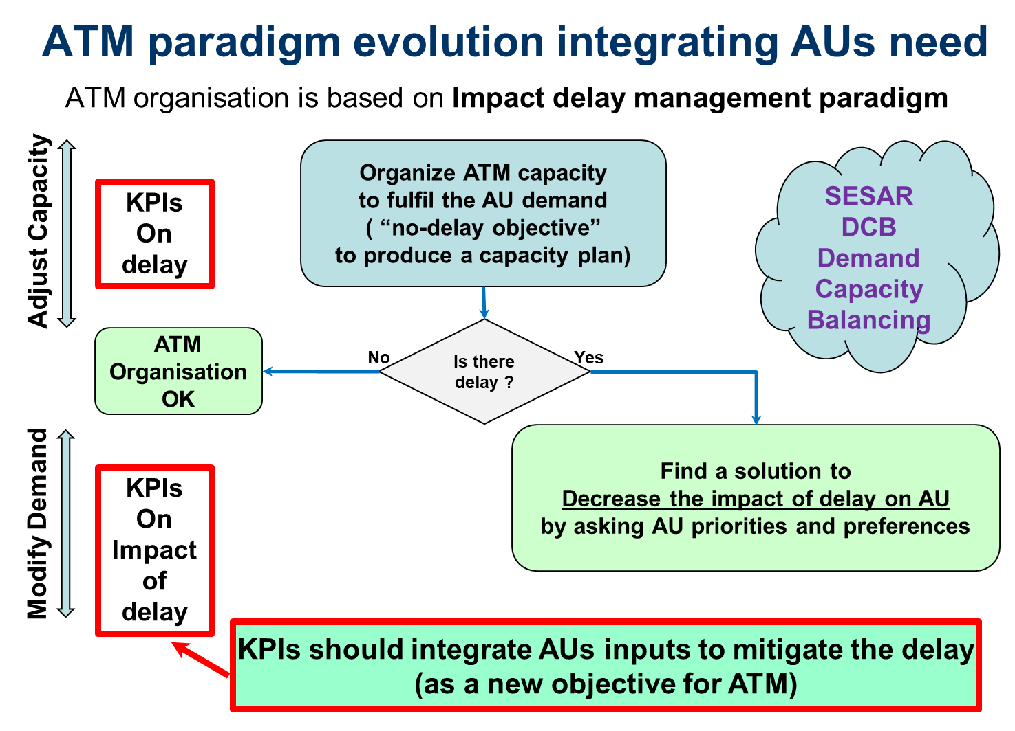

Figure 3: ATM paradigm including AUs to solve problems

#### From Delay management to Cost Management and Improve Passenger Experience

Only managing traffic through delay, including reactionary delay, overlooks that:

* The impact of delay is not the same depending on the number of passengers inside the aircraft and the type of flight;
* There is a specific passenger flow (PAX Flow) including transit passengers that connect to other flights;
* Curfew constraints (hard and PPR requirements), that are usually known in advance;
* Operating crew have duty flight time limitation (FTL) constraints;
* Planned maintenance requirements have significant operational impacts;
* Commercial / reputational impacts that are unique to each airline’s business model;
* VIP on board (airline reputation possible issue),
* Issue with cargo (for example live stocks on board),
* Protection after diversion, medical emergency, religious reason....
* Delay is not the only way to manage impact on AUs.

##### Reactionary delay management

Managing ATFM delay through Airport reactionary delay is an initial step to decrease the overall ATFM delay but it is still an action to decrease the delay itself. It does not necessarily fulfill the impact of delay especially on the AU’s fleet. E.g. increasing delay on a flight, even if the next rotation is impacted, could have less impact then on a flight with no reactionary delay that has a significant impact given that passengers in transit may miss their next flight.

Even more, Airport reactionary delay approach can be counterproductive for an AU HUB operation, because fleet organisation / timetable is based on passenger flow as well as aircraft rotation.



Figure 4: Reactionary delay in ATM

Reactionary delay does integrate many elements involved in the impact of delay on the AU’s fleet, but only manages the delay on the next flight operated by the same aircraft.

##### AU event oriented management

The Operational cell in the AU are faced, every day for a large number of their flights, to solve the problem of managing delay in real time to avoid big impacts on their entire fleet. A solution for a flight is not taken only by managing the flight itself or the next rotation, but according to the full lines of flying, which can impact into the following day (s).

Major elements, taken as the driver of action, are based on losing a time window to operate flights. These time windows are based on events occurring if these windows are not respected.



Figure 5: Operational Impact of delay for AUs

##### AU Cost management

According to the different tools available on the different FOC of the different airlines, evaluating possible solutions face to delay could be a difficult task that experienced organizations can handle (experienced dispatchers …). Comparing different options and scenarios to decrease the impact of delay is driven by the operational cost impact off the delay on the fleet (sometime integrating operational changes until D+2). Cost is the common denominator of the impact to evaluate different kind of solutions. The cost is not always easily quantifiable to allow comparisons or easy decision making when faced with complex situations and AU reputational value is not easy to judge. However, a cost approach is proposed integrating all the relevant elements to calculate a cost value for delay.

Operational cost of delay, including punctuality reputation, is one of the most efficient ways to compare solutions, but as it is not mandatory to use UDPP, a conventional approach is of course allows. Whilst no mandatory method is applied to UDPP, UDPP priority values are always used to give the best solution. No mandatory method to be applied to the UDPP prioritisation is foreseen because priority management is an internal airspace user business. However, UDPP priority values are always used to give the best solution according to the priority values given.

In some OCC, and according to FOC, we cannot speak directly about Cost management or operational cost. The dispatcher does not have this info, and only uses his operational knowledge and experience about his network and fleet. His main goal is just to reduce big delay on particular flights to avoid disruptive situation (curfew, crew time and maintenance are the main reasons). However, these impacts are de facto linked to the cost.

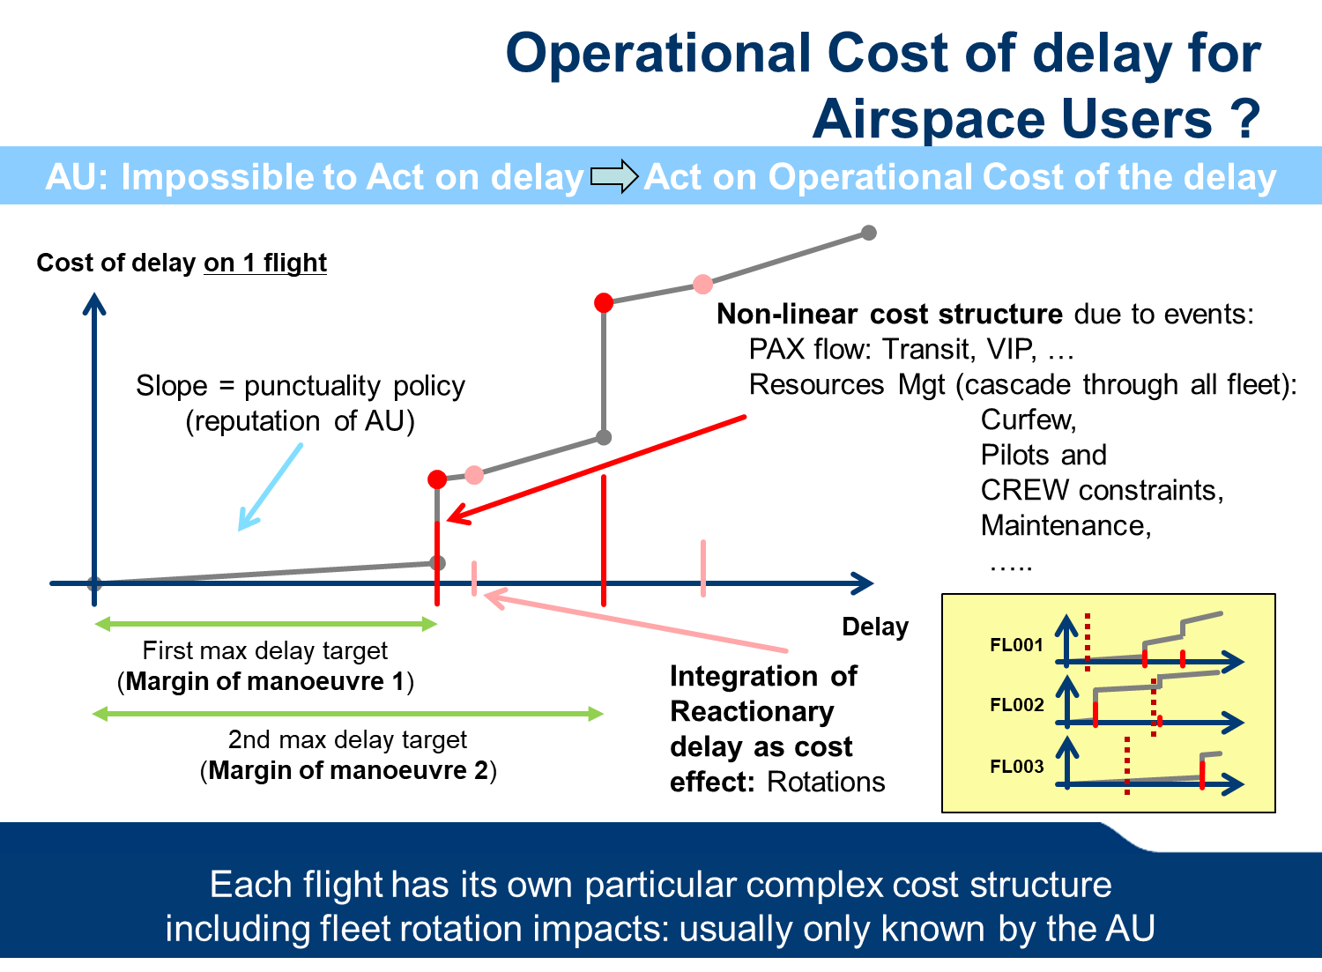

Figure 6: Operational cost of delay for AUs

A very simple example is given above to illustrate that reordering flights can decrease the impact of delay.



Figure 7: Operational Cost of delay reordered

Imbalanced situation is delegated to UDPP to be solved.

#### The UDPP delegation and UDPP measure

If an imbalance situation is detected by DCB and has to be solved, according to the overcapacity characteristic and situation, a different kind of measure can be applied:

* A STAMs can be apply for small overloads, to reduce the impact on Network (few flights are moving)
* An ATFCM Regulation can be applied for heavy overloads, involving all flights in the regulation area. This type of measure could be solved also by a UDPP measure with less impact on AUs.
* A UDPP measure: whatever the type of overload, it is delegated to the AUs to provide their operational solution. This is achieved through the UDPP rules and processes.

The UDPP delegation is the term used in this document to trigger the use of UDPP in a specific area of interest resulting in traffic crossing a Capacity Constrained Situation or a normal Capacity situation, which has a demand that exceeds the available capacity. This UDPP delegation becomes an active “UDPP measure” to manage the imbalance.

To mitigate the imbalanced situation, an Airport or NM/DCB action must be taken.

A hotspot declaration could issue a UDPP measure to solve an imbalanced situation.

Originally, the imbalance, or the hotspot, does not necessarily define all the impacted flights relative to the situation (because the effect of the imbalance is not known initially: e.g. no idea of the recovery period). When the UDPP measure is created, the different constraint declarations (CCS) are used to calculate all the impacted flights (all flights having delay) according to the Capacity constraints in a CASA like way (FPFS), and then, all the flights touched by the constraints are involved in the UDPP measure.

Nevertheless, a UDPP measure can be set to a larger time window than the calculated one generated by the impacted flights, or on a window with any CCS declared, to allow AU to reorganize flights if needed. It is up to the resource owner (e.g. Airport) to define this “UDPP measure” in collaboration with AUs.

#### The UDPP prioritization

The UDPP concept is based on minimising the impact of delay to AUs.

The main objective for an AU is to mitigate and reduce the impact of delay on their operational fleet until flights, or lines of flights are back on schedule (which may be D+2 or longer).

AUs expect UDPP prioritisation to be robust and efficient. The main element is to have a confidence of the result over the time until execution, with the minimum variability on it, to stabilize as soon as possible the arrival or departure time of the flights.

This implies that:

* the knowledge of the problem: the constraint, have a good degrees of stability
* The result of the UDPP prioritisation has a good stability over time.

From a generic approach view, UDPP could be seen as a tool to manage scarce resources, in the case of exceeding demand, by integrating AUs’ needs to the solution.

The UDPP function receives all of the priorities from all of the AUs involved in a declared capacity problem, and the UDPP function generates the AUs’ preferred sequence of flights for its fleet during this particular problem.

The objective of the prioritisation algorithm is to have a new reordered list of flight in the UDPP measure that best feed the AU expectation.

All AU will not necessarily use UDPP; therefore, those not using UDPP will receive baseline slots as defined in a CASA regulation.

Important statement:

To facilitate UDPP, a number of techniques are used (FDR, SFP, Margins). The values given by the AU (priority values / margins) are strictly relative to the UDPP measure and specific to each AU. These priority values cannot be used outside this defined environment and represent nothing more than a way to reorder the flight in the constraints.

Concerning the UDPP Margins approach:

Currently UDPP Margins are defined only in the framework of UDPP, which guarantee the equity and the security of the associated AU data.

In future work (no defined in wave 1), Margins could have an important value to manage the ATM, but first, data protection, security issues and equity must be clearly studied.



Figure 8: What is UDPP?

##### Introduction of the UDPP features.

The UDPP feature can be used, by each AU that has more than one planned flight to enter into the congested period, when a UDDP measure is published.

The common aim of the UDDP algorithm is that, regardless of any actions performed by the AUs, the equity aspect is maintained.

The UDPP Prioritization must cover all the possible needs for an AU to rearrange the list of their flights. To enable broad usage of UDPP features, a number of parameters have been defined and are described in the following chapters.

UDPP features are originally based on the extension of the Slot Swap capability validated in SESAR1 Step 1, which is currently under deployment.

UDPP concept is based on three features:

* **FDR**: a prioritisation feature only based on the generalisation of the slot swap extension
* **SFP**: a specific prioritisation feature to force flight times into a time window even if there is no AU slot available for it.
* **Margins**: a feature to manage time windows associated to each flight.

##### Equity in UDPP

The notion of equity is fully integrated in the UDPP concept. All AUs claim to have an equitable solution to the problem of delay.

Today the FPFS method is widely accepted by AU to be fair and equitable as it preserves the original sequence of flights. In ATFM operations it is accepted as it minimizes the total delay by using available resources at 100% of the declared capacity

Equity in UDPP is implemented in a way that one AU’s prioritisation does not negatively affect another AU.

To ensure equity, each AU's total delay shall remain the same, if no flight is suspended (explained in 3.3.2.3.3).

Equity in UDPP is managed and measured by two criteria:

* by comparing, the sum of the baseline delay obtained by the equitable algorithm (FPFS) on the AU flights (defined as an initial ATFM delay) with the result of the UDPP algorithm,
* and by the fact that whatever the time position in the sequence the cumulative delay of the solution is always equal or greater than the cumulative delay of the baseline delay for the AU (issue from the CASA like algorithm: FPFS). In other words, the AU cannot take a slot if it does not give one at or before the slot they want to take. This is especially important for SFP to manage Protected flights.

##### UDPP FDR feature

The FDR feature is based on enhanced slot swapping validated in SESAR 1.

According to the slot assigned to each flight of an AU, FDR gives the possibility for the AU to assign its own list of flights to each slot given by the FPFS slot list. In particular, the flight the AU is interested to decrease the impact of the delay on its fleet can be “swapped” with another flight from its fleet. For this, the AU can put a priority value on each flight to be reordered.

FDR priority values can be set to:

* A priority number from 1 (highest priority) to 999 (lowest priority) to give flights a relative ranking number (up to the AU to choose the range of priority to apply. This range can be decided according to the way and the AU internal tool used to manage the UDPP measure. E.g.: this priority value could be a ranking value over all the AU flights within the UDPP measure).
* “L” Lowest priority flight of the AU: specifies the AU’s lowest priority flight(s) whatever the value given to its other flights (could be seen as the 1000 priority value). The flight will take the last slot of the AU.
* “B” Baseline priority: specifies to keep the baseline delay of the flight as the current target delay.
* “S” to suspend a flight: specifies that the flight will no longer be in the middle of the UDPP measure, up to the AU to take a decision concerning this flight (cancellation, diversion, rerouting …). It becomes the least important flights of the UDPP measure, and the flight will be allocated after the last not suspended flights of the UDPP measure.

To avoid giving priorities to all the flights in the UDPP measure, the AU can set a default priority value to be taken if no priority is given to a flight.

Generally, two priority values can be considered to have default values:

* The “B” value is given as an default value if the AU wants to limit the number of changes of flights, in this case the reordering is apply only on flights with a priority value.
* The value 5 is given as a default value, if the AU has decided to use priority from 1 to 9 only (or 50 for using priority from 1 to 99). This default value allows flights with no priority to be part of the reordering as middle priority flight.
* Other values are allowed according to each AU’s specific way of managing priorities on flights.

Note that if no suspended priority value is used (“S”), because FDR is based on slot swapping, there is no impact on other flights from other AUs and the sum of delay for each AU is the same without or with priority values.

The specific suspended priority value allows the AU to take advantage of this action to create a better situation for him, for its other flights. At the same time, because a suspended flight is allocated to an available slot after the last flight of the UDPP measure, it can be considered that the UDPP Measure is decreased and all of the AUs will benefit from this action.



Figure 9: example of FDR

##### UDPP SFP feature

The SFP feature is the specific priority value “P” (for protect) to give to the AU the possibility to protect the schedule of a flight (Pflight) even if there is no direct current slot allocated to the AU.

To do so the AU must have, a minimum of one slot before the original schedule of the protected flight (within a window: called the Pobjective) to not affect other AUs negatively from its action.

If an AU places a P on a flight, the UDPP algorithm, first tried to find an AU slot within the Pobjective time window. If no slot is available at the Pobjective time window, the algorithm finds the first available slot earlier then the flight’s schedule. When a slot is found, the AU’s flight with this current slot is swapped to in the actual slot of the Pflight and the Pflight is allocated to its new slot closer to the original Schedule.

Note that:

* If a slot is available within the Pobjective, the solution is identical to a flight with a FDR value of 1 (or 0, ensuring that it's a higher than any 'priority 1 already assigned) .
* If no slot is available within the Pobjective, no negative impact is generated to the other AUs but positive impact may be experienced.



Figure 10: example of SFP

The Pobjective of a Pflight is given by two parameters:

* The MaxDelayProtection: this AU parameter gives the maximum delay acceptable for a Pflight according to its schedule time: (e.g. 5mn or 10mn). This parameter, defined by the AU, and applicable to all its Pflights, can be changed dynamically to adjust AU objectives on Pflights.
* The HotspotFlightEarlierSchedule: this airport parameter (common to all AUs) gives the maximum early departure or arrival delay buffer allowed by the airport to manage flights. (e.g. 5mn = 5minutes before schedule is allowed)

Note that, if margins are specified for a Pflight, Margins are taken in replacement of these two Pobjective parameters (above) if they are compatible (see 3.3.2.3.5).

##### UDPP Margins feature

Margins on flights provide the AU with the possibility to express time constraints on certain flights with time values, as per below. Currently, a specific algorithm has been developed named “Margin” to allow the possibility of such feature.

Margins on flights can be given by two values:

* “Time not After”: specifies a time by which the flight is requested not to be later than the value indicated.
* “Time not Before”: specifies a time by which the flight is requested not to be earlier than the value indicated.

The objective of the algorithm is to rearrange flights automatically according to these time constraints using the AU’s own slots (similar to FDR, but not based on priority values, but based on time values).

Within the 'Margin' algorithm, a priority value can be allocated on flights where the margin has been set. This priority value can then be used in tandem with the time values indicated in Margins and is used when not all the margin values can be met, in this case the highest priority Margin (Prio = 1) is matched first etc…. Another way to see this priority value is to allow it according to the importance of the cost or lack of resource generated by going over this margin.

For example a flight with a “Time not After” with a priority=1 will be managed first, and then, have its ‘Time not After” objective realized. Then a flight with a “Time not After” with priority=6 will be managed after and its ‘Time not After” objective will not be necessarily realized if the available AU slot cannot give it.

Providing Margins is not mandatory on flights, if no Margin value is given on a flight, the flight is managed as a FDR flights (using only the priority value or the default one if priority is also not given for this flight).

##### Margins on Protected flights

The protection of a flight does not necessarily mean that the flight will be on time (even with a Pobjective given by a small window representing the On-time Objective).

The AU can, if required, protect a flight within a time window by defining Margins.

If margins are defined for a specific Pflight, the Margins replace the time value of the Pobjective:

* If a “Time Not After” is given to a protected flight, this time replaces the upper Pobjective time (normally set by Schedule + MaxDelayProtection).
* If a “Time Not Before” is given to a protected flight, this time replaces the lower Pobjective time (normally set by Schedule – HotspotFlightEarlierSchedule).

Only one of the two Margins could be given.

The algorithm checks that:

* The Time Not After could not be earlier then the schedule.
* The Time Not Before could not be earlier then the Schedule - HotspotFlightEarlierSchedule.
* The Time Not After >= Time Not Before

##### FDR, SFP and Margin are mixed in the same priority value approach

All the UDPP features are managed through a single algorithm, allowing the AU to use a mix of the different possibilities to organize his fleet.

The algorithm manages the flights in the following order:

1. Manage Protected flights (flight with a “P” as priority value)
2. Manage Margin flights (flight with a “time not after” value without a “P” as priority)
3. Manage default Baseline flights (flight with No Margins values, no priority value, and when the defaults priority is “B”)
4. Manage flights with priority value (flights with a priority value 1 to 999 or “L” (= to 1000) with no Time not after)
5. Manage Suspended flights (flights with a “S” as priority value)

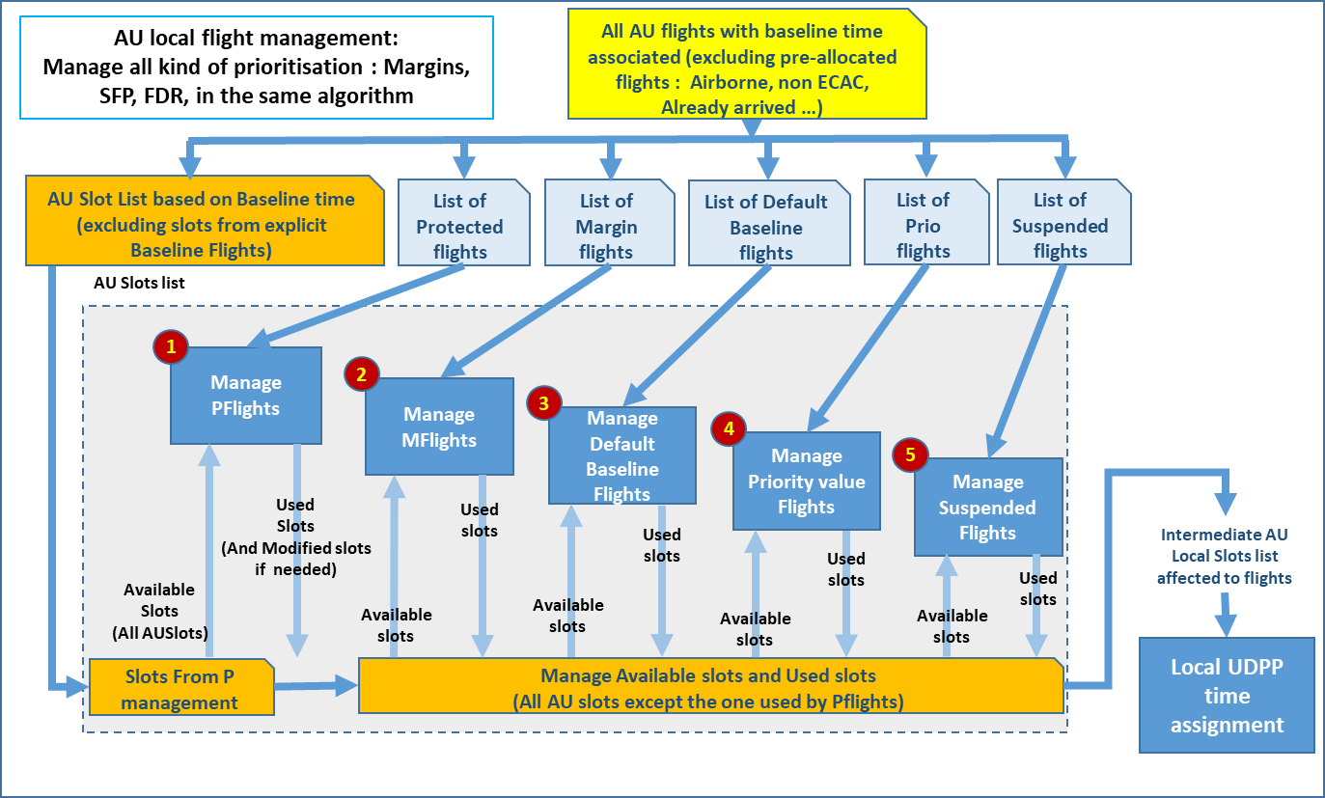

Figure 11: Management organisation of the flights

##### AU inputs: different ways of thinking

AUs have a number of different options when mitigating the impact of delay on their fleet.

No specific features is mandatory, the objective is to allow AUs a large possibility to interact with the UDPP algorithm according to their own capability, configuration, model and tools.

Whilst the use of the different UDPP techniques / solutions is not mandatory, the objective is to allow AUs the possibility to interact with the UDPP algorithm through the use of these techniques in order to reduce the impact of delay.

Some example are defined here.

* Usage of default value: the default value is apply when no priority is given to a flight.

This default value can be set by AU to “B”: in this case, only flights with a priority value are part of the re-ordering. This way of setting priorities limits the number of changes for the AU flights, but also limits the number of possibilities to find a solution.

If the default value is set to a number (e.g. 5), all flights in the UDPP measure are rearranged and the delay is distributed over all the AU flights.

N.B.: “B” can be specifically set to a flight if the AU wants to exclude the flight from the reordering: keep Baseline as a solution.

* Usage of the “Protect” priority:

Generally, “P” is used for important flights to allow them to be “on time” even if no slot is available for the AU. This can cause extra overall delay by pushing lowest priority flights later in the sequence. To be noted that starting by using priority 1 for this flight could be helpful for rearranging the sequence without impacting the overall delay.

On the other hand, using 'P' with margins, could increase the possibility of finding a solution.

* Usage of Suspend “S” or Lowest “L” priority

“S” is foreseen to be used only when the impact of pushing a flight completely outside of the UDPP measure is beneficial to the AU.

Otherwise, use “L” for lowest priority flights. The flights will be assigned in the last slot of the AU.

##### UDPP features timeline

UDPP can be considered a consolidation of different processes and features: FDR, SFP, Margins, but also Extended Slot Swap developed in SESAR1 Step1 environment.

The different features can be used depending on the magnitude, and type, of problem that the AU is trying to mitigate.



Figure 12: UDPP features on timeline

##### UDPP mapping on ATM

The objective of the paragraph is to show where, when and with which type of problem UDPP can be use and has a good benefit.

Tree major types of data are used to segregate the use of UDPP. Form each type, a number / value is used and can be defined as follow:

* The severity of the problem:
  + Large impact on AUs (large delay, large duration): Regulation, DCB big hotspot
  + Large to small impact on AU (delay and duration consistent): DCB hotspot
  + Small impact (low delay, rerouting, or optimisation needed): Optispot, STAM
  + No problem: but optimisation can be still needed
* The anticipation time to the problem:
  + Long term – before other optimisation
  + Start other optimisation – before execution (define the Cut-Off time)
  + During execution
* Where the problem occurs:
  + Airport Departure
  + Airport Arrival
  + En-route

The following table shows the value of UDPP:

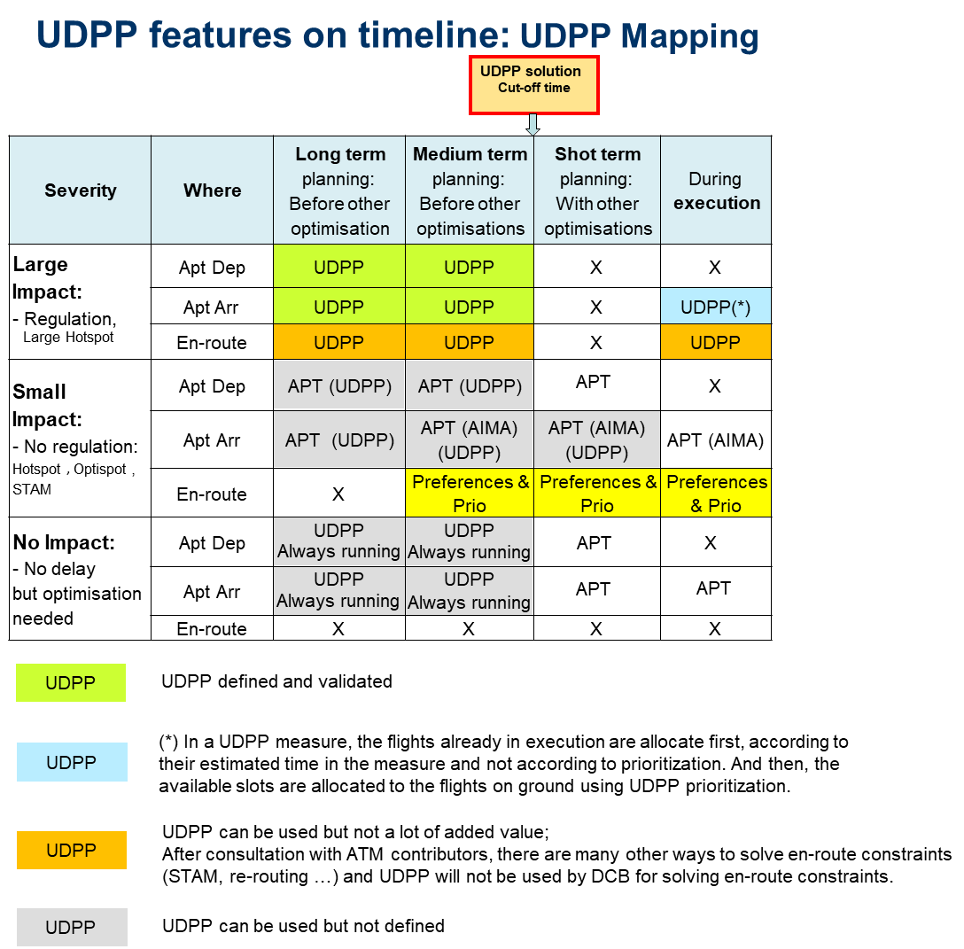

Table 7: UDPP features on timeline

#### Time parameters and timeline

##### Time reference and Arrival Schedule time

For the passenger, the arrival time (scheduled in-block time: SIBT) represents the 'contractual obligation' between themselves and the airline to arrive no later than this time. However today, the SIBT is not of real value at ATM level due to volatility in flight planning (route selection / wind component etc…) and there remains a mismatch between “airport runway slot allocation” and commercial need.

In many cases, the SIBT is overestimated and is based on performance of the city pair / flight number in previous seasons. This is not considered abuse, but the AU will base its schedule to deliver the passengers as per the 'contract'. This provides uncertainty at ATM level. Complexity is further added due to that, on occasion, some airport slots are oversold.

At level 3 coordinated airports, the SIBTs are checked for consistency against the airport slot.

When comparing scheduled arrival and departure times, it is observed that in many cases the minimum turnaround time (MTTT) cannot be respected. This is particularly relevant when flights on a given day are operating with extended block times.

Today nothing is done to check all of the validity of the arrival Schedule, and this schedule is not used to organize the ATM.

A good approach, allowing ATM operations that are more robust, will be to check the arrival schedule by the airport and the ATM in order to be in coherence with ATM actors.

##### UDPP Cut-off time: UDPP measure close time

The UDPP cut-off time is the time after which prioritisation values from the AU's can no longer be accepted.

Before this time, when an AU prioritizes its flights and submits them, the new sequence of flights is calculated and maintained, integrating the modification into the network.

The UDPP cut-off time is specified when the UDPP delegation is decided, which corresponds to the publication of the UDPP managed hotspot.

The time value is given by the owner of the resource (e.g.; Airport; probably under the APOC coordination) according to the uncertainty of the situation and the characteristics of the different components influencing the final sequence.

The components influencing the value of the cut-off time are linked to different optimisation tools used to manage the airport, these components are:

* Starting time of the runway optimisation;
* Arrival manager (AMAN);
* Departure Manager (DMAN), Pre-departure sequence;
* DCB Airport;
* …

After a specific Workshop with Airspace Users, Airports and DCB experts, some elements have been clarified.

When a UDPP measure is applied on the airport of arrival, the allocation of CTOT from the departure airports means that there is no cut-off time required from the airport perspective (the CTOT provides a natural 'stop'). From a DCB perspective, should there be a need for a DCB en-route action, a cut-off time must be defined to allow DCB to manage the measure effectively.

##### UDPP Time for freezing flights input

A UDPP measure can be published a long time in advance, using the AU schedules as the basis for the demand. However, if published too far in advance, the full demand may not be evident, as all flight plans may not yet be filed.

The UDPP time for freezing flights is defined and published at the same time as the notification for the UDDP measures.

The UDPP time for freezing flights is specified when the UDPP function stops integrating new flight plans in the UDPP measure. After this time, new flight plans would be set at the end of the calculated hotspot.

The time value for freezing flights is given by the owner of the resource (e.g.; Airport; probably under APOC coordination) according to the uncertainty of the traffic, the situation and the characteristic of the different components influencing the final sequence, as defined for UDPP cut-off time.

UDPP extended Slot Swap (ESS) is a particular case that could be allowed without any freezing time because it’s not used in the same way that FDR and SFP and Margin.

##### UDPP max anticipation schedule delay

This value gives the maximum anticipated delay for each reference flight time (e.g. 10mn) that the UDPP feature is able to give to a flight to rearrange the sequence.

During a UDPP measure, this value gives the possibility to the AU to arrive earlier according to the flight reference time (schedule) and the prioritisation, in a manageable way.

This value gives room for optimisation of resource (e.g. runway throuput).

This value is decided and published by airport, in coordination with the AUs.

##### Summary of UDPP Time events on timeline



Figure 13: UDPP Time Events on timeline

##### UDPP over ATM actors timeline



Figure 14: High-level concept elements on timeline

#### Concept view of interactions between ATM actors

This graph represents a simple concept view of the interactions between ATM actors in the framework of UDPP.

It should be noted that impact assessment given to AUs when prioritizing flights through the UDPP service, is supported by the DCB actor (linked to the Net status) integrating AOP data through the AOP/NOP integration capability. The AOP/NOP integration is under the responsibility of the DCB actor.



Figure 15: Concept view of interactions between ATM actors

#### Time management: UDPP priorities, AU Preferences and DCB STAMs

Today, to solve a capacity problem, the majority of the features defined, and other features currently under deployment, are based on time management without integrating the AU needs.

These time solutions are based on:

* CTOT to manage the take of time, and/or
* TTA, to manage the arrival time.

DCB STAM functionality availability: Today if a TTA or/and CTOT is already defined on a flight, it indicates that, due to a constraint, the flight has already been treated as such to manage the DCB constraint. In this case, the FMP must try to avoid using this flight for STAM actions, which generate a double penalization for this flight (delay + Level-Cap for example). Nevertheless, if this flight is absolutely needed for solving the problem, the FMP must try to avoid changing the flight arrival time, to ‘not disturb’ an already managed organisation. In this case, a light STAM level cap is possible to apply.

If User Preferences are allowed to manage STAM, the same constraint is preferred when time constraint is applied on arrival (not changing arrival time) but User Preferences can be used if compatible.

UDPP prioritisation is a Measure to manage a specific constraint. This measure involves the AU giving their preferred solution, which is less impacting than the standard FPFS delay.

Today UDPP priorities are not visible outside the UDPP server and are specific to the problem and relative to the AU flights only (relative priority). These priority values will not be accessible until they are outside of the UDPP server, and until a clear view on the equity principle related to the use of the value is clearly defined.

#### UDPP investigation: Absolut priority (E-OCVM V1)

Absolute priority (A-PRIO) is a V0 concept that complements the Enhanced DCB framework defined in PJ09S03 OSED. During Wave1, no clear solution has been identified for having and indicators (A-PRIO) to compare flights between different AUs to support DCB identifying candidate flights for short-term ATFM measures (STAM).

After investigations, the A-PRIO concept has been stopped, showing that extracting elements form the current available data could not give relevant element to set an Absolut priority value.

A-PRIO concept has been investigated by PJ07S01 as a continuity of the User Preference mechanism and finally has been called “Priority Flight”. This “Priority Flight” information is given by AUs as extra input when needed.

#### UDPP investigation: Low Volume Users in Constraint (E-OCVM V1)

This particular concept is in maturity level1 and has to be further developed in order to become a reality'. It will not be part of the human in the loop validation exercises in wave 1.

AUs should be able to use UDPP even if there are very few flights in the constraint. However, some AUs would want to participate but have limited flexibility due to the low volume of their operations (the so-called LVUCs, i.e., Low Volume Users in Constraint). See Figure 16 to find an illustration of the problem of access for LVUCs and the need to develop a new UDPP feature to give flexibility for adapting their operations to the changing operational environment, thus increasing the opportunities for LVUCs to mitigate disruptions and minimise their costs in the event of congestion problems that trigger UDPP measures.

It is key from the point of view of 'access and equity', to find a new feature that allows the LVUCs to participate in the UDPP mechanism. To be accepted, such feature must show evidence, under the consideration of realistic operational scenarios, that the equity is preserved in the long term, i.e., no significant impact is caused on other AUs at the end of the reference period, e.g., 1 year.



Figure 16: Illustration of the need to give access and flexibility to LVUCs

The **Flexible Credits for LVUCs (FCL)** is a new UDPP feature built upon the existing collaborative decision-making mechanisms that would allow the LVUCs to participate in the re-allocation of slots. It aims to provide enhanced flexibility to the AUs for re-distributing delays among their flights with **Delay** **Credits (DCs)**, a virtual currency without monetary value. The most relevant characteristic of the FCL mechanism is that LVUCs can accumulate credits in a particular UDPP measure by accepting extra delay in some flights, and such credits can be used in other UDPP measures (occurring in different time), compensating the LVUCs for their current and previous efforts that benefit other AUs. LVUCs can decide at any moment if credits are fully or partially transferred from one UDPP measure to another, or alternatively they are used in the same UDPP measure (in the cases in which the LVUC has more than one flight in a UDPP measure). Business aviation operators usually have few flights involved in a given UDPP measure, so they will benefit greatly from the introduction of this new mechanism.

It is expected that LVUCs will accept more delay in those flights with delay allocated far from their operational margins (i.e., relatively low cost of delay in the current situation), thus giving the margins on behalf of other AUs, in exchange of credits. These credits will be used in future UDPP measures to reduce their overall costs when one or more of theirs flights are impacted severely by delay.

For example, consider the illustration case in Figure 17 in which a LVUC only has one flight (FL001) in UDPP measure 1 and one flight (FL002) in UDPP measure 2. In either of the two cases the LVUC cannot improve his situation (i.e., reduce the cost impact of delay) even if access is given to him to the current Enhanced Slot Swapping, FDR or SFP features. However, with FCL the AU could have an access to UDPP and could substantially improve his situation. Note that in this example the flight FL001 has a certain amount of delay (D1) that could be increased, due to the operational margins available, with relatively low impact in terms of cost. Accepting the extra delay D1’ (D1’ > D1) the AU is giving his position and reducing the delay (positive impact) to other AUs between the original and the new sequence position. The AU can then be rewarded for this, with an amount of delay credits proportional to extra delay accepted (in this document 1 DC = 1 minute of delay). In UDPP Measure 2 the LVUC could use the credits available from UDPP Measure 1, because in this example the flight FL002 has an amount of delay D2 that has an important impact in terms of costs for the LVUC. After using part or full of the credits available, the AU can reduce the delay for that flight from D2 to D2’ (D2’ < D2), which is an amount of delay within the operational margins available for that flight, and therefore with marginal cost of delay. The AUs in between the baseline and the new position are impacted negatively, but with just one position in the sequence. Typically, it means 3 minutes or less of extra delay, which can be considered as a negligible impact if the total allocated delay to a flight is within its operational margins (see in Appendix B the simulations results and other evidence that supports such sentence).



Figure 17: Illustration of an LVUC exchanging delay and credits between two UDPP Measures

It is expected that the impact on these flights will be always negligible (LVUCs requests will be cross-checked against the operational margins of impacted AUs before accepting them), and that the extra costs for other AUs will be compensated in the long-term by the positive impacts received when LVUCs are giving their positions and by having access to the rest of UDPP features (e.g., FDR/SFP) to which LVUCs cannot have real access. The final goal of including LVUCs is to ensure a higher level of equity by increasing the access to all the operators irrespective to their volume of operations.

In addition, the consideration of an AU as a LVUC may change in different UDPP measures according to the circumstances; therefore, even large airlines can be often[1] considered as LVUCs in many UDPP measures (typically in UDPP Measures triggered at airports in which they only operate a few flights). The access to FCL and LVUC rules to any AU –in those UDPP Measures in which the AU can be considered as LVUC– can increase even further the acceptability of some circumstantial degree of inequity in favour of the LVUCs in individual UDPP Measures.

Another example is illustrated in Figure 18. The sequence in the example is dominated in number of flight and slots by two AUs (non-LVUCs). These AUs are represented in the figure by sticks coloured in green and blue, whereas an LVUC has been represented with two flights identified in the sequence with orange colour. The example illustrates how the LVUC can reduce in this specific scenario the total impact of delay (costs) by increasing +24 minutes the delay of flight 1 to obtain 24 delay credits and reducing the delay of flight 2 by giving the 24 credits gotten previously. In this example, a 20% of cost reduction could be achieved, due to the non-linear relationship between the fleet cost structure and delay. The impact to other flights is considered negligible (3 minutes of extra delay per flight, if impacted).



Figure 18: Illustration of an LVUC exchanging delay and credits in the same UDPP Measure

Note that, in addition to FCL,LVUCs could sometimes have access to FDR/SFP features by grouping together in a voluntarily basis and operating as a single operator through a virtual flight operation centre (V-FOC). Such approach would respect equity out of the V-FOC (i.e., LVUCs could exchange their own slots without generating impact to others), but two major questions should be addressed in future research to guarantee that the access to LVUCs through V-FOCs is effective in practice: a) how often a set of LVUCs would be willing or will be able[2] to make a group to form a V-FOC; b) whether such mechanism is flexible enough, e.g., if all the LVUCs in a V-FOC want to reduce their delay; and c) how the equity can be preserved within the VFOC over the time. Such last question is an internal private aspect of the AUs grouping in a V-FOC, but if a pragmatic way of coordination for AUs in a V-FOC is not foreseen, the concept of V-FOC could not work in practice and thus the actual access supposedly given to LVUCs would be not effective.

In conclusion:

1. **FCL could be recommended as a mechanism to give access for LVUCs to UDPP**. FCL can provide high flexibility to LVUCs and according to the evidence (see Appendix B), the equity could be controlled by fine-tuning the set of rules that limit the number of flights in a UDPP measure and the maximum negative impact on time allowed per flight (MNIT).
2. **FCL is compatible and can co-exist with the FDR and SFP features** (in which LVUCs have little flexibility). LVUCs could be constrained if the impact generated by their actions in FCL could have a large impact on other AUs, e.g., if the operational time constraints of other AUs flights cannot be fulfilled as a consequence of a FCL prioritisation. FCL could also coexist with other ways to give access to LVUCs, such as the concept of V-FOCs.
3. **All the AUs could have access to FCL when they can be considered LVUCs at any particular UDPP measure**, which occurs quite often daily and therefore it could have a large positive impact on the flexibility and cost-efficiency of all the AUs. Special rules may apply for AUs that always are LVUCs (e.g., business aviation).
4. **FCL may generate little and controlled inequities momentarily** in form of negligible impact/extra delay received in some flights, which is justified by the need to give access to LVUCs to UDPP. Non-LVUCs in a UDPP Measure should have **benefits from participating in FDR and SFP that are expected to be larger** than the negligible impacts potentially occasioned circumstantially to them by the LVUCs that use FCL. In addition, **increasing the flexibility of LVUCs in turn will benefit to all the AUs**, since all the AUs may be LVUCs in some UDPP Measures.
5. **Further research is needed** (current concept is in V1) to fully understand how to adapt the system to have a good balance between the benefits received by the AUs when they have access to UDPP and the efforts and negative impacts that are necessarily tolerable to guarantee the equity and to increase the flexibility for all the participants.

#### Use Cases

UDPP is described through a single Use case, integrated in the DCB processes.

DCB processes are based on Use cases defined in the DCB OSED (see PJ09.03 OSED document, and will not be described in this document).

PJ09.03 OSED reference: Chap 3.5.2.9.1 the Collaborative process, specifically the Chap 3.5.2.9.1.[2 and 3] dealing with the description of the DCB Collaborative Workflow for Hotspot Arrival Management using TTA prepared in the SBT Elaboration process with APOC [full and limited] delegation.

The description of the relationship between Regional ATFCM and Local ATFCM is also defined in the DCB OSED Chap 3.5.2.9.1: The Collaborative process. It is synthetized here from the UDPP point of view, to understand the global context and the UDPP integration and behaviour.

Only relations with UDPP services and AU are described.

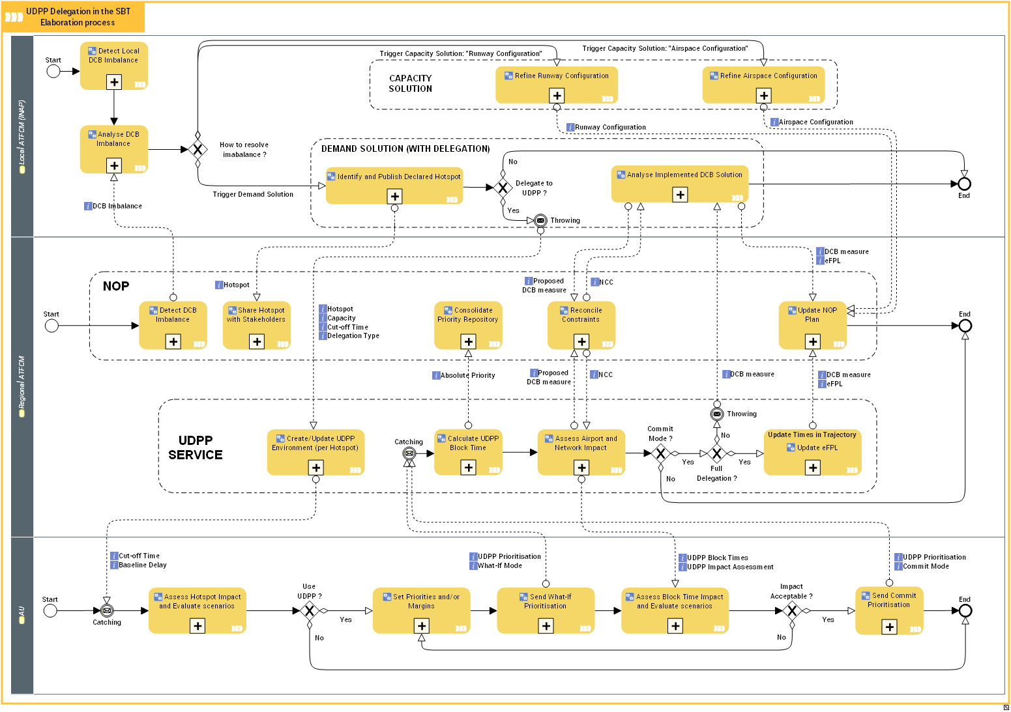

Figure 19: Use case 1 - UDPP delegation in the SBT elaboration process

The Integration of the UDPP process is based on SESAR2020 PJ09.3 (DCB) definition on process interactions. The different type of delegation and modus operandi between local and regional ATFCM is defined in the PJ09.3 OSED as basis of coordination between the ATM Actors in the S2020 vision. For more details, see PJ09.3 OSED: Chap 3.5.2.9.1 The Collaborative Framework Process.

In this Use case definition, all the part above the UDPP SERVICE container is part of PJ04.2 or PJ09.3 definition. There have been defined here to make and understand the links between the 3 entities. These parts have to be defined in PJ04.2 or PJ09.2 and managed as assumptions in PJ07.2 (UDPP).

The Integration of the UDPP process is based on the following high-level steps:

* Detection of imbalance (DCB)
* DCB create a UDPP measure (DCB with Local ATFCM: part of Airport): delegation is given to the UDPP service to manage the imbalance
* The UDPP service manages the UDPP measure, and allows what-if and publishes according to AUs prioritizations and kind of delegation.
* The AU is alerted by the Network if a UDPP measure concern them
* AU prioritises their flights to decrease the impact of the delay according to their business model and operations (AU).
* The UDPP service manages the new sequence and issues times according to the prioritisations made by the AU. It returns the Network impact to the AUs based on this new sequence. This impact assessment is based upon the implementation of the data exchanges foreseen between PJ09.03 and PJ04.02. If no impact is observed at Airport level, then only the Network impact is considered and passed back to the AU during the prioritisation process.
* The UDPP service publishes a new sequence and times organisation to the Network according to the type of delegation (full delegation, partial delegation).

Description of UDPP nodes:

The DCB service (Network: no need to make the distinction between local and regional ATFCM: it is a DCB internal organisation):

* DCB (or the responsible body to delegate) allows the delegation to AUs of an imbalance problem and set a UDPP measure with the delegation characteristics: Cut-off times, delegation type …)
* DCB integrates UDPP solution according to the delegation type.

The UDPP service:

* The UDPP service is instantiated when a UDPP measure is created. Once created, the characteristic of the measure is given: the different cut-off times, the problem to solve, and delegation type. The UDPP service obtains all required data from the Network to manage the UDPP measure (capacity constraints, impacted flights) and create a new sequence (CASA like) to evaluate the impact and publishes delay.
* If flights have already priority values through extended flight plans (FF-ICE field: within fleet priority), UDPP services considers them and publishes the new sequence to the network accordingly.
* AU asks UDPP service to consider the new delay and sequence according to the prioritisation given to it, in what-if or commit mode.
* The UDPP service checks the impact of the new delay / sequence to the Network (and Airport, as defined) and returns this impact assessment result back to the AU.
* When AU sends Commit prioritizations, according to the delegation mode, the UDPP service sends back to DCB the new sequence and times for implementation (partial delegation) or implements directly the UDPP solution in full delegation mode.

The AU actors:

* The AU asks to the Network if a UDPP measure concern them.
* If a UDPP measure exists, AU gets all the measure characteristics and the subsequent operational impacts / delays to their flights.
* 'If the AU wishes to use UDPP to decrease the impact of the CCS, they give their priorities and margins to their flights and call the UDPP service to obtain new delay and the impact on the Network.
* AU can use what-if scenarios to evaluate the new impact.
* When the new delay / sequence is acceptable to the AU, they can then submit their finalized prioritisation to become effective in the Network.

Activities description :

The colors in the following table highlight the status of the activity:

* In black: non UDPP activity currently defined in the relevant project and used by UDPP
* In blue: UDPP activity defined in this document
* In red: Activity out of the scope of UDPP or not defined in other relevant project.

|  |  |
| --- | --- |
| Activity | Description |
| Analyse DCB Imbalance | [DOD 7.2 modelling] The Local Traffic Manager and/or the Flow Manager analyse the demand versus the given resources and capabilities in his area, in order to foresee the resulting problems. |
| Analyse Implemented DCB Solution | The Local Traffic Manager and/or the Flow Manager monitors the proper execution of the DCB plan to resolve the hotspot and take additional measures in case of plan deviation of necessary |
| Assess Airport and Network Impact | The UDPP service assesses the impact of the new prioritisation to the network by running a network what-if in the NOP. If What-If NOP does not exist the impact on network will be visible only after submit by the AU. |
| Assess Block Time Impact and Evaluate scenarios | AU assesses the output of the what-if of their prioritisation to take decision to implement of not. If not AU can modify the prioritisation and run a what-if again |
| Assess Hotspot Impact and Evaluate scenarios | AU assesses the impact of the delay to their fleet within a UDPP measure to take decision to prioritise their flight or not |
| Calculate UDPP Block Time | This UDPP central function, convert priority to new delay, according to all AU prioritization values and equity rules. |
| Consolidate Priority Repository | DCB activity |
| Create/Update UDPP Environment (per Hotspot) | Create the UDPP measure according to the traffic and the constraints on the element to manage: e.g. get all traffic arriving in Airport, apply the constraints, and generate de delay to the corresponding flights. This Activity maintains also the different flight delay according to the possible evolution of the constraints or the evolution of the traffic. |
| Detect DCB Imbalance | The Local Traffic Manager and/or the Flow Manager monitor the balance between demand and capacity in real time by analysing entry and occupancy counts and associated workload values, and comparing them respectively with situational traffic capacity values and occupancy traffic monitoring values. |
| Detect Local DCB Imbalance | The Flow Manager (INAP) function analyses the local imbalance figures (complexity, ….). |
| Identify and Publish Declared Hotspot | Identify DCB imbalances that need to be monitored and/or resolved by creating and publishing a corresponding hotspot. |
| Reconcile Constraints | This function collects the planned DCB constraints from local NMF actors and provide the Network Consolidated Constraints (NCC) aiming at reconciling the interfering local constraints. |
| Refine Airspace Configuration | DAC activity |
| Refine Runway Configuration | Airport activity |
| Send Commit Prioritisation | When AU are OK with the prioritisation he has put in place, AU can submit it to the Network |
| Send What-If Prioritisation | AU can run a What-if to evaluate the result of a prioritization. |
| Set Priorities and/or Margins | AU can set prioritisation to their flights to decrease the impact of the delay (SFP, FDR, Margins) |
| Share Hotspot with Stakeholders | The local hotspots are collected by the Collaborative NOP and accessible by NMF actors |
| Update eFPL | UDPP send new time for flights within the UDPP measure. |
| Update NOP Plan | The dDCB/DCB solutions descriptions and their intended use are updated and published in the NOP. |

### Differences between new and previous Operating Methods

|  |  |  |
| --- | --- | --- |
| **Activities (in EATMA) that are impacted by the SESAR Solution** | **Current Operating Method** | **New Operating Method** |
| in DCB | Manage Hotspot | UDPP measure are part of the possible solution to manage imbalance/hotspot |
| In Airport | Airport apply only regulation to manage overloaded situation | Airport can delegate to AU through UDPP measure the management of the overload in coordination with DCB |
| AU | Not possible to deal with impact of delay | AU can rearrange their flight sequence to decrease impact of delay on their fleet. |

Table 8: Difference between new and previous Operating Method

# Safety, Performance and Interoperability Requirements (SPR-INTEROP)

## UDPP enablers form other projects

This sub-chapter of the document define enablers from other Project/Process needed to start the UDPP function. Without these elements, UDPP could not exist because a “UDPP measure” cannot be created.

The DCB (PJ09) through a local NMF has to delegate to UDPP (the AUs) the resolution of an imbalance and then a UDPP measure can be declared.

## Operational Requirements

[REQ]

|  |  |
| --- | --- |
| [REQ]Identifier | REQ-07.02-OPS-OLOC.0001 |
| Title | NMF (local ATFCM) delegate imbalance resolution to UDPP |
| Requirement | DCB shall allow AUs to mitigate a Capacity Constraint Situation through UDPP functions |
| Status | <In progress> |
| Rationale | In order to decrease the impact of a capacity problem causing delays, APT or NM actor through a NMF function can allow AU to mitigate the situation with UDPP |
| Category | <Operational> |

[REQ Trace]

|  |  |  |
| --- | --- | --- |
| Relationship | Linked Element Type | Identifier |
| <ALLOCATED_TO> | <SESAR Solution> | PJ07.02 |
| <ALLOCATED_TO> | <Activity> | Create/Update UDPP environment |
| <ALLOCATED_TO> | <Allocate To> | PJ09.03 |
| <ALLOCATED_TO> | <role> | Local ATFCM (INAP) |
| <ALLOCATED_TO> | <Sub-Operating Environment> | DCB_Env |

[REQ]

|  |  |
| --- | --- |
| [REQ]Identifier | REQ-07.02-OPS-OLOC.0002 |
| Title | Decision to Trigger UDPP |
| Requirement | A collaborative procedure involving both the Airports and the AUs shall be established for deciding when to trigger a UDPP event. |
| Status | <In progress> |
| Rationale | Both actors have different views of the situation and therefore, may have different opinions on whether UDPP would be a useful situation. |
| Category | <Operational> |

[REQ Trace]

|  |  |  |
| --- | --- | --- |
| Relationship | Linked Element Type | Identifier |
| <ALLOCATED_TO> | <SESAR Solution> | PJ07.02 |
| <ALLOCATED_TO> | <Activity> | Create/Update UDPP environment |
| <ALLOCATED_TO> | <Allocate To> | PJ04.02 |
| <ALLOCATED_TO> | <role> | Local ATFCM (INAP) |
| <ALLOCATED_TO> | <Sub-Operating Environment> | Very large APT |
| <ALLOCATED_TO> | <Sub-Operating Environment> | Large APT |
| <ALLOCATED_TO> | <Sub-Operating Environment> | Medium APT |

[REQ]

|  |  |
| --- | --- |
| [REQ]Identifier | REQ-07.02-OPS-OLOC.0003 |
| Title | Airport can define constraints (CCS) on its runways |
| Requirement | The NMF shall allow Airports to set constraints (declare a Capacity Constraint Situation) on its runways |
| Status | <In progress> |
| Rationale | In order to define a capacity problem (CCS) Airport must have the possibility to define constraints on their resources (currently only Runway capacity). NB: the concept could be extended to other Airport resources like terminal, de-icing bay …. |
| Category | <Operational> |

[REQ Trace]

|  |  |  |
| --- | --- | --- |
| Relationship | Linked Element Type | Identifier |
| <ALLOCATED_TO> | <SESAR Solution> | PJ07.02 |
| <ALLOCATED_TO> | <Activity> | Create/Update UDPP environment |
| <ALLOCATED_TO> | <Allocate To> | PJ04.02 |
| <ALLOCATED_TO> | <role> | Local ATFCM (INAP) |
| <ALLOCATED_TO> | <Sub-Operating Environment> | Very large APT |
| <ALLOCATED_TO> | <Sub-Operating Environment> | Large APT |
| <ALLOCATED_TO> | <Sub-Operating Environment> | Medium APT |

[REQ]

|  |  |
| --- | --- |
| [REQ]Identifier | REQ-07.02-OPS-OLOC.0004 |
| Title | Identify overloaded areas |
| Requirement | DCB shall identify the overloaded areas with the help of Airports through the NMF. |
| Status | <In progress> |
| Rationale | In order to define a regulation or a UDPP measure a DCB NM Function must identify the imbalanced area to be managed. |
| Category | <Operational> |

[REQ Trace]

|  |  |  |
| --- | --- | --- |
| Relationship | Linked Element Type | Identifier |
| <ALLOCATED_TO> | <SESAR Solution> | PJ07.02 |
| <ALLOCATED_TO> | <Activity> | Create/Update UDPP environment |
| <ALLOCATED_TO> | <Allocate To> | PJ09.03 |
| <ALLOCATED_TO> | <role> | Local ATFCM (INAP) |
| <ALLOCATED_TO> | <Sub-Operating Environment> | DCB_Env |

[REQ]

|  |  |
| --- | --- |
| [REQ]Identifier | REQ-07.02-OPS-OREG.0001 |
| Title | UDPP functions are available for AUs to prioritise flights |
| Requirement | A UDPP Centralized function shall build a new sequence according to AU prioritisation. |
| Status | <In progress> |
| Rationale | The UDPP function is operating to allow AUs to manage their fleet in face of capacity problem.  An assumption has been done that a DCB actor (FMP or Airport) initiate the UDPP process from a Capacity constrained Situation. |
| Category | <Operational> |

[REQ Trace]

|  |  |  |
| --- | --- | --- |
| Relationship | Linked Element Type | Identifier |
| <ALLOCATED_TO> | <SESAR Solution> | PJ07.02 |
| <ALLOCATED_TO> | <Activity> | Create/Update UDPP environment |
| <ALLOCATED_TO> | <Allocate To> | PJ07.02 |
| <ALLOCATED_TO> | <role> | Regional ATFCM |
| <ALLOCATED_TO> | <Sub-Operating Environment> | NOP_Env |

[REQ]

|  |  |
| --- | --- |
| [REQ]Identifier | REQ-07.02-OPS-OREG.0002 |
| Title | A UDPP communication link is available to each AU if needed |
| Requirement | A private UDPP communication link shall be available to AUs to perform UDPP prioritisations privately |
| Status | <In progress> |
| Rationale | UDPP link shall be available to AUs to prioritise their flights in a safe manner, avoiding publication of sensitive information to other AUs. AUs Priorities and Margins must stay private. |
| Category | <Operational> |

[REQ Trace]

|  |  |  |
| --- | --- | --- |
| Relationship | Linked Element Type | Identifier |
| <ALLOCATED_TO> | <SESAR Solution> | PJ07.02 |
| <ALLOCATED_TO> | <Activity> | Create/Update UDPP environment |
| <ALLOCATED_TO> | <Allocate To> | PJ07.02 |
| <ALLOCATED_TO> | <role> | Regional ATFCM |
| <ALLOCATED_TO> | <Sub-Operating Environment> | NOP_Env |

[REQ]

|  |  |
| --- | --- |
| [REQ]Identifier | REQ-07.02-OPS-OREG.0003 |
| Title | NMF allow What-If on flights |
| Requirement | NMF shall allow the UDPP function to assess the impact of changing the departure or arrival time to flights through a what-If function |
| Status | <In progress> |
| Rationale | In order to avoid possible instability and to be proactive in the solution to stabilize the fleet and ATFM organisation, a NMF what-if function can be available to show the impact of the AU prioritisation. |
| Category | <Operational> |

[REQ Trace]

|  |  |  |
| --- | --- | --- |
| Relationship | Linked Element Type | Identifier |
| <ALLOCATED_TO> | <SESAR Solution> | PJ07.02 |
| <ALLOCATED_TO> | <Activity> | Assess Airport and Network impact |
| <ALLOCATED_TO> | <Allocate To> | PJ09.03 |
| <ALLOCATED_TO> | <role> | Regional ATFCM |
| <ALLOCATED_TO> | <Sub-Operating Environment> | NOP_Env |

[REQ]

|  |  |
| --- | --- |
| [REQ]Identifier | REQ-07.02-OPS-OREG.0004 |
| Title | DCB through the NMF shall allow the integration of the result of UDPP as a mitigation to manage a capacity reduction |
| Requirement | DCB through a NMF shall allow the integration of the result of UDPP as mitigation for the management of a capacity reduction |
| Status | <In progress> |
| Rationale | In order to take into account AUs needs to mitigate delays, DCB shall integrate the output of the UDPP function. |
| Category | <Operational> |

[REQ Trace]

|  |  |  |
| --- | --- | --- |
| Relationship | Linked Element Type | Identifier |
| <ALLOCATED_TO> | <SESAR Solution> | PJ07.02 |
| <ALLOCATED_TO> | <Activity> | Update NOP plan |
| <ALLOCATED_TO> | <Allocate To> | PJ07.02 |
| <ALLOCATED_TO> | <role> | Regional ATFCM |
| <ALLOCATED_TO> | <Sub-Operating Environment> | NOP_Env |

[REQ]

|  |  |
| --- | --- |
| [REQ]Identifier | REQ-07.02-OPS-OSVC.0001 |
| Title | UDPP creates and maintains the UDPP environment (Delay on flights) |
| Requirement | The UDPP function shall create and maintain the UDPP environment to permit AUs prioritisation according to the possible variability of the Network |
| Status | <In progress> |
| Rationale | A UDPP set of functions shall be available and maintained to allow AU to operationally make flight prioritisation. |
| Category | <Operational> |

[REQ Trace]

|  |  |  |
| --- | --- | --- |
| Relationship | Linked Element Type | Identifier |
| <ALLOCATED_TO> | <SESAR Solution> | PJ07.02 |
| <ALLOCATED_TO> | <Activity> | Delegate hotspot resolution to UDPP |
| <ALLOCATED_TO> | <Allocate To> | PJ09.03 |
| <ALLOCATED_TO> | <role> | Regional ATFCM |
| <ALLOCATED_TO> | <Sub-Operating Environment> | UDPP_Funct_Env |

[REQ]

|  |  |
| --- | --- |
| [REQ]Identifier | REQ-07.02-OPS-OSVC.0002 |
| Title | UDPP Calculate UDPP block Time |
| Requirement | The UDPP function shall calculate new Block times according to the AUs prioritisation values and the current Network data |
| Status | <In progress> |
| Rationale | A UDPP function must manage the flight prioritisations of all the AUs in a constraint (CCS) and produce a new sequence of flight with new time accordingly. |
| Category | <Operational> |

[REQ Trace]

|  |  |  |
| --- | --- | --- |
| Relationship | Linked Element Type | Identifier |
| <ALLOCATED_TO> | <SESAR Solution> | PJ07.02 |
| <ALLOCATED_TO> | <Activity> | Calculate UDPP block time |
| <ALLOCATED_TO> | <Allocate To> | PJ07.02 |
| <ALLOCATED_TO> | <role> | Regional ATFCM |
| <ALLOCATED_TO> | <Sub-Operating Environment> | UDPP_Funct_Env |

[REQ]

|  |  |
| --- | --- |
| [REQ]Identifier | REQ-07.02-OPS-OSVC.0003 |
| Title | Flight Cut-Off Time for prioritisation |
| Requirement | Within a UDPP measure, a flight can be (re-)prioritized only if it's not pre-allocated: Non-ECAC, ATFCM Exempt, Airborne, if the current time is too late to modify the departure time (TSAT-30min) |
| Status | <In progress> |
| Rationale | Airports must have enough time in order to react to the changes to optimise the operations at the arrival airport. |
| Category | <Operational> |

[REQ Trace]

|  |  |  |
| --- | --- | --- |
| Relationship | Linked Element Type | Identifier |
| <ALLOCATED_TO> | <SESAR Solution> | PJ07.02 |
| <ALLOCATED_TO> | <Activity> | Calculate UDPP block time |
| <ALLOCATED_TO> | <Allocate To> | PJ07.02 |
| <ALLOCATED_TO> | <role> | Regional ATFCM |
| <ALLOCATED_TO> | <Sub-Operating Environment> | UDPP_Funct_Env |

[REQ]

|  |  |
| --- | --- |
| [REQ]Identifier | REQ-07.02-OPS-OSVC.0004 |
| Title | UDPP assesses the new time impacts on the network |
| Requirement | The UDPP function shall assess through NMF the impact of the new flight times issued from the new calculation of delay based on prioritisation |
| Status | <In progress> |
| Rationale | UDPP function must transmit to AUs the Network impact of a new sequence organisation. E.g. If a flight with the new time is entering in another regulation, the most penalized time is given to this flight and highlighted to the AU to decide or not to change the prioritization. |
| Category | <Operational> |

[REQ Trace]

|  |  |  |
| --- | --- | --- |
| Relationship | Linked Element Type | Identifier |
| <ALLOCATED_TO> | <SESAR Solution> | PJ07.02 |
| <ALLOCATED_TO> | <Activity> | Assess Airport and Network impact |
| <ALLOCATED_TO> | <Allocate To> | PJ07.02 |
| <ALLOCATED_TO> | <role> | Regional ATFCM |
| <ALLOCATED_TO> | <Sub-Operating Environment> | UDPP_Funct_Env |

[REQ]

|  |  |
| --- | --- |
| [REQ]Identifier | REQ-07.02-OPS-OSVC.0005 |
| Title | UDPP submit a new block Time corresponding to AUs priorities |
| Requirement | UDPP shall submit to the Network a new block Time corresponding to the AU Prioritisation |
| Status | <In progress> |
| Rationale | In order to apply flight prioritisation to the network, the UDPP function shall produce new times for flights and a NMF function shall update the Network time for these flights (submit the AU needs to the network). |
| Category | <Operational> |

[REQ Trace]

|  |  |  |
| --- | --- | --- |
| Relationship | Linked Element Type | Identifier |
| <ALLOCATED_TO> | <SESAR Solution> | PJ07.02 |
| <ALLOCATED_TO> | <Activity> | Update eFPL |
| <ALLOCATED_TO> | <Allocate To> | PJ07.02 |
| <ALLOCATED_TO> | <role> | Regional ATFCM |
| <ALLOCATED_TO> | <Sub-Operating Environment> | UDPP_Funct_Env |

[REQ]

|  |  |
| --- | --- |
| [REQ]Identifier | REQ-07.02-OPS-OAUF.0001 |
| Title | AU assess the impact of delay on their fleet |
| Requirement | The AUs shall have the possibility to check the impact of delays on their all fleet of the day and possibly the day after in case of curfew problem |
| Status | <In progress> |
| Rationale | In order to decrease the impact of delay on AU fleet, the AU must have the possibility to evaluate the impact of delay for flights in constraints over the whole fleet. |
| Category | <Operational> |

[REQ Trace]

|  |  |  |
| --- | --- | --- |
| Relationship | Linked Element Type | Identifier |
| <ALLOCATED_TO> | <SESAR Solution> | PJ07.02 |
| <ALLOCATED_TO> | <Activity> | Assess measure impact and evaluate scenario |
| <ALLOCATED_TO> | <Allocate To> | PJ07.02 |
| <ALLOCATED_TO> | <role> | AU |
| <ALLOCATED_TO> | <Sub-Operating Environment> | FOC_Env |

[REQ]

|  |  |
| --- | --- |
| [REQ]Identifier | REQ-07.02-OPS-OAUF.0002 |
| Title | AU set priorities and/or Margins on flights |
| Requirement | The AUs shall have the possibility to allocate Priorities and/or Margins on flights if needed |
| Status | <In progress> |
| Rationale | AU shall have a tool to allocate priorities and/or margins on flights within a UDPP measure. |
| Category | <Operational> |

[REQ Trace]

|  |  |  |
| --- | --- | --- |
| Relationship | Linked Element Type | Identifier |
| <ALLOCATED_TO> | <SESAR Solution> | PJ07.02 |
| <ALLOCATED_TO> | <Activity> | Set Priorities and/or Margins |
| <ALLOCATED_TO> | <Allocate To> | PJ07.02 |
| <ALLOCATED_TO> | <role> | AU |
| <ALLOCATED_TO> | <Sub-Operating Environment> | FOC_Env |

[REQ]

|  |  |
| --- | --- |
| [REQ]Identifier | REQ-07.02-OPS-OAUF.0003 |
| Title | AU can send what-if to UDPP services |
| Requirement | The AU shall have the possibility to send what-ifs to UDPP services to evaluate the result and impact of the prioritisation |
| Status | <In progress> |
| Rationale | To test and evaluate the impact of new prioritisations the AU shall have the possibility to send a What-If to the UDPP services. |
| Category | <Operational> |

[REQ Trace]

|  |  |  |
| --- | --- | --- |
| Relationship | Linked Element Type | Identifier |
| <ALLOCATED_TO> | <SESAR Solution> | PJ07.02 |
| <ALLOCATED_TO> | <Activity> | Send What-If prioritisation |
| <ALLOCATED_TO> | <Allocate To> | PJ07.02 |
| <ALLOCATED_TO> | <role> | AU |
| <ALLOCATED_TO> | <Sub-Operating Environment> | FOC_Env |

[REQ]

|  |  |
| --- | --- |
| [REQ]Identifier | REQ-07.02-OPS-OAUF.0004 |
| Title | AU assess the new block time impacts on their fleet |
| Requirement | The AU shall have the possibility to assess the result of a prioritisation over its fleet |
| Status | <In progress> |
| Rationale | To evaluate the impact of a new prioritisation the AU shall have the possibility to check the result of a UDPP what-if function. |
| Category | <Operational> |

[REQ Trace]

|  |  |  |
| --- | --- | --- |
| Relationship | Linked Element Type | Identifier |
| <ALLOCATED_TO> | <SESAR Solution> | PJ07.02 |
| <ALLOCATED_TO> | <Activity> | Assess block time impact and evaluate scenario |
| <ALLOCATED_TO> | <Allocate To> | PJ07.02 |
| <ALLOCATED_TO> | <role> | AU |
| <ALLOCATED_TO> | <Sub-Operating Environment> | FOC_Env |

[REQ]

|  |  |
| --- | --- |
| [REQ]Identifier | REQ-07.02-OPS-OAUF.0005 |
| Title | AU can submit the prioritisation to Network |
| Requirement | The AU shall have the possibility to submit the prioritisation to the Network to be implemented as new block time. |
| Status | <In progress> |
| Rationale | AUs shall have a tool to submit the prioritisation values given to flights in a UDPP measure. |
| Category | <Operational> |

[REQ Trace]

|  |  |  |
| --- | --- | --- |
| Relationship | Linked Element Type | Identifier |
| <ALLOCATED_TO> | <SESAR Solution> | PJ07.02 |
| <ALLOCATED_TO> | <Activity> | Send Submit Prioritisation |
| <ALLOCATED_TO> | <Allocate To> | PJ07.02 |
| <ALLOCATED_TO> | <role> | AU |
| <ALLOCATED_TO> | <Sub-Operating Environment> | FOC_Env |

[REQ]

|  |  |
| --- | --- |
| [REQ]Identifier | REQ-07.02-OPS-OSVC.0006 |
| Title | UDPP calculates UDPP block Time for non UDPP participating AUs |
| Requirement | The UDPP function shall calculate a flight block times in the same manner than the Network Manager CASA (called in UDPP CASA like algorithm) and assign it on flight of AUs who do not use UDPP (Equity). |
| Status | <In progress> |
| Rationale | A UDPP function must manage the flights of AUs who do not participate in UDPP. Delays assigned to Non-participating AUs flights must be calculated in the same manner than the Network Manager CASA: (FPFS algorithm used by Network Manager for slot allocation on regulations), because this algorithm is considered as equitable by AUs.  Whatever the UDPP prioritisation given by the AUs, other AUs who not participate in UDPP must not be impacted negatively by priorities (Equity). The total delay of the problem must stay the same (optimal use of the runway throughput in planning). |
| Category | <Operational> |

[REQ Trace]

|  |  |  |
| --- | --- | --- |
| Relationship | Linked Element Type | Identifier |
| <ALLOCATED_TO> | <SESAR Solution> | PJ07.02 |
| <ALLOCATED_TO> | <Activity> | Calculate UDPP block time |
| <ALLOCATED_TO> | <Allocate To> | PJ07.02 |
| <ALLOCATED_TO> | <role> | Regional ATFCM |
| <ALLOCATED_TO> | <Sub-Operating Environment> | UDPP_Funct_Env |

Table 9: REQuirement capture layout

## SPR

### Safety Requirements for UDPP

After having carried out the Safety Assessment (see PJ07.02 OSED part II - SAR), no Safety Requirements have been derived at this stage.

Nevertheless, a Safety Issue (Ref. IO01, see PJ07.02 OSED part II – SAR) remains open that will need to be resolved during the next phases of the solution.

### Performance Requirements for UDPP

The following performance requirement define the need in term of:

1. Capacity: CAPA
2. Punctuality: PUN1
3. Predictability: PRED
4. Cost effectiveness: COST
5. Flexibility: FLEX
6. Human Performance: HUMP
7. Fuel efficiency: Not applicable bud predictability help decreasing used fuel.
8. Equity: EQUI
9. Safety: SAFT

[REQ]

|  |  |
| --- | --- |
| [REQ]Identifier | REQ-07.02-OPS-CAPA.0001 |
| Title | Airport Runway throughput |
| Requirement | The UDPP function shall not decrease the runway throughput |
| Status | <In progress> |
| Rationale | AU prioritisation must not negatively impact the runway throughput of the airport when the UDPP measure is put in place |
| Category | <Performance> |

[REQ Trace]

|  |  |  |
| --- | --- | --- |
| Relationship | Linked Element Type | Identifier |
| <ALLOCATED_TO> | <SESAR Solution> | PJ07.02 |
| <ALLOCATED_TO> | <Activity> | Calculate UDPP block time |
| <ALLOCATED_TO> | <Allocate To> | PJ07.02 |
| <ALLOCATED_TO> | <role> | Regional ATFCM |
| <ALLOCATED_TO> | <Sub-Operating Environment> | Very large APT |
| <ALLOCATED_TO> | <Sub-Operating Environment> | Large APT |
| <ALLOCATED_TO> | <Sub-Operating Environment> | Medium APT |

[REQ]

|  |  |
| --- | --- |
| [REQ]Identifier | REQ-07.02-OPS-PUN1.0001 |
| Title | Punctuality on Airport |
| Requirement | The punctuality on airport within a UDPP measure shall be increased by an average of 0,245% |
| Status | <In progress> |
| Rationale | Punctuality on airport is defined differently according to the size of the airport : - Very large= 0.089% - Large=0.074% - Medium=0.052% - Small=0,03% |
| Category | <Performance> |

[REQ Trace]

|  |  |  |
| --- | --- | --- |
| Relationship | Linked Element Type | Identifier |
| <ALLOCATED_TO> | <SESAR Solution> | PJ07.02 |
| <ALLOCATED_TO> | <Activity> | Calculate UDPP block time |
| <ALLOCATED_TO> | <Allocate To> | PJ07.02 |
| <ALLOCATED_TO> | <role> | Regional ATFCM |
| <ALLOCATED_TO> | <Sub-Operating Environment> | Very large APT |
| <ALLOCATED_TO> | <Sub-Operating Environment> | Large APT |
| <ALLOCATED_TO> | <Sub-Operating Environment> | Medium APT |

[REQ]

|  |  |
| --- | --- |
| [REQ]Identifier | REQ-07.02-OPS-PRED.0001 |
| Title | Predictability of flights |
| Requirement | Flights within a UDPP measure shall be more predictable |
| Status | <In progress> |
| Rationale | Flight within a UDPP measure are managed better by the fact that they have an arrival target time (TT) and are part of a measure well known by the Airspace User. Currently these TT are imposed by NM (the regulation) without any AU possibilities to adapt. Currently when a flight take-off, pilot ask to reduce the delay because it is not adapted and cost a lot for the Airline. With UDPP, AUs have adapted all the fleet to take into account the constraint and we hope that changing the planning in execution will be less mandatory for the Airline than in current situation. |
| Category | <Performance> |

[REQ Trace]

|  |  |  |
| --- | --- | --- |
| Relationship | Linked Element Type | Identifier |
| <ALLOCATED_TO> | <SESAR Solution> | PJ07.02 |
| <ALLOCATED_TO> | <Activity> | Calculate UDPP block time |
| <ALLOCATED_TO> | <Allocate To> | PJ07.02 |
| <ALLOCATED_TO> | <role> | Regional ATFCM |
| <ALLOCATED_TO> | <Sub-Operating Environment> | Very large APT |
| <ALLOCATED_TO> | <Sub-Operating Environment> | Large APT |
| <ALLOCATED_TO> | <Sub-Operating Environment> | Medium APT |

[REQ]

|  |  |
| --- | --- |
| [REQ]Identifier | REQ-07.02-OPS-COST.0001 |
| Title | Cost effectiveness of the UDPP solution |
| Requirement | Prioritisation shall decrease the cost of the delay for the AU |
| Status | <In progress> |
| Rationale | When a UDPP measure is defined, the delays allocated to the flights in the measure impact the entire fleet such as missed passenger connections. This impact to the fleet is the Cost of the delay to the AU. In order to decrease this cost of delay, AUs will make prioritisations on the flights within in the measure. |
| Category | <Performance> |

[REQ Trace]

|  |  |  |
| --- | --- | --- |
| Relationship | Linked Element Type | Identifier |
| <ALLOCATED_TO> | <SESAR Solution> | PJ07.02 |
| <ALLOCATED_TO> | <Activity> | Calculate UDPP block time |
| <ALLOCATED_TO> | <Allocate To> | PJ07.02 |
| <ALLOCATED_TO> | <role> | Regional ATFCM |
| <ALLOCATED_TO> | <Sub-Operating Environment> | Very large APT |
| <ALLOCATED_TO> | <Sub-Operating Environment> | Large APT |
| <ALLOCATED_TO> | <Sub-Operating Environment> | Medium APT |

[REQ]

|  |  |
| --- | --- |
| [REQ]Identifier | REQ-07.02-OPS-FLEX.0001 |
| Title | Flexibility for AU to prioritize flights |
| Requirement | The UDPP function shall give the AU a higher degree of flexibility |
| Status | <In progress> |
| Rationale | UDPP functions and interface have to give to the AU the possibility to rearrange their fleet according to their needs. UDPP do not have to impose a way to manage the flights. The UDPP functions must be useful for all kind of AU (regular, low cost …) and open enough to implement different AU working methods. Whatever the way AUs make prioritisation, a set of algorithm manages the equity and the final sequence. |
| Category | <Performance> |

[REQ Trace]

|  |  |  |
| --- | --- | --- |
| Relationship | Linked Element Type | Identifier |
| <ALLOCATED_TO> | <SESAR Solution> | PJ07.02 |
| <ALLOCATED_TO> | <Activity> | Calculate UDPP block time |
| <ALLOCATED_TO> | <Allocate To> | PJ07.02 |
| <ALLOCATED_TO> | <role> | Regional ATFCM |
| <ALLOCATED_TO> | <Sub-Operating Environment> | Very large APT |
| <ALLOCATED_TO> | <Sub-Operating Environment> | Large APT |
| <ALLOCATED_TO> | <Sub-Operating Environment> | Medium APT |

[REQ]

|  |  |
| --- | --- |
| [REQ]Identifier | REQ-07.02-OPS-HUMP.0001 |
| Title | What-if response time |
| Requirement | The UDPP functions shall provide the response to What -if within limited time (10 sec). |
| Status | <In progress> |
| Rationale | AU must be able to evaluate the impact on their fleet via what- if function in due time to evaluate the effect of the prioritisation on each flight. This mean that the new time for each flight must be available to evaluate the prioritisation and decide to change the prioritisation or to Submit it. |
| Category | <Human Performance> |

[REQ Trace]

|  |  |  |
| --- | --- | --- |
| Relationship | Linked Element Type | Identifier |
| <ALLOCATED_TO> | <SESAR Solution> | PJ07.02 |
| <ALLOCATED_TO> | <Activity> | Calculate UDPP block time |
| <ALLOCATED_TO> | <Allocate To> | PJ07.02 |
| <ALLOCATED_TO> | <role> | Regional ATFCM |
| <ALLOCATED_TO> | <Sub-Operating Environment> | Very large APT |
| <ALLOCATED_TO> | <Sub-Operating Environment> | Large APT |
| <ALLOCATED_TO> | <Sub-Operating Environment> | Medium APT |

[REQ]

|  |  |
| --- | --- |
| [REQ]Identifier | REQ-07.02-OPS-HUMP.0002 |
| Title | Submit response time |
| Requirement | The UDPP functions shall provide the response to Submit within limited time (10 sec). |
| Status | <In progress> |
| Rationale | Au must be able to evaluate the impact on their fleet via Submit function in due time. This mean that the new time for each flight must be available to confirm that the prioritisation has been taken as new AU wishes. |
| Category | <Human Performance> |

[REQ Trace]

|  |  |  |
| --- | --- | --- |
| Relationship | Linked Element Type | Identifier |
| <ALLOCATED_TO> | <SESAR Solution> | PJ07.02 |
| <ALLOCATED_TO> | <Activity> | Calculate UDPP block time |
| <ALLOCATED_TO> | <Allocate To> | PJ07.02 |
| <ALLOCATED_TO> | <role> | Regional ATFCM |
| <ALLOCATED_TO> | <Sub-Operating Environment> | Very large APT |
| <ALLOCATED_TO> | <Sub-Operating Environment> | Large APT |
| <ALLOCATED_TO> | <Sub-Operating Environment> | Medium APT |

[REQ]

|  |  |
| --- | --- |
| [REQ]Identifier | REQ-07.02-OPS-EQUI.0001 |
| Title | Equity between AUs |
| Requirement | The UDPP function shall generate an equitable solution between AUs |
| Status | <In progress> |
| Rationale | Equity is a Key factor from the AU perspective to have a common solution in face of situations generating delays. |
| Category | <Performance> |

[REQ Trace]

|  |  |  |
| --- | --- | --- |
| Relationship | Linked Element Type | Identifier |
| <ALLOCATED_TO> | <SESAR Solution> | PJ07.02 |
| <ALLOCATED_TO> | <Activity> | Calculate UDPP block time |
| <ALLOCATED_TO> | <Allocate To> | PJ07.02 |
| <ALLOCATED_TO> | <role> | Regional ATFCM |
| <ALLOCATED_TO> | <Sub-Operating Environment> | Very large APT |
| <ALLOCATED_TO> | <Sub-Operating Environment> | Large APT |
| <ALLOCATED_TO> | <Sub-Operating Environment> | Medium APT |

[REQ]

|  |  |
| --- | --- |
| [REQ]Identifier | REQ-07.02-OPS-SAFT.0001 |
| Title | Impact of several coexisting UDPP measures |
| Requirement | The validation activities shall check whether the implementation of several co-existing UDPP measures at ECAC level do not affect significantly the stability of the Network, and if positive, the adequate mitigations shall be designed |
| Status | <In progress> |
| Rationale | In order to ensure that the implementation of several UDPP measures in the same timeframe does not lead to any safety risk, additional validation activities needs to be performed to analyse the impact. Depending on the outcomes, adequate mitigations shall be designed to maintain safety at acceptable level. |
| Category | <Safety> |

[REQ Trace]

|  |  |  |
| --- | --- | --- |
| Relationship | Linked Element Type | Identifier |
| <ALLOCATED_TO> | <SESAR Solution> | PJ07.02 |
| <ALLOCATED_TO> | <Activity> | Update eFPL  Update NOP Plan |
| <ALLOCATED_TO> | <Allocate To> | PJ07.02 |
| <ALLOCATED_TO> | <role> | Regional ATFCM |
| <ALLOCATED_TO> | <Sub-Operating Environment> | Network |

## INTEROP

| Identifier | Name | Issuer | Intended Addressees | Information Element | Involved Operational Activities | Op | Sys |
| --- | --- | --- | --- | --- | --- | --- | --- |
| IER-07.02-OPS-AUI.0001 | UDPPMeasure_FlightsBaselineDelay | Regional ATFCM | AU | Create/Update UDPP Environment (per Hotspot) o--> Catching | UC-01 | Baseline Delay |  |
| IER-07.02-OPS-AUI.0002 | UDPPMeasure_Cut-offTime | Regional ATFCM | AU | Create/Update UDPP Environment (per Hotspot) o--> Catching | UC-01 | Cut-off Time |  |
| IER-07.02-OPS-AUO.0001 | UDPPPrioritisation_PriorityOnFlightsInWhat-If | AU | Regional ATFCM | Send What-If Prioritisation o--> Catching | UC-01 | UDPP Prioritisation in What-If mode |  |
| IER-07.02-OPS-AUI.0003 | UDPPPrioritisation_NewTimes | Regional ATFCM | AU | Assess Airport and Network Impact o--> Assess Block Time Impact and Evaluate scenarios | UC-01 | UDPP Block Times |  |
| IER-07.02-OPS-AUI.0004 | UDPPPrioritisation_Impact | Regional ATFCM | AU | Assess Airport and Network Impact o--> Assess Block Time Impact and Evaluate scenarios | UC-01 | UDPP Impact Assessment |  |
| IER-07.02-OPS-AUO.0002 | UDPPPrioritisation_PriorityOnFlightsInSubmit | AU | Regional ATFCM | Send Commit Prioritisation o--> Catching | UC-01 | UDPP Prioritisation in Submit Mode |  |
| IER-07.02-OPS-UDPI.0001 | UDPPMeasure_LocationAndFlights | Local ATFCM (INAP) | Regional ATFCM | Throwing o--> Create/Update UDPP Environment (per Hotspot) | UC-01 | Hotspot |  |
| IER-07.02-OPS-UDPI.0002 | UDPPMeasure_Capacity | Local ATFCM (INAP) | Regional ATFCM | Throwing o--> Create/Update UDPP Environment (per Hotspot) | UC-01 | Capacity |  |
| IER-07.02-OPS-UDPI.0003 | UDPPMeasure_Cut-offTime | Local ATFCM (INAP) | Regional ATFCM | Throwing o--> Create/Update UDPP Environment (per Hotspot) | UC-01 | Cut-off Time |  |
| IER-07.02-OPS-UDPI.0004 | UDPPMeasure_DelagationType | Local ATFCM (INAP) | Regional ATFCM | Throwing o--> Create/Update UDPP Environment (per Hotspot) | UC-01 | Delegation Type |  |

| Identifier | Name | Issuer | Intended Addressees | Information Element | Involved Operational Activities | Op | Sys |
| --- | --- | --- | --- | --- | --- | --- | --- |
| IER-07.02-OPS-UDPO.0001 | UDPPMeasure_NewTimesProposition | Regional ATFCM | Regional ATFCM | Assess Airport and Network Impact o--> Reconcile Constraints | UC-01 | Proposed DCB measure |  |
| IER-07.02-OPS-UDPI.0005 | UDPPMeasure_NewTimesImpact | Regional ATFCM | Regional ATFCM | Reconcile Constraints o--> Assess Airport and Network Impact | UC-01 | NCC |  |
| IER-07.02-OPS-UDPO.0002 | UDPPMeasure_SolutionInPartialDelegation | Local ATFCM (INAP) | Regional ATFCM | Analyse Implemented DCB Solution o--> Update NOP Plan | UC-01 | Agreed DCB measure | ATFMMeasure |
| IER-07.02-OPS-UDPO.0003 | UDPPMeasure_SolutionInFullDelegation | Regional ATFCM | Local ATFCM (INAP) | Throwing o--> Analyse Implemented DCB Solution | UC-01 | Agreed DCB measure | ATFMMeasure |
| IER-07.02-OPS-UDPO.0004 | UDPPMeasure_SolutionInFullDelagation_eFPL | Regional ATFCM | Regional ATFCM | Update Times in Trajectory o--> Update NOP Plan | UC-01 | eFPL |  |

# References and Applicable Documents

Content Integration

1. B.04.01 D138 EATMA Guidance Material
2. EATMA Community pages
3. SESAR ATM Lexicon

Content Development

1. B4.2 D106 Transition Concept of Operations SESAR 2020

System and Service Development

1. 08.01.01 D52: SWIM Foundation v2
2. 08.01.01 D49: SWIM Compliance Criteria
3. 08.01.03 D47: AIRM v4.1.0
4. 08.03.10 D45: ISRM Foundation v00.08.00
5. B.04.03 D102 SESAR Working Method on Services
6. B.04.03 D128 ADD SESAR1
7. B.04.05 Common Service Foundation Method

Performance Management

1. B.04.01 D108 SESAR 2020 Transition Performance Framework
2. B.04.01 D42 SESAR2020 Transition Validation
3. B.05 D86 Guidance on KPIs and Data Collection support to SESAR 2020 transition.
4. 16.06.06-D68 Part 1 –SESAR Cost Benefit Analysis – Integrated Model
5. 16.06.06-D51-SESAR_1 Business Case Consolidated_Deliverable-00.01.00 and CBA
6. [Method to assess cost of European ATM improvements and technologies, EUROCONTROL (2014)](http://www.eurocontrol.int/sites/default/files/content/documents/sesar/business-case/EUROCONTROL%20Method%20to%20Assess%20Costs%20v1.0.pdf)
7. ATM Cost Breakdown Structure_ed02_2014
8. Standard Inputs for EUROCONTROL Cost Benefit Analyses
9. 16.06.06_D26-08 ATM CBA Quality Checklist
10. 16.06.06_D26_04_Guidelines_for_Producing_Benefit_and_Impact_Mechanisms

Validation

1. 03.00 D16 WP3 Engineering methodology
2. Transition VALS SESAR 2020 - Consolidated deliverable with contribution from Operational Federating Projects
3. European Operational Concept Validation Methodology (E-OCVM) - 3.0 [February 2010]

System Engineering

1. SESAR Requirements and V&V guidelines

Safety

1. SESAR, Safety Reference Material, Edition 4.0, April 2016
2. SESAR, Guidance to Apply the Safety Reference Material, Edition 3.0, April 2016
3. SESAR, Final Guidance Material to Execute Proof of Concept, Ed00.04.00, August 2015
4. SESAR, Resilience Engineering Guidance, May 2016

Human Performance

1. 16.06.05 D 27 HP Reference Material D27
2. 16.04.02 D04 e-HP Repository - Release note

Environment Assessment

1. SESAR, Environment Reference Material, alias, “Environmental impact assessment as part of the global SESAR validation”, Project 16.06.03, Deliverable D26, 2014.
2. ICAO CAEP – “Guidance on Environmental Assessment of Proposed Air Traffic Management Operational Changes” document, Doc 10031.

Security

1. 16.06.02 D103 SESAR Security Ref Material Level
2. 16.06.02 D137 Minimum Set of Security Controls (MSSCs).
3. 16.06.02 D131 Security Database Application (CTRL_S)

## Reference Documents

The following documents were used to provide input / guidance / further information / other:

1. ED-78A GUIDELINES FOR APPROVAL OF THE PROVISION AND USE OF AIR TRAFFIC SERVICES SUPPORTED BY DATA COMMUNICATIONS.[3]
2. Ruiz, S., Guichard, L., and Pilon, N, 2017. Optimal Delay Allocation under High Flexibility Conditions during Demand-Capacity Imbalance. Proceedings of SESAR Innivation Days. (available for download at:

<http://www.sesarju.eu/sites/default/files/documents/sid/2017/SIDs_2017_paper_75.pdf>)

1. Vossen, T.W. and Ball, M.O. “Optimisation and mediated bartering models for ground delay programs”, Naval Research Logistics, 53, pp. 75–90, 2006.
2. Cost and Benefit Mechanisms

# Stakeholders identification and Expectations

|  |  |  |
| --- | --- | --- |
| **Stakeholder** | **Involvement** | **Why it matters to stakeholder** |
| Airlines (Airspace users) | Act on flight on UDPP measure | Reduce the Impact on Fleet when ATFCM delay occur |
| Airport (APOC) | Assess new sequence and implement it. | Integrate new sequence in Airport management (including Impact assessment for what-if) |
| Network | Delegate imbalance solution to AU through UDPP | Allow delegation, produce impact assessment of UDPP solution and implement it. |

Table 10: Stakeholder’s expectations

[…]

# Benefits mechanisms

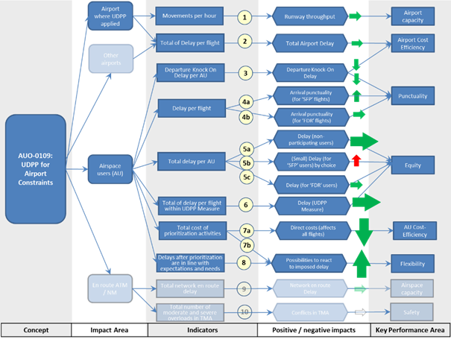

**Notes:**

The corresponding descriptions matching the numbers are:

1. UDPP prioritization acts on the schedule only, and does not attempt to interfere with ATC optimization of the traffic. ATC will be at liberty to rearrange the arrival (or departure) sequence as it sees fit, hence a horizontal green arrow.  However, in theory at least, prioritizing flights at an airport with two or more arrival runways (or departure runways) could lead to extra loading of one of the runways, and under-loading of another if flights cannot change their assigned runways, which might reduce runway throughput. The effect could be slight, if noticeable at all, and could be investigated in a live trial or a detailed airport simulation.  (Note, no deterioration in runway throughput was reported in the DFlex live trial in SESAR 1.)
2. The Airport’s costs are calculated by the total delay.  As UDPP should not create any differences in the total delay of the DCB measure, it should not affect the airport’s total delay.  However, due to the schedule disruption, there could be knock-on effects for departures, although the effect, if noticeable, is probably very slight.  This is not foreseen as it is expected that an Airspace user will try to reduce the delay between flights with shorter turnaround times, ensuring that the flights do not depart later.
3. It is anticipated that AUs will prioritise flights with shorter turnaround times that cause a knock-on effect throughout the rotation leading to the departures becoming delayed.  This leads to higher costs for both the Airport and the Airspace Users.  This knock-on effect is the aircrafts next leg departure delay which is anticipated to reduce by a small amount as this is not the primary factor in the decision making and cost calculations.

4a.       AUs using the SFP UDPP feature will experience a modest improvement in punctuality because these flights will be put back on schedule.  Some of these flights may still be delayed by ATC if operationally necessary.

4b.       FDR will have no or little effect on punctuality because an AU will only be swapping his flights amongst his own slots in the UDPP Measure; few flights will have the opportunity to be put back on schedule.

5a.       Non-participating AUs will not experience any increased total delay because the AUs that use UDPP either swap their own allocated slots or produce positive impacts on total delay when using SFP due to the AU sacrificing one of its own flights.  Shown by UDPP algorithm testing for equity, see Appendix B in the VALR [54].

5b.       AUs using the SFP UDPP feature will experience a modest increased total delay as a flight is sacrificed and gains more delay in order to protect the schedule time of another flight of higher priority.  However, other airspace users will experience a small reduction in total delay in compensation because the total delay for the hotspot will not change.

5c.       Any airspace user using FDR will not experience a change to their total delay because FDR only allows flights to be changed amongst an airspace user’s allocated slots in the sequence.

6.         The total amount of delay within the UDPP Measure will not change and it is only rearranging flights within the available slots provided through the CASA algorithm.

7a.        Direct costs (fuel, crew time, airport fees, passenger service costs, maintenance, navigation charges…) will reduce.  Each flight has its own unique cost-delay curve.  By rebalancing delay with UDPP an airspace user can minimize the total cost of additional delay incurred from ATFCM delay and its knock-on effect on the schedule.  Indirect costs such as infrastructure, training and staffing will probably increase, but are expected to be small in comparison to savings on direct costs.  Indirect costs are estimated in the CBA [59].

7b.       UDPP prioritization provides airspace users with another means to react to the imposed ATFCM delays, increasing flexibility.  This should be reflected in the cost savings for the airspace user.

1. UDPP prioritization provides AUs with another means to react to the imposed ATFCM delay and the knock-on effects to the airspace users’ schedule.  Part of flexibility for airspace users is getting what they have asked for, but this will be limited by constraints from airports and the wider network.  A resequencing that is fully accepted by ATC is indicative of good flexibility for airspace users.

9 and 10 have not been measured for Wave 1 and must be measured during Wave 2 for the scope of V3 Maturity as integration.

1. The network’s airspace capacity will be unaffected by UDPP because UDPP prioritization will be moderated/constrained by constraints imposed by ATC and the Network Manager. Besides, given most flights depart and arrive on schedule, UDPP is likely to be applied to very few flights, so the whole network impact could be very slight, if any at all.

10.       Overloading the TMA could lead to a situation in which the intended 4D trajectories of two or more airborne aircraft are in conflict – a pre-existing hazard. So, a pre-existing hazard which can and will be addressed by the project, hence a white horizontal arrow.

# Costs mechanisms

The costs mechanisms for UDPP are defined in the CBA document:

This CBA document describes the costs and the benefits associated to the deployment of UDPP concept, as described in this OSED, across ECAC. Details of areas for further development and improvement in V3 are provided.

A summary of the discounted values (actualisation across years) is shown in the following graph:

To be noted that AUs stakeholders are defined in the eATM Portal by :

* SA: Civil Schedule Aviation
* BA: Business Aviation

|  |  |  |  |  |  |  |
| --- | --- | --- | --- | --- | --- | --- |
| **2019-2040** | | | | | | |
| Discounted |  | NPV (M€) | Costs (discounted) | Benefits (discounted) | Discount rate | Discounted |
| ANSP | 0.0 | 0.0 | 0.0 | 8% |
| APT | 0.0 | 0.0 | 0.0 | 8% |
| NM | -4.5 | 4.5 | 0.0 | 8% |
| BA | 0.0 | 0.0 | 0.0 | 8% |
| SA | 225.8 | 52.6 | 278.4 | 8% |
| Overall | 221.3 | 57.2 | 278.4 |  |

Table 11: Discounted CBA results (per stakeholder and overall)

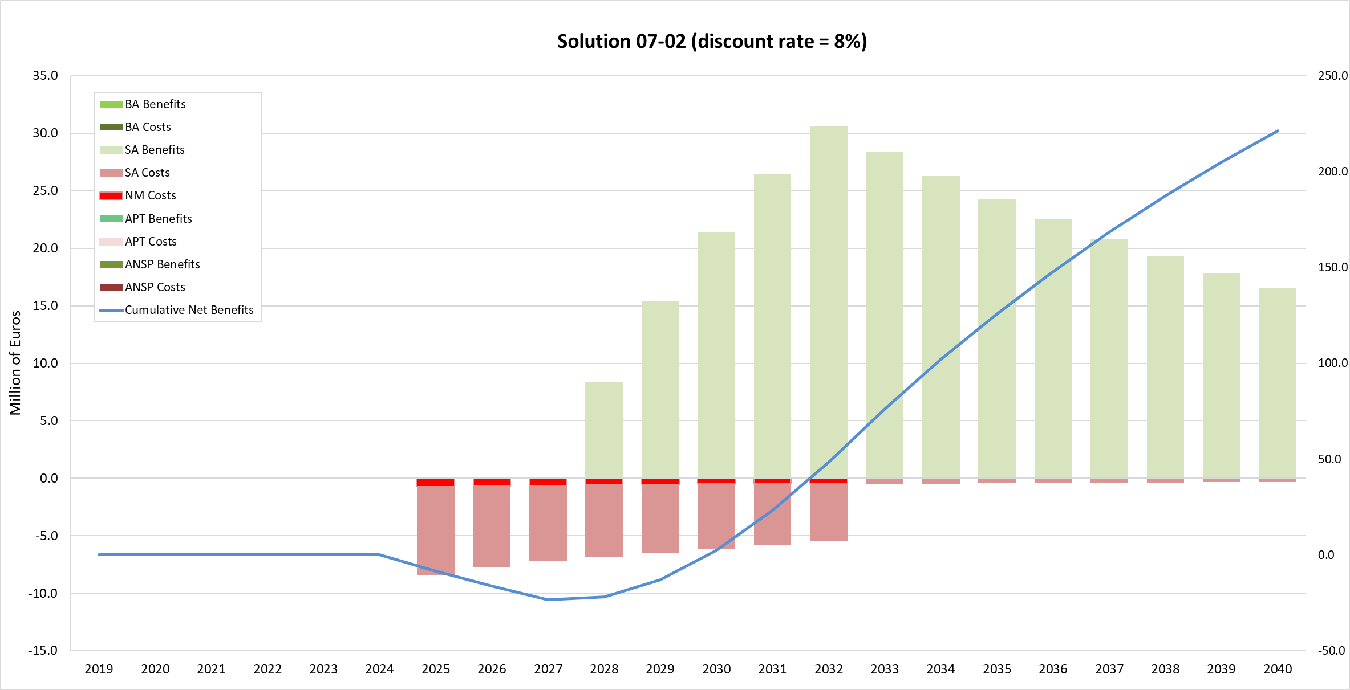

Figure 20: Annual Investment Levels and Benefits (Discounted)

1. UDPP algorithms description

# Introduction

UDPP is a set of AU functions to mitigate delay from AU perspective.

The objective of the AUs, in case of major delay, is to reduce the impact of the delay on their fleet.

To do this, a set of UDPP algorithms has been specified and produced to generate a new time to be assigned to AUs flights from priorities and/or margins input coming from AUs, and implementing equity and rules to support efficient coordination.

The objective of the UDPP algorithm is to give the best solution for the given problem according to the inputs of the AUs: all the UDPP algorithms must always generate a solution; there is no blocking point to stop the UDPP time generation.

The concept description of the AU tools, SFP, FDR and Margins is written in this OSED.

This document describes the different algorithms to implement the UDPP functions.

# Definitions

Slot Definition in UDPP:

Currently in UDPP, we use the term Slot because UDPP manages flights like a NM regulation, except that, instead of using CASA to give the time solution, the flight reordering in managed by the UDPP server (the entity who regroup all the UDPP functions) and a new UDPP time is given relative to the priorities given by AUs.

Today, UDPP Slots define only a time without a time window around like normal CASA Slot.

Future investigation will be done to add to this UDPP time an appropriate time Window. This investigation will be done in wave 2 when UDPP functionalities will be integrated in the NM system.

Baseline time (Baseline Slots List), Baseline delay:

Time assigned to a flight by the CASA-like algorithm (First Schedule First Planned). This time is calculated by the UDPP server according to the Capacity definition on the Resource to manage (e.g. Runway) and the planned flights on it. Values are saved in the Baseline Slot List.   
Baseline Delay is [BaselineTime – Flight Reference time= generally ScheduleTime)

Flight Reference time:

Currently the Reference time is the schedule time of the flight, but according to Airport Runways management style, sometime the flight Schedule is ignored and only current situation is managed.

In this kind of Airport, the Reference time could be the current flight time when “UDPP Measure” is created.

In this document, we can use Schedule time instead of Reference time because it is the standard definition of the Reference time.

AU Intermediate Local Slots List:

Intermediate Slot list generated by the Ranking Method, because the Baseline Slot List can be updated by the management of the Protected flights (Pflights)

AU Local Slots List:

AU can manage only its own slot list. The AU Local Slots List is the time given on each AU flights after AU prioritisation method (selected by AU) by conversion of AU input priority and settings, implementing Equity, using only flights of the AU. This Local Slots list has to be merge with all the other AUs flights to have the final UDPP solution: the UDPP Slot list.

UDPP Slots List:

Final result of UDPP, merging all AU Local Slot Lists.

Airborne flights:

Used to specify flights not available for prioritisation: keep the current time as target UDPP Slot.

Terminated flights:

Flight already landed (no way to change anything in term of prioritisation), excluded from lists.

CCS (Capacity Constraint Situation):

Definition of the constraints on the resource, (e.g.; the runway capacity constraints: could be a stair given by more than one consecutive constraint…)

UDPP Measure:

The set of flights concerned by a Capacity Constraint Situation (delay is given on each flight).

HotspotFlightEarlierSchedule:

Early time departure or time arrival authorised by the Airport and accepted by the AUs, to be used by UDPP algorithms. This value is an authorized negative delay given in minutes relative to the Flight Reference time (Schedule). This value also implies that AU must be ready to accept this earlier time.

Hotspot time for freezing Input flight list (late filler):

Time when the “UDPP Measure” is closed to flights insertion, AU flights list becomes fixed; if any, new flights are put at the end of the “UDPP Measure”. NB: This time normally must be relative to flights and not to “UDPP Measure” (through a moving window).

Hotspot Closed time (to AUs modification):

Absolute time relative to the “UDPP Measure” until AUs can set priorities on their flights, over this time, the last priorities given by AUs to their flights are taken as “UDPP Measure” solution.

Pflight:

Flight with “P” priority: Protected Priority (highest priority for the AU).

Psolution:

It’s the local time solution of a Pflight. This time could be slightly changed when merging all AUs flights or by the optimisation (merge function)

Sflight:

Flight with “S” priority: Suspended Priority (lowest priority of the “UDPP Measure”: flight(s) candidate(s) for Cancellation).

Lflight;

Flight with “L” priority: Lowest Priority (lowest priority of all flights of the Airline in the “UDPP Measure”). if several Lflights are set, Lflights are managed in their baseline time order.

Bflight:

“Baseline” priority: keep baseline delay as target time for UDPP algorithms (this time could be earlier according to resource optimisation). Two kind of Bflight are possible:

Explicit Bflight: a B priority value is given for this specific flight by the AU

Default Bflight: no specific priority is given for this flight, but a B priority is given as the Default priority value.

# General UDPP algorithm view

The UDPP Algorithms are composed by 3 consecutive steps:

**1) The Baseline Slot Allocation** using Resource constraint definition (CCS, all flights concerned …) to generate Baseline Slot Allocation (CASA-like Algorithm).

**2) The local AU flights management** uses AU input flight priorities (priorities and/or margins) and settings, implementing Equity, to generate a new AU local Slot List for each AU flights inside the “UDPP Measure” (based only on the local AU flights). Basically convert AU Prioritization in Time to be merge with all AUs flights.

**3) The merge of all AUs Flights:** In the “UDPP Measure”,each AU can send its priorities independently one from each other. To generate the What-If or Submit sequence adapted to the specificity and dynamicity of the CCS, the merge function integrates all AU local prioritisation given at the different time.

To be noted that when one AU send its prioritisation, all AU flights in the UDPP Measure are recalculated according to the last current status of all flights integrating last flights prioritisation, to have always an up-to-date solution for all flights.

This algorithm structure organisation has been elaborated to manage Protected flights and Suspended flights that could generate possible changes of the Initial Slot List produced by the Baseline Slot Allocation.

According to Holes created in the Baseline Slot list by the Suspended flights and the possible re-arrangement of the Slot time due to Protected flights, a final recalculation of an Optimum UDPP slot list is mandatory to avoid loss of runway throughput.



Figure 21: General UDPP algorithm view

# Global and AU algorithm parameters

A set of parameters is defined to allow UDPP algorithms to be tuned to the Airport characteristics and tuned to the specific needs of the AU.

## Global Airport Parameters (applied to all AUs):

* Hotspot time for freezing Input flight list (late filler):   
  Time when the “UDPP Measure” is closed to flights insertion of its schedule time (e.g. could be in the middle of the “UDPP Measure”). Slot list could change according to the dynamicity of the situation but new flights (late fillers) are pushed at the end of the “UDPP Measure”, in this case, the end of the “UDPP Measure” is modified. NB: This time could normally be relative to flights and not to the “UDPP Measure” starting time (through a moving window) but to give priority to flight already planned, only flights using empty slots inside of the current UDPP measure can be inserted in the middle of the sequence.
* Hotspot Closed time (to AUs modification):   
  Time until AUs can set priorities; over this time, the last priorities given by AUs are taken as “UDPP Measure” solution.
* Hotspot Flight Earlier Schedule:  
  This parameter specifies the early Departure/Arrival anticipation buffer in minutes, subtracted from Reference Time (e.g. 5min before Schedule Time). It defines the maximum early departure / arrival time an AU can match. NB: currently the NM ATFCM functions do not allow negative delay; this could cause a sub-optimisation the resource (Runway) by the fact that a flight could not take an earlier slot if possible.

1. The “HotspotFlightEarlierSchedule” parameter is used for managing Pflights in AU local ranking model but also in the Merge function to optimize the resource (Runway).   
   This parameter is used in combination with the *Time Window For Protection* (see next paragraph)
2. “HotspotFlightEarlierSchedule” is also used for managing all prioritized Flights in the Merge function, for resource (runway) optimisation.
3. UDPP Suspended After last flight for Merge: This parameter specifies the way the Suspended flights are allocated in the final Merge function:
   * If yes, the Suspended flights are pushed after the last non-Suspended flight of all the AUs.
   * If No, Suspended flight could be allocated in the middle of the “UDPP Measure” where there is a sufficient time slot to host it.

## Parameters Specific to each AU (defined by AU and can be dynamically changed)

* Default Priority Value: it is the value taken as default Priority, when no priority is specified for an AU flight.
* Max delay for Protection (MaxDelayProtection):  
  The “MaxDelayProtection” parameter specifies the maximum delay (based on Reference Time) to manage Protected flights.   
  This parameter is used for the *Time Window For Protection*: Pobjective (see next parameters).

1. Time Window for Protection (called Pobjective):   
   the default Time Window for Protection is defined by [Reference Time – HotspotFlightEarlierSchedule, Reference Time + MaxDelayProtection].
2. If a Margin value is specified for this flight, The Margins values “Time Not Before” and/or “Time Not After”, overwrite the default Pobjective
3. A Protected flight has first to find a solution inside its Time Window. In this case, there is no impact on overall delay of the Airline because an AU slot is used. If more than one flight is in this time window (Pobjective), the flight with the later time in the window is taken to limit the impact on the others AU flights.

* Local Ranking model: AU can dynamically apply a ranking model: Priorities only (1) or Priority and Margins (2) to manage their flights with UDPP.

# UDPP Algorithms

## The CASA-like time calculation on constrained resources

**Input:**

All flights that could concern the “UDPP Measure” extracted from NM according to the resource to manage.

The CCS who defines the minimum size of the “UDPP Measure” (the “UDPP Measure” could not start after the beginning of the CCS and could not stop before the end of the CCS).

According to the traffic on the CCS, the “UDPP Measure” could start before the CCS if residual delay before creating the CCS, and end after the CCS to manage the recovery period.

If the CCS impact and the CCS itself is disjunctive (no times in common: this could exist for a CCS with a rate of 0):

* starting time of “UDPP Measure” is the earliest time between the 2 starting times (CCS and CCS impact)
* ending time of “UDPP Measure” is the latest time of the 2 ending times (CCS and CCS impact)
* NB: this rule also cover the previous rule but the first rule stay defined to clarify the definition.
* Side effect on that:

We could have some empty slots in the baseline sequence that can be used by AUs when making prioritisation. In this case, we can see differences between total delay from baseline time and total delay of What-If (less total delay with UDPP).

**Output:**

* Baseline Slot List (All Flights in the “UDPP Measure”). Currently the size of the slot is not defined yet and used in UDPP. It will be studied later one.

**Objective:**

* This algorithm (CASA-like algorithm) generates the baseline delay on Schedule/Reference Departure / Arrival Time or any constraint to manage flights affected by the Capacity Constraint Situation.
* This part of the UDPP server, creates the “UDPP Measure” with associated baseline delay relative to the reference time (baseline time) on each flight by allocating flight on resources (runway) according to their current capacity definition including the CCS characteristics.

Capacity Constraint Situation (CCS) example:

Normal Capa = 60 (flights/hours) --> minimum time between 2 flights = 1 minute.

From 6:00 to 7:59 Capacity = 30 --> minimum time of 2 minutes between 2 flights.

From 8:00 to 9:59 Capacity = 45 --> minimum time of 1 minute and 20 seconds between 2 flights.

Etc….

N.B. Pre-allocated flights (airborne flights, non ECAC flights, terminated flights …) are forced to their current time (like in CASA).

1. Due to the CCS, All flights are allocated to a slot and have a baseline time. A “UDPP Measure” is automatically created by UDPP around the constraints, starting by the first flight with “a delay (delay different to 0)” and ending just before the first flight after the CCS starting with “0 delay”, this includes the recovery period. The UDPP Measure can start before the beginning of the CCS due to existing delay not previously managed.  
   The “UDPP Measure” ‘could be’ manually adjusted by the owner of the resource, only by adjusting the CCS time starting and finishing because the CCS period is the minimum period of the “UDPP Measure”. This period is always checked and published manually by the owner of the resource and become the “UDPP Measure”.

“UDPP Measure” Dynamicity:

A time is given to freeze flights entering in the “UDPP Measure”, called “Hotspot time for freezing Input flight list” (like in CASA - e.g. 2h before “UDPP Measure”). When the Freezing time is passed, no more flights can be added inside the “UDPP Measure” except if the is empty slots available, new flights are pushed at the end of the “UDPP Measure” and the “UDPP Measure” is extended. These new flights can be managed by the AU as the others, only the Baseline Slot Time is at the end of the “UDPP Measure”. In this case, flights are not excluded from the AU priority management.

Before this freeze time, new fights can be added inside the “UDPP Measure” according to their Reference time (Schedule or Current)

The Content of the “UDPP Measure” is always updated when an AU send a flight prioritisation. This “UDPP Measure” must reflect the up-to-date status of all the flights and CCS especially when time run and some flight become pre-allocated.

UDPP global Delay Calculation for network KPI (to be developed later):

When UDPP delay is mitigated by Airlines, a new method to calculate Network delays must be issued to take into account the AUs wishes: flights with High priority must have less delay than flight with Low priority. A new formula for delay calculation must be issued taking into consideration a ponderation factor due to AU prioritisation. AU prioritisation must be taken as a new demand from AUs face to the CCS problem.

NB: The “Baseline time” (baseline slot allocation) is relative to the flight reference time taken as initial condition (Schedule or Current time). According to the specificity of the different Airport, the UDPP can be specially tuned to cope with this specificity: the Reference time could be the Schedule time or the current value of the time when the “UDPP Measure” is created. In this case, the Baseline Slot list takes current situation as reference. The schedule time can still be used to specify the minimum time to be allowed to flights (with HotspotFlightEarlierSchedule subtracted if defined). But this possibility is not managed by NM ATFCM because the schedule is ignored.

## The AU local flight management: local ranking models + time assignment

The ranking models are basically the 2 models of prioritisation used by UDPP: (“Priority only”, “Priority and Margins) and a re-assignment of the flights on the available slots, but due to the management of the Protected flights and the Suspended flights, they are a bit more elaborated to adapt the solution to the AU needs.

**Input:**

* AU flights
* Baseline Slot List for the AU,
* Priority values (including flights margins if any) for each flight
* and the AU parameters (Default Priority Value and Max delay for Protection)

**Output:**

AU Local Slots List

**Objective:**

Convert AU Priority values to new time for AU flights according to parameters and equity.

The objective of this local part, specific to each AU, is to generate a new local time for each flight (AU Local Slot List) according to input given by the AU (priority values, margins values, ranking model) and equity rules. This is basically based on using allocated AU Baseline Slots (baseline time generated by the CASA-like Algorithm) to rearrange the flights in a more convenient and efficient sequence for the AU.

Figure 22: AU local flight management



The AU local flight management is split into 2 consecutive parts:

1. **The Local Ranking algorithm**: based on AU input priority values and/or input margins and parameters.

The objective of this part is to translate the Priority inputs values (made of integers, letters, margins) into an AU flight list sorted according to the need of the AU, and an intermediate AU Slot List (with times) possibly modified by the management of the Pflights.

1. **The Time Assignment** of flights on intermediate AU Local Slots (the local slot list times could be modified by the Pflight management.

According to the type of Algorithm selected by the AU, when the AU calls the function What-If or Submit, the AU local flight management runs the selected Algorithm to manage its own flights.

1. The “Priority only” ranking model: uses only the input priority values entered by the AU
2. The “Priority and Margins” ranking model: uses the input priority values to manage flights but using also the input Margins as time target. This Algorithm type regroup all the possibility to manage flight in one model.
3. Flights in AU Slots list containing flights with airborne and terminated status are excluded from the ranking methods but must be still visible for AU and UDPP functions.

### The Local Ranking models

#### The “Priority only” model

To be noted that this “Priority only” algorithm is still defined in this document because it can be used as a Ranking model but it is replaced by the “Priority and Margins” model who merge all king of prioritisation. There is no difference between “Priority only” outputs and “Priority and Margins” outputs if no Margins are defined for flights.

The definition of this model is done on the “Priority and Margins” model chapter. The difference is that the management for the Margin flights is not done for “Priority only”.



Figure 23: Ranking Model: Priority Only

#### The “Priority and Margin” model

The ‘**Priority** **and Margin’** model of algorithm manage all type of priorities: SFP, FDR and Margins with or without a priority value.

UDPP priority values can be:

* “P” to Protect a flight: very important AU flight(s) (Pflight), to be as closed as possible of the Margins if defined or the Reference time if not (see 4.2)
* A priority number from 1 (highest priority) to 999 (lowest priority) (Nflight) to give flights a relative ranking number.
* “L” Lowest priority flight: to specify the AU lowest priority flight(s) (Lflight) whatever the value given to its other flights (could be seen as the priority value = 1000)
* “B” for Baseline: (Bflight) to keep Baseline delay of the flight as the target time.
* “S” to UDPP Suspend a flight (Sflight): this flight becomes the less important flight of the “UDPP Measure”, it a candidate to avoid “UDPP Measure” or to be cancelled later on.

A Margin value can be given on flights:

* “Time Not After” (TNA) specify the latest time to be given to a flight
* “Time not Before” (TNB) specify the earliest time to be given to a flight

To be noted that, according to the current status of the flight and the clock, a dynamic value of TNB and TNA is calculated to drive the possible local slot allocation (see 5.2.1.3 Dynamic Management of Time Not Before and Time Not After).

A combination of Priority and Margin is possible and give a large amount of possibility to the AUs to give constraints to the UDPP algorithm to have a slot corresponding to the UDPP rules and AU constraints. This combination allows representing the cost/delay curve of a flight: Time Not After (TNA) is the time constraint not to exceed and the Priority is relative to the extra cost if exceed.

To implement this model, the Management of the different flights generates a list of flights to be given to the Local UDPP time assignment.

The local flight management for this algorithm is based on 5 steps organised in the following order:

1. the management of the Protected flights (Pflights), then
2. the management of the Margin flights (Mflights), then
3. the management of the default Baseline flights (dBflights), then
4. the management of priority flights (numbers and ‘L’) (Nflights), then
5. the management of the Suspended flights (Sflights).

The description of the Local AU flight management is graphically explained in the following figure.

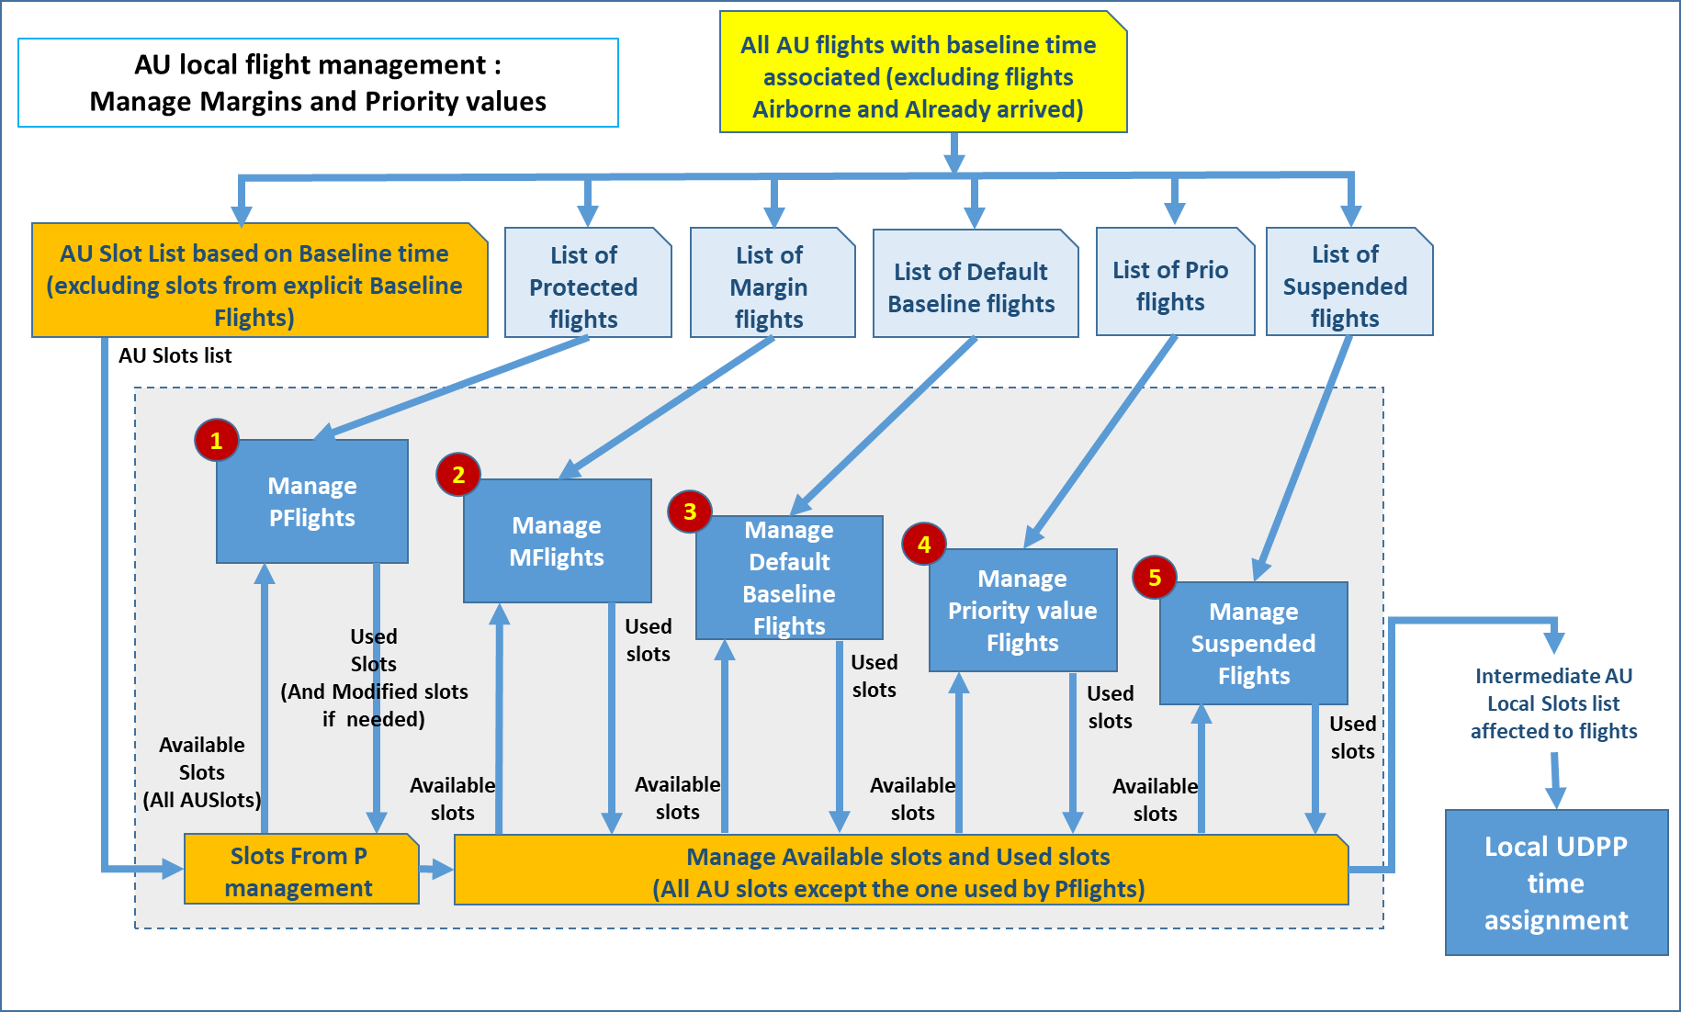

Figure 24: Local flight management: Priority and Margins

##### Step 1 - Manage Protected flights (Pflight) (with Margins or not)

The objective of this part is to assign a slot to the Protected flights using ‘Time not After’ and ‘Time not Before’ if defined for this Pflight.

A Pflight is defined by the fact that its priority is “P” with Margin or not.

1. The Pflights have a particular priority, which corresponds to the highest priority of the fleet “P”.
2. To find a time for the Protected flights, the first objective is to find a local slot “close to their schedule” in the AU Baseline Slot List to fulfil the “Pobjective” (defined hereafter) for these flights.
3. The AU slots used to find a Pflight solution are All AU Local Slots, including default Bflights (refer to Default Priority Value parameter) but excluding AU Explicit Bflights as well as Airborne and Terminated flights.
4. Pobjective of a flight is given by 2 parameters or Margin if defined:
   * The MaxDelayProtection: this AU parameter gives the maximum delay acceptable for a Pflight according to its schedule time: (e.g. 5mn or 10mn). This parameter, defined by the AU, can be changed dynamically to adjust AU objectives on Pflights.
   * The HotspotFlightEarlierSchedule: this Airport parameter (common to all AUs) gives the maximum early departure / early arrival buffer subtracted to Schedule Time of all AU Pflights: (e.g. 5mn)

Pobjective: find a slot time inside the Time Window for Protection [Reference Time – HotspotFlightEarlierSchedule, Reference Time + MaxDelayProtection]

Protection Algorithm (for Pflights):

The Management of the Protected Flight algorithm is the first algorithm applied for the “Priority and Margins” algorithm model when the What-If or Submit button is pressed.

It’s based on 2 steps:

1. Find an already defined AU Local Slot matching Pobjective (defined above), allocated to a AU flight with a priority lower than Pflight.

If found: the Psolution is the Slot of the flight found.

1. If no Pobjective solution is found:
   1. Find the first AU slot before the Schedule of the Pflight with a priority different of P.
   2. If a AU slot target exists, change the Slot of the targeted flight by the Slot of the Pflight and gives to the Pflight its Reference Time. This produces an Intermediate Local Slot List.
   3. If the targeted flight has an Default Priority of B, its priority is not touched. Except the Pflights, all the other AU flights will be managed in the next phases according to their priority and margins including default B priority.

Figure 25: Pflight management example



This function is described as follow:

* Get all Pflights to be managed (The possible slot list is given by all AU slots excluding explicit Bflights)
* Sort flights by ‘Time not After’ then ‘Baseline time’ if same ‘Time not After’ (if no ‘Time not After’ is specified the implicit value (for Pflights) = Reference time + Max delay for protection)
* Manage Pflights: finding solution between ‘Time not After’ and ‘Time not Before’ (Pobjective) when a solution is found :

1) Update the UDPP Intermediate time of the Pflights (assign a slot to the Pflight : could be the one on the Pobjective, or a created one at the ‘Time not After’ value if no flight in Pobjective) and

2) update slots of the target flight if necessary (the other flights taken to manage the Pflights).

The Pflight must be assigned in the same order than their ‘Time not After’ value if the schedule is appropriate. If not, reorder them.

To be noted that, if more than 1 Protected flight is defined, because the algorithm start managing Pflight looking from the closest earlier flight, it is possible that the order of Pflights, at the end of the management, are not respected (earlier Pflight must have a time earlier than a later one). Because the algorithm use an earlier available slot to solve its Pobjective, the slot become more and more earlier to find the solution and then later Pflight has an earlier solution. This is clearly visible if many Pflights are defined.

This can be solved by rearranging the slots of the Pflights by sorting them by ‘Time not After’ which is part of the Pobjective (assuming that if no ‘Time not After’ is given the time value is : the Reference time + Max delay for protection).

NB: this Pflights Management can change the slot assigned to the AU if no Pobjective solution is found for a Pflight. This new slot list (with increase value of the sum of delay) is the one taken to manage the others flights.

##### Step 2 - Manage Margin flights

Margin flights are defined by the fact that there is for the flight,a **‘Time not After’ value** given but h AU and **its priority value is not P** (otherwise it’s a Pflight). If no value is given on ‘Time not After’ field, it’s not an Mflight, if a P is given on priority value, it’s a Pflight whatever the content of the ‘Time not After’ field.

There is no default Margin for an Mflight. If there is no ‘Time not After’ value, the flight is **NOT** a Mflight and is manages according to its priority value or default priority value.

The Margin ‘Time not After’ and the Priority value are used to manage the Margin flights. If no priority is given, the defaults priority value is taken (defined by AU in the interface as defaults priority and also used to manage priority only flights). For Margin management, if the **defaults priority value** given is **Baseline, the priority assign to the Mflight** is considered **as lowest priority (‘L’)** . This because default B for a Mflight is declared less importance than a real priority value (it’s considered that flight will have a cost less important to manage than others if delay go over its ‘Time not After’).

The candidate Slot for the Margin flights can be found on all the available slot of the AU **except the one already assigned to the Pflights** and the one **with an explicit B value** (explicit Baseline priority value given on a flight).

The Margin flights are assigned to slots in the same order then their priority value and ‘Time not After’ value, using the ‘Time not After’ as time objective to be not over (use the latest time slot before being over the ‘Time not After’). For flights with, same priority value, same time not after, the order must be as the baseline time. In other word, the list of Mflights is sorted by : 1) Priority values (including default one) then 2) if same priority by ‘Time not After’ then 3) if same priority and ‘Time not After’, the Baseline time.

If it’s not possible to fulfil the Margin as define by the ‘Time not After’: first an earliest available slot must be assign to the Mflight, respecting the fact that the flight already assigned must not have a degraded slot (earlier slot but not later) which is given by the priority rule; an second a slot later if no possibility earlier.

In algorithm language:

* Get all flights to be managed: Margin flights (All AU flights in the UDPP measure with ‘Time Not After’ value except Pflights, and explicit B flights).
* The assignment will be done on the list of available slots for the AU (to be share with Margin and not Margin flights) except the slot already used by the Pflights.
* Sort Margin flights by ‘Priority’ then ‘Time not After’, then ‘Baseline time’
* On each Margin flights, call the **Function “Manage Time Solution”** to assign a slot to Margin flights (see function description after)

##### Step 3 - Manage the Default Baseline flights (dBflights)

The objective of this part is to assign a slot to the defaults baseline flights (dBflight).

Default Baseline flights are defined by the fact that 1) the default priority value is set to ‘B’, 2) and the flight has no priority value and no Margin.

The objective is to assign to these flights a slot closed to their Baseline time value.

The slot assignment of the baseline flight is done in the same way than the Margin flights, minimizing the degradation of the already assign flights (Margin flights).

The objective is to:

* Assign **default B flights** to the closest slot (not degrading Mflight slots) of their Baseline time. This is done by calling the **Function “Manage Time Solution”** exactly in the same way than Margin flights, but with target time = to the Baseline time of the flight (instead of the ‘Time not After’ for Mflights).

##### Step 4 - Manage the priority value flights (Nflights)

Nflights are defined by the fact that they have no Margins defined on its and not “P” and not “S” as priority value. Lflights are part of Nflights management but with a priority = to 1000.

The objective is to rearrange the sequence of the flight according to priority given by the AU. It is implemented by sorting AU flights by priority then by Baseline time. This ordered list is used to assign slots in the remaining AU Local slots of the AU.

This priority value could be specifically given for the flight or given by the default one.

The first part of this algorithm is to get all the AU flights to be used for this step; All AU flights except the one previously assigned: Pflights, Mflights, and dBflights and the Sflights.

Then sort flights by priority then Baseline times: Lflights the Lowest priority (priority = 1000).

* Then Assign **Nflights** on remaining slots in the ordered list on empty slots (not before its Reference time of course).
* If a flight could not be assigned on an empty slot due to its reference time, use the same function then for the Margin flights: **Function “Manage Time Solution”** but with a target time value at the end of the “UDPP Measure”. In this case fill the empty slot by the end of local slot list.

##### Step 5 - Manage the Suspended flights

The assignment of the Suspended flights (Sflights) is done in this step by giving to these flights the time of the end of the hotspot (set its local UDPP time to the end of the UDPP Measure). The real Time will be given at the end of the Merge phase see part (3) of the graphic of the General UDPP algorithm view.

#### Dynamic Management of Time Not Before and Time Not After

The management of TNA and TNB could be generalised to each flight of all the AUs. This 2 values become times constraint to assign flights to the right slot.

These values are not necessary issued by the Margin field TNB and TNA given by the AU but calculated according to the status of the flight and the type of priority given on it.

The calculation is done in 3 steps, 1) The calculation of the status of the flights, 2) the static value of the TNB and TNA and then 3) the validity of TNA according to the status of the flight.

1) Status of the flight:

The status of a flight, is given by the current time, and determines if the flight is pre-allocated (already airborne …) or not. This status is expressed by “Max prioritisation time” and given by the formula:

(MaxPrioritisationTime = CTOT + Flight duration + 20mn) > Current time

If the current time is earlier then the MaxPrioritisationTime, then the flight must be considered as pre-allocated at its current CTOT.

2) Static value of TNB and TNA:

TNB = Margin TNB value TNB if exist

or Reference time – EarlyScheduleTime for Pflights

or Reference time for others flights

TNA = Margin TN value if exist

or end of UDPP measure

3) Validity of TNB and TNA value:

Final TNB = latest time between (TNB, MaxPrioritisationTime): according to the current time, MaxPrioritisationTime can replace the reference time to calculate the UDPP output.

Final TNA = earliest time between (TNA, end of the UDPP measure)

The dynamic approach of the TNA and TNB avoid giving impossible solution to flights.

#### Generic functions to manage flight position

##### Function - Manage Time Solution

The objective of this function is to assign a slot close or earlier to the flight ‘Time not After’, with minimum impact on previously assigned slots.

This function has, as input, the flight to manage and its ‘Time not After’ objective associated.

It uses the slots list, with already assigned flights.

1st Try to assigned slot with equal or earlier objective, by calling first Function: Manage Solution Earlier.

2nd If no Earlier slot solution is possible, assign first later available slot.

##### Function - Manage Solution Earlier

This function called by ‘Manage Time Solution’, try to find an **equal or earlier slot** to be assigned to a flight.

For that, this function loops from the target slot of the desired slot to the 1st slot of the list (earliest).

And Call the Function: Move flight Earlier

And Return the slot assigned if succeed or a negative value if not possible

##### Function – Move Flight Earlier

This function is **the heart of the Margin management**. It’s a recursive function to find a slot earlier by pushing already used slots according to their possibilities.

In algorithm language:

* Loop until an earlier slot has to be tested: An earlier slot has to be tested if the target slot is used, and the flight to move, to free it, is blocked according to its schedule.
* Try to assign to the target flights the target slot time (target time is the one before going over the Margin ‘Time not After’).
* If the slot is empty (slot not already used) gives it to the target flights. This end the function.
* If the slot is already used:

Test if possible to shift already assign flights on it to earlier slot, to free the slot (because previously assign flight must have an earlier slot) by calling **Function: Move flight Earlier** (itself on flight using the slot). This is the recursive call of this function.

If the shift is possible, assign the target flight to the target slot and return the free slot. By this, all the movable flights (driven by the level of recursively) shift the other flights needed to make it free (done by finishing the recursive call of the function).

If the shift is not possible (no slot available before, or time too early according to reference time (schedule)), return a negative value corresponding to the blocking target slot.

For information: the management of the shift flights earlier (make the slot free) is implemented by a recursive call to shift all the already affected flights with the test of the possible shift. This recursive function returns the value of the shift to be done or the fact that it is not possible. The real shift is done by the calling function (itself but recursively before) when the result is positive and gives the slot to be shift. A shift of a flight could be done if the reference time is earlier or equal to the target time to shift. To be noted that the fact that if a flight in the slot list is not shiftable, does mean that an earlier flight cannot be taken as target slot to fulfil the Time not After of the flight to assign.

### Local Flight Time Assignment

**Input:**

AU Intermediate Local Slots List

AU sorted flight List (by ranking algorithm)

Priority values (to manage Sflights)

AU parameters (Max delay for Protection)

**Output:**

AU Local Slots List

**Objective:**

The objective of this final local part is to calculate AU Local Slot time to be used later as an input of the merging function integrating all AUs inputs. NB: Airborne and terminated flights keep the same current time in slot list.

The previous “Local ranking method” phase (previous chapter) gives a priority sorted AU Flight list, and a AU Slot list.

The Local Flight Time Assignment puts all AU sorted flights in the AU Slot list (could be changed by Pflights management).

Synopsis:

Loop on all flights in sorted AU flight list (given by the selected ranking method)

1. If the flight is a Sflight, the time assigned to it corresponds to the End Of “UDPP Measure” minus 5 seconds to be sure that the flight will be managed as a flight inside the “UDPP Measure” (it’s an intermediate solution, the final real time will be given in the merge function because it depends on the other Suspended flights from the other AUs and possible holes in the final sequence).
2. Else Assign the first available AU Time Slot equal or after the Psolution for Pflights and the flight schedule for the others. To be noted that “HotspotFlightEarlierSchedule” time has been used for Psolution and not used here for the local solution because the objective is not to optimise the resource at this stage.

End Loop

## The Merge function

The Merge function is triggered by the Local Slot assignment done at each AU WhatIf or Commit demand. It’s the last step to generate UDPP slot times.

Figure 26: Merge function and Absolute Priority



**Input:**

AU Local Slots List of All the AUs

Priority values of all the flights (to manage Sflights)

**Output:**

Final UDPP Solution = UDPP Slot List.

**Objective:**

The objective of this function is to merge the local AU Assigned time of all flights from all AUs (given by the previous phase). All Sflights will be first excluded from this merge and re-introduced after all other flights.

1. The merge function performs the following actions:

Sort all AU “UDPP Measure” flights by the AU Local Time Slot (if same Assigned Time then ordered by the Baseline Slot Time), ignoring the Suspended flights (Sflights).

1. Assigned each flight on the managed resource (e.g. runway) in an optimum way: make the same Slot allocation than the one performed to create the Baseline Slot List (CASA-like algorithm) but instead of taking flights Reference (Schedule) as input, take All AUs Local Slot List, and Ignoring first all Suspended flights, but also using HotspotFlightEarlierShedule as possible departure time (to optimise the resource) (see after).
2. Apply the following rules optimisation:

Use the HotspotFlightEarlierSchedule on all flights to optimise the resource (e.g. runway throughput): get a slot later or equal than [Schedule time - HotspotFlightEarlierShedule]  
nb: This optimisation is based on the usability of the resources given by the different constraints provided by the resource owner (CCS).

1. Then assign Suspended flights (sorted by Baseline Time):

First Sort Sflights by Baseline time then, 2 options are possible and are actually implemented waiting for AUs feedbacks:

* + Starting from the beginning of the “UDPP Measure”, and where there is a hole in the sequence (available time to add a flight: enough time before and after a possible slot), put the Sflight, and loop until no more Sflight to assign (some Sflights could be out of the “UDPP Measure”).
  + Starting from the last assigned flight in the “UDPP Measure” and continue the Merge with the Suspended flights Sflight, not touching existing flight time even out of the “UDPP Measure” (some Sflights could be out of the “UDPP Measure”).

1. Flexible Credits for Low Volume Users in Constraint (FCL) – E-OCVM V1

This appendix presents in detail the FCL mechanism proposed, together with some evidence that support the concept description and the business case.

# FCL design criteria

The following bullet points are the most significant design criteria that have been introduced in the FCL feature (most of them requirements or recommendations given by AUs):

* FCL should be based on the use of credits and incorporate the principles and rules of UDPP
* Possibility to use credits obtained in the past at any future UDPP Measure (for LVUCs)
* Continuous model in terms of delay management (avoid drastic efforts)
* Rewards and charges should be accurately measured and be proportional to the positive and negative impact generated to others (to preserve equity)
* Take into account the compatibility of the different AUs prioritisations
* Should allow LVUCs optimising the impact/cost of delay
* Make it compatible and coexistent with the mainstream UDPP, i.e., FDR and SFP features (in which LVUCs have little flexibility).

# FCL rules to preserve equity under high flexibility conditions

In FCL high flexibility is given to an LVUCs to minimise its own global delay costs, i.e., the LVUC has full freedom to transfer its total *baseline delay* (i.e., initial ATFM delay) among its flights and to exchange freely flight sequence positions with other AUs only being subject to two particular equity constraints: 1) AU’s total baseline delay cannot be reduced, and 2) the Maximum Negative Impact of Time (MNIT) for individual flights in a UDPP Measure must be respected.

The main rules of FCL are defined as:

1. Any AU with a given number of flights (3 or less is considered as an initial proposal) in a UDPP Measure is considered as LVUC in the context of such a UDPP Measure (note: perhaps other criteria might be used to determine whether an AU is an LVUC in a given UDPP Measure, e.g., the AUs’ share of flights in the UDPP Measure, but such a concept requires further research);
2. Any LVUC in a UDPP measure can save credits obtained by increasing the delay in some flights (thus giving better sequence positions to other AUs) and used them in that particular UDPP measure or keep them to use such credits in future UDPP measures;
3. Any LVUC in a UDPP measure can use Leftover Operational Credits (LOCs) obtained in the past to protect flights in the current UDPP measure; LOCs could be weighted up to take into account the differences of the UDPP measures in terms of duration and severity, so that the equity among AUs can be preserved (out of the scope of this research);
4. LVUCs can request any[4] target place in the sequence (e.g., corresponding to the optimal delay allocation for that flight), irrespective of where and when the efforts were done to obtain the credits (note that this rule is significantly different from SFP that requires the efforts to take place in a sooner position in the sequence);
5. The AUs’ total delay at the end of the reference period (e.g., 1 year) must be the same (more or less, in practice) as the baseline delay (delay without UDPP, e.g., FPFS).
6. The Maximum Negative Impact of Time (MNIT) represents the maximum minutes of additional delay that LVUCs can cause to a flight of another AUs. LVUCs might be unable to protect and reduce the delay for a particular flight if the MNIT has been reached for any of the flights it affects.
7. All the requests will be sorted by the requested time and will be integrated in the sequence in FIFO order and minimising the impact to others. No empty positions should be found in the sequence (compression) and requests that could generate impact greater than MNIT will be allocated the nearest feasible solution.

# Assumptions and principles of the mechanism

The proposed method is based on the following assumptions:

* All transactions of credits and slots exchanges will be done through the Airport or DCB triggering the UDPP mechanism, which will act as a broker and supervisor.
* AUs must be consistent and accept any consequence derived from their own decisions.
* Regarding the NM and the FCL system, one minute of delay will be considered as having the same[5] 'value' for all the flights (i.e., 1 minute delay = 1 DC).
* No negative delays are allowed during the slot re-allocation (this could be relaxed later, but for the moment this assumption is taken for the sake of simplification).
* No uncertainty associated with the new slot allocations planned during UDPP is considered (i.e., Confidence Index = 1).
* Having credits is useful and positive for the AUs since they provide flexibility to adapt the operations to changing and unforeseen conditions. AUs must contribute to the network with something in exchange, e.g., assuming extra delays for some flights under a regulation, i.e., giving their sequence positions to other AUs.
* No loss of value or expiry of credits is currently considered (although this may be reviewed later).
* AUs are able to and have the necessary information (e.g., historical records) to make decisions involving different UDPP measures over the time, thus making a stochastic/probabilistic management of delay and management of impact of delay.
* The FCL decisions should be made and supervised carefully by expert human operators that will ensure the stability of the system and the application of good practice (i.e., automation shall be only provided to support human decision-making and control).
* If an AU sends no sequence position request for a given participating flight, it is assumed that it is willing to take advantage of any delay reduction opportunity for such flight[6].
* FCL can coexist with the FDR and SFP features that would be used by non-LVUC operators.
* Special care should be taken when extending the validity of the credits through different UDPP measures, as the severity, duration or the flights involved are different in each situation. Hence, the credits should not have the same value in all UDPP measures. This is out of the scope of this research, but in future research an equivalence factor could be developed to update the number of credits to transfer credits from one UDPP measure to another, being equitable for the AUs involved, e.g., associating the number of credits given or requested according to the amount of delay associated to the positions released or taken.

# Initial proposal benefits and limitations

The properties and advantages of FCL compared to SFP are detailed below:

* The use of Delay Credits (DCs) is simple and versatile.
* FCL allows several methods to obtain credits, not limited to suspending flights (e.g. supporting extra delay in exchange of credits). This may enhance the flexibility for all users, since AUs can now decide to protect flights not necessarily on-time, but just reducing the delay to the desired level (between zero and BD). More flexible delay management and cost management are available for the LVUCs.
* The same can be said of suspensions: AUs do not necessarily need to send a flight to the last slot position of their flights or at the end of the sequence (*maximum delay*), but can rather decide any other slot in between which already generates positive externalities to some AUs and the flight is rewarded accordingly. Also, it increases the efficiency, since AUs can take into account the non-linear cost functions of delay of a particular flight and be more precise with the amount of delay that should be applied to optimise the relationship between sacrifice and reward.
* The positive and negative impacts to each user are precisely quantified and registered every time there is a slot change.
* The 'rewards' and 'charges' (in the form of credits) are applied to the AUs accordingly (and exactly) to the positive and negative externalities generated to the other users. In particular an AU will be rewarded by his efforts according to the extra delay accepted for some flights (positive externalities given to the other AUs) and will be charged according to the delay reductions in some other flights (negative externalities to others), so the two effects are compensated and neutralised proportionally.
* Global scope (generalised time-space usage) is better, since the value of credits can be directly applied to different UDPP measures. AUs can now distribute their assigned delay among their actual and future flights taking into consideration the (private) cost and revenue functions (actual or expected) for each particular flight, thus giving flexibility to AUs to optimize the delay management with a long-term perspective.
* FCL is compatible with current FDR and SFP mechanisms (although further research must be conducted to further validate this).
* FCL offers a high degree of flexibility to set the close-out ('respond-by') time of the market, and also offers the capability of AUs to change their decisions of participation/non-participation at the beginning of each negotiation cycle.
* FCL mechanism has been designed to be simple and easy to manage by human experts (with the help of decision support tools).

# Body of evidence

To guarantee equity over the time **all the AUs should receive, at the end of a reference period, proportional levels of ATFM delay minutes as well as proportional flexibility levels that will allow them to adapt their operations and minimise their impact of delay in the event of capacity constrained situations**.

This chapter shows and discusses the early evidence found during the research conducted. The purpose is to proof that a UDPP feature enabled for LVUCs, e.g. FCL, is equitable for all the AUs in the long-term (e.g., after 1 year). Proof of equity is fundamental to generate commitment from all ATM actors to proceed with implementation of new UDPP features.

Part of the research conducted in this project has been published as a paper in the SESAR Innovation Days 2017 conference [38]. As explained in the paper, generating proof of equity for UDPP mechanisms that allow the exchange of slots between AUs over the time is largely complex; see Figure 27.



Figure 27: Conceptual map of Flexibility versus Equity

## Techniques used for the generation of evidence

The FCL concept is at V0 maturity (identification of ATM needs and definition of strategic objectives), although some V1 validation exercises were conducted in previous research. In this sense, FCL should be considered close to V1 gate, at least in many aspects. Therefore, it could be argued that FCL is in between the maturity levels V0 and V1.

According to E-OCVM [24] the purpose of validation activities at early maturity stages are oriented to the collection of feedback and requirements to further develop and refine the FCL concept, and progressively deliver more and more evidence of the feasibility and impact benefit of the concept; see Figure 28. Taking this into account, this document provides **evidence for V0** (establishment and quantification of the need for change) **and for V1** (operational technical solution, logical architecture, identification of research needs and validation strategy aspects), although **some early evidence is also provided through fast time simulations for V2 and V3 maturity levels** (V2: feasibility of the FCL mechanism; and V3: system integration of the many de-centralised AUs’ decision-making processes).

The approach followed in this research takes as inputs the knowledge generated in the literature review, discussion with experts, fast time simulations and validation exercises via expert judgement and builds a new set of evidence, this time more focused on addressing some of the recommendations and requirements requested by the AUs for the LVUCs mechanism during the validation exercises.

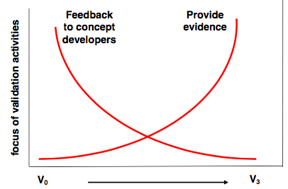

Figure 28: Focus of validation activities at different maturity levels. Source: E-OCVM v3.0 guide

The potential implications of introducing high flexibility subject to equity will be discussed via the **theoretical analysis of the User Delay Optimisation Model (UDOM)**, a simplified mathematical framework developed in the context of this research to capture the complex relationships between time, cost of operations and the flexible and equitable allocation of slots and delay. Two different degrees of equitable flexibility have been explored: a) the equity condition must be fulfilled at each single UDPP measure; and, b) equity requirements can be fulfilled after many UDPP measures in a long-term period (e.g., one year). Section 5.2 summarises the outcomes achieved with such analytical approach.

At V0 stage the identification of the ATM problems and needs is also fundamental for the business case to take the GO/NO-GO to further pre-industrial research. For this reason a **quantitative characterisation of the hotspots (potential UDPP measures) and LVUCs has been conducted, through the statistical analysis of historical data records**, with the purpose to answer questions such as: how often the AUs are affected by regulations and hotspots, how many and how often LVUCs are affected by delay in hotspots, how often the AUs could be considered LVUCs in different hotspots, and how many LVUCs can be found in a typical hotspot, among others. Section 5.3 shows the most relevant results and outcomes of such data mining process.

**Expert Judgement** has been included in the concept, taking advantage of the PJ07 expert panel activities in where the early results and work-in-progress were presented and discussed with AUs. The mathematical framework and its outcomes have been also reviewed by independent scientific experts before acceptance of the paper in the SID 2017 conference and during the presentation of the paper in the conference held in Belgrado, Serbia. The feedback and outcomes of the expert judgement have been included in each of the following sections, and will be explicitly mentioned where relevant.

Finally, a simplified prototype has been implemented to analyse some use cases and perform some simulations (**fast-time simulations analysis**). The prototype includes the possibility to process and analyse simplified but quite realistic scenarios, to emulate the LVUCs decision-making (in a simplified scenario their optimal requests can be calculated with UDOM), to merge the different requests, and to analyse the impact of the 'emulated gaming' on performance (cost of delay, flexibility, equity, and equity over the time).

## Analysis of the concept through the User Delay Optimisation Model (UDOM)

This section summarises the main observations and conclusions after the analytical assessment of an hypothetical case in which high flexible conditions are given to an AU (typically an LVUC) only subject to a unique constraint of equity: the AU cannot reduce his total baseline delay. The paper is therefore analysing one of the most fundamental properties of CFL, i.e., the free usage/exchange of slots by part of an AU in a single UDPP measure or across multiple UDPP measures (over the time). The full paper content [38] can be downloaded at:

<http://www.sesarju.eu/sites/default/files/documents/sid/2017/SIDs_2017_paper_75.pdf>

The paper analysed the UDOM context with a wider and more abstract perspective, i.e., not limiting the potential usage of high flexibility conditions to LVUCs. In this section however, only the results applicable to the potential utilisation of the FCL mechanism by part of LVUCs are presented.

With the utilisation of UDOM to analyse the high flexibility conditions constrained by equity, the dominant strategies of the AUs can be anticipated. The most relevant observations and conclusions are the following:

1. Under high flexible conditions constrained by equity a **LVUC can minimise his costs** by transferring delay among their flights (either in the short term or in the long term), while his total baseline delay remains the same at the end of the reference period.
2. The equity constraint forces the LVUC to increase delay (and related costs) in some flights, which ensures an **efficient utilisation of the slots taken by a LVUC,** and the **avoidance of the free-riding problem.**
3. Under equity constraints a LVUC will find trade-off solutions for the distribution of the delay among his flights. This implies the existence of an **optimal level of delay** (typically greater than zero) for each of his flights.
4. In contrast with the today’s 'no-delay paradigm’, the minimisation of fleet costs under **CFL rules will lead to increasing the delay for some flights**, and not necessarily for the 'less important' ones, e.g., an 'important' flight could receive 20 minutes of extra delay, if its baseline delay is 15 minutes and it has a delay tolerance of 40 minutes.
5. **A specific position in the sequence shall be requested by a LVUC** for each flight of his fleet such that the delay allocated to such flight will coincide with the **optimal 'target’ delay**.
6. **LVUCs can compute their optimal delay for their future flights using UDOM adapted to stochastic optimisation**. This adaptation requires taking into consideration the probability for each future flight of being affected by a UDPP measure, and the expected delay in each situation. It must be pointed out that some **AUs confirmed during the expert judgement sessions that they typically have access to historical records and statistics of operations**, and that they could use such information for cost optimisation. Also note that such stochastic optimisation is necessary for LVUCs that only operate one flight in a UDPP measure.
7. For some flights the LVUC will like to reduce their delay, thus taking positions from the flights before in the sequence, and increasing their delay. The **delay increased per flight of other AUs (negative impact) will be equal to the size in minutes of each position in the sequence**.
8. If the number of LVUCs is not too large, the **impact to others might be considered negligible** (which is congruent with the results of the validation exercise conducted in the past with expert panels, although further research and validation must be done).
9. If MNIT = 0 is ruled, the **equity condition could increase flexibility** in the system, because the LVUCs are forced to offer positions to other AUs, thus reducing their delay and neutralising potential negative impacts of other flights using FCL and reducing their delay (*“Equity creates market”*). This fact is also true when MNIT > 0; in such a case, the flexibility introduced by the definition of MNIT > 0 is enhanced by the equity constraint.
10. **Smooth coordination among AUs might be possible** with a reduced set of simple UDPP rules and constraints.
11. AUs could be just **focused on optimising their own operations** (thus fulfilling one important system requirement from AUs)

## Data analysis for the characterisation of LVUCs and hotspots

The purpose of the historical data analysis is to characterise the 'problem' of LVUCs in real operations, in order to generate evidence that should be useful to develop the business case of the FCL or any other potential UDPP feature aimed at giving access to LVUCs.

The specific data-mining tasks were addressing the following research interests:

* To identify **how often AUs might be LVUCs**
* To identify **how often we can find LVUCs in ATFM regulations/hotspots**
* To analyse how the **delay** is today spread among AUs
* To discuss with the AUs about what could be an acceptable **equity target** for UDPP for LVUCs (**objective** **validation criteria)**
* To develop further the **rules for FCL** on the basisof the data mining results and start discussing about the **potential** **integration with the 'normal' UDPP, i.e., FDR and SFP.**

Next bullet list describes the data used for the analysis:

* Data from **DDR2** (historical records)
* **Only arrival** regulations
* **20 AIRACs** (20 x 28 = 560 days), **from Jan 2016 to Jul 2017**
* **Some data adjustments were done** to recode HOP! that was labelled as XXX ('unkown') but whose two-letter code (AF) could be used to identify it.
* A total of 19000 arrival regulations were analysed (**34 'arrival' regulations in average per day)**
* **Some limitations were identified** after contrasting the results of the data analysis with the AUs, limitations that are commented in Section 6 but **it is expected that** **these limitations should not** **imply significant differences with regards the results presented** in this section.

Table 12describes the characteristics of a statistically typical hotspot. The most relevant results possibly are that **hotspots occur every day during daylight hours (all day) at many airports** in the network, typically affecting more to the major ECAC airports that held the 90% of the traffic. **Delay affects all the AUs** **more or less evenly** with an average of 22 min., while **the 40% of the times the delay will be larger than 40 min., and a 5% of flights will have more than 60 min**. delay. In most of the hotspots there is a **large presence of LVUCs (around 75% of AUs in a typical hotspot).** Finally, in around the 85% of the cases in which an AU have flights in a hotspot, the AU may have 3 or less flights (thus **AUs can be considered as LVUC in the 85% of the hotspots**). Figure 29 to Figure 43 show the evidence.

|  |  |  |
| --- | --- | --- |
| **Hotspot characteristic** | **Description of a 'typical hotspot'** | **Evidence** |
| Period | * + Significant number of hotspots every day at any season   + Peaks in summer and Christmas   + More often in weekends, but common every day   + Within 5.30-20.00 (with more intensity within 10.00 and 16.00) | Figure 29 Figure 30 Figure 31 Figure 32 |
| Duration | * + 3 h in average (typical variance: between 2 h and 4 h) | Figure 33 Figure 34 |
| Reason | The three most important factors are:   * Airport capacity * Weather * ATC capacity | Figure 35 Figure 36 |
| Impact on AUs | * + It affects more often to major operators and airports (which altogether held the 90% of the traffic)   + Avg. delay per AU: 22 min.   + The 40% of flights have more than 40 min. of delay   + A 5% of the flights have more than 60 min. of delay   + AUs are impacted more or less evenly (equity) | Figure 37 Figure 38 Figure 39 |
| Number of AUs and Flexibility Potential | A typical regulation affects to 9 different AUs (typical dispersion between 4 and 12 different AUs), with the following number of flights:   * 6 AUs with 1 flight * 1 AU with 2 flights * 1 AU with 3 up to 6 flights * 1 with more than 6 flights   All AUs could be considered LVUCs (3 flights or less) in around 85% of the hotspots in which they have some flights affected | **Error! Reference source not found.** |

Table 12: Description of a statically typical hotspot

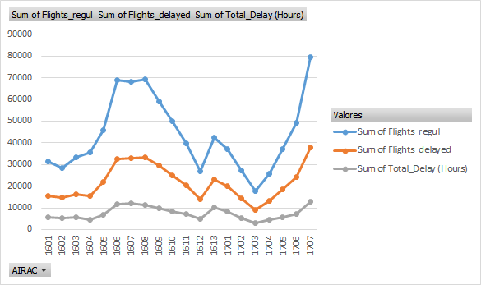

Figure 29: Evolution of flights regulated, flights delayed and total delay (in hours) in 20 AIRACs



Figure 30: Distribution of hotspots per weekday

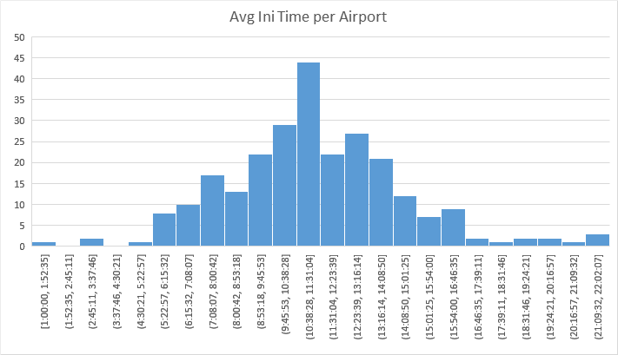

Figure 31: Histogram of initial times per regulation

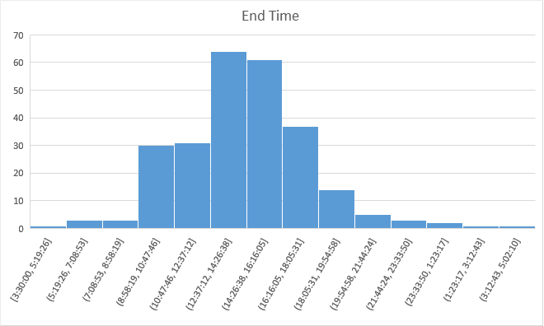

Figure 32: Histogram of end times per regulation

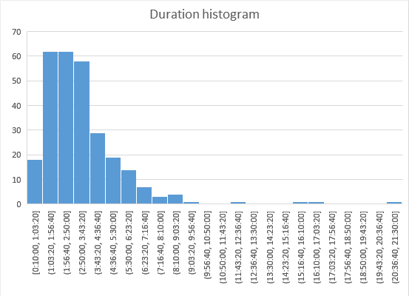

Figure 33: Histogram of regulation durations

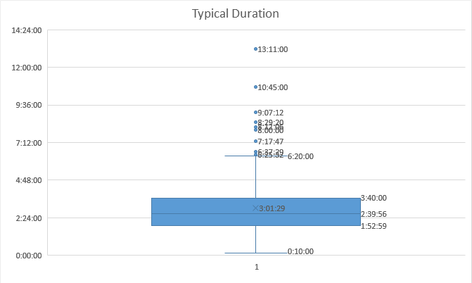

Figure 34: Statistical characterisation (box diagram) of regulation durations

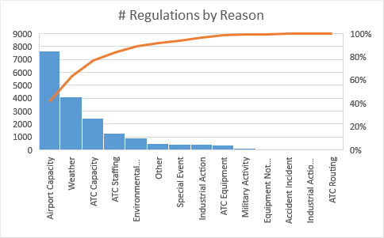

Figure 35: Number of regulations by reason

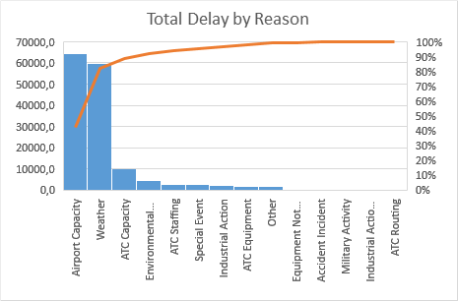

Figure 36: Total delay by reason

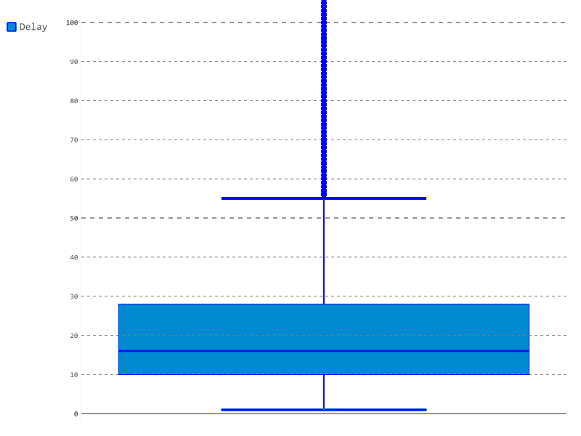

Figure 37: Statistical characterisation (box diagram) of delay

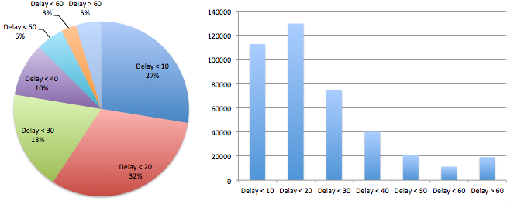

Figure 38: Delay magnitude distributions (pie and bar charts)



Figure 39: Distribution of delay among the 100 AUs with more regulations

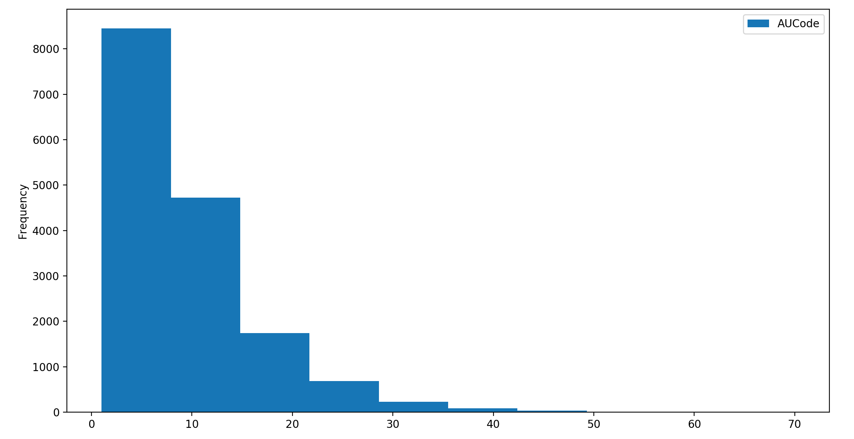

Figure 40: Statistical characterisation (histogram) of regulation durations

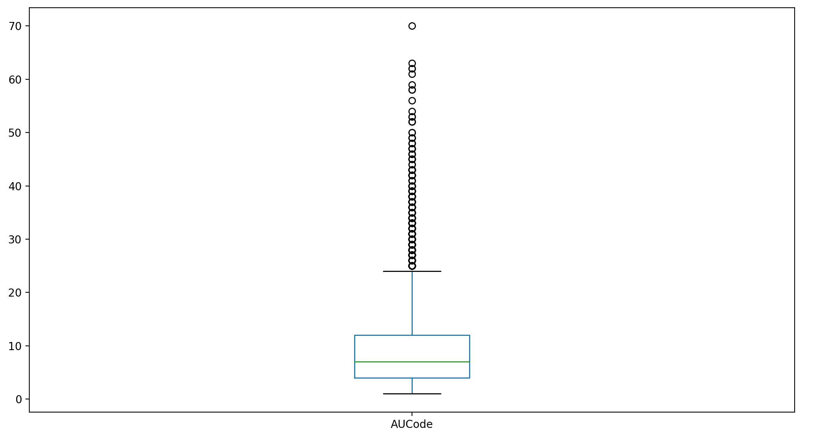

Figure 41: Statistical characterisation (box diagram) of regulation durations

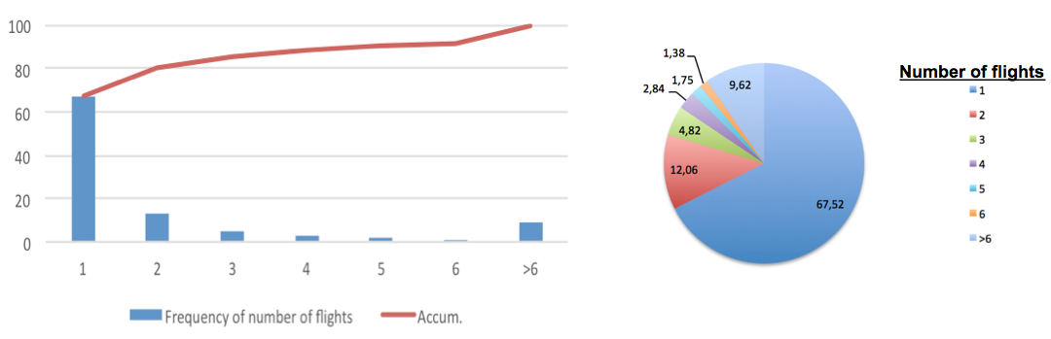

Figure 42: Frequency of AUs with a certain number of flights in a hotspot (bar and pie charts)

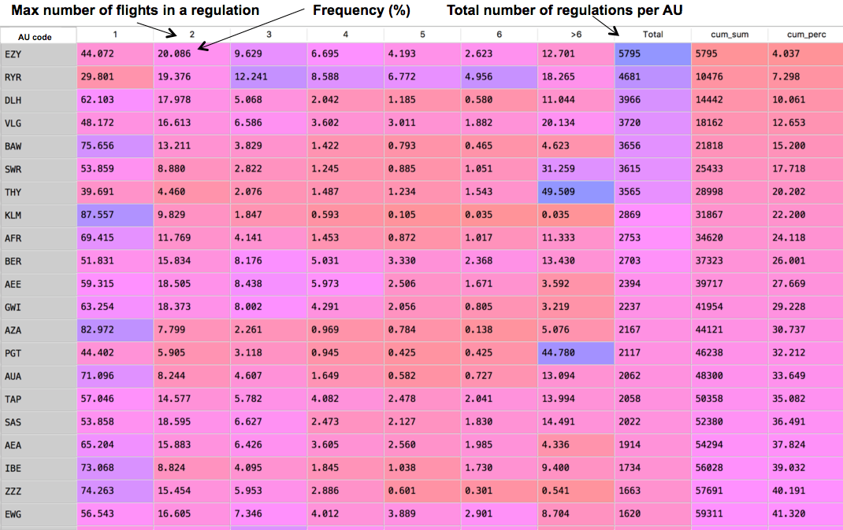

Figure 43: Frequencies of a certain number of flights in a hotspot per AUs (partial data shown)

## Case studies and Simulations

The purpose of the following case studies is to observe the impact of the utilization of FCL in terms of how the delay is distributed among the different Airspace Users (AUs) and to find strategies to provide higher flexibility to the Low Volume Users in Constraint (LVUCs).

First, a description of the traffic and UDPP measure scenario will be provided.

Second, a description of the cost models and related assumptions and simplifications will be presented.

After, the following case studies will be analysed (taking into account the AUs recommendations[7] and requirements):

* Case study 1: All the AUs using the FCL system
* Case study 2: LVUCs with up to 3 flights in the UDPP measure (single UDPP measure optimisation)
* Case study 3: LVUCs with up to 3 flights in the UDPP measure (multiple UDPP measure optimisation)
* Case study 4: LVUCs with up to 4 flights in the UDPP measure (multiple UDPP measure optimisation)
* Case study 5: All AUs with 6 flights or less can use FCL but only for prioritising up to 3 flights (multiple UDPP measure optimisation)
* Case study 6: All AUs with 6 flights or less can use FCL but MNIT = 6 (multiple UDPP measure optimisation)

### Description of the traffic scenario

The scenario used for the case studies has been previously used in some UDPP validation exercises, and has been slightly adapted for the purposes of this new research. It is based on historical traffic demand of 96 flights at a coordinated airport from 12:15 to 17:00 approximately. Figure 44 shows the available capacity per time period of 15 minutes and also the number of flights for a position in the sequence. It is assumed that the nominal capacity (typically set to 40 flights per hour) has been dropped to 20 flights per hour. Consequently, the size of the positions in the sequence is 3 minutes.



Figure 44: Capacity and demand of the airport per periods

The left part of Figure 45 shows the original demand per period and the constraints of capacity. For simplicity, the last period is considered unconstrained. An overloaded period applies between 30’ and 120’. The right of the figure shows the demand after Demand and Capacity Balancing regulations. The orange bars depict the displacement of delays affecting the sequence of flights until the end of the recovery period of the UDPP measure, i.e., the imbalance ends after period 285’ in this case.

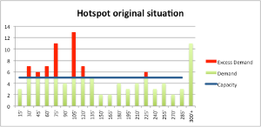 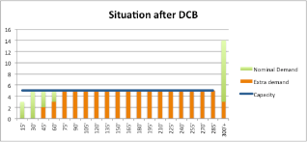

Figure 45: Capacity and demand before Demand and Capacity Balance (left) and after (right)

Figure 46 shows the schedule list after the application of the FPFS policy to the original demand, showing the Expected Time of Arrival (ETA) planned for each flight, the new Controlled Time of Arrival (CTA) assigned by FPFS policy (CTA FPFS) and the calculated delay; also the new user-preferred CTA after the application of FCL prioritizations (UCTA FCL) and the calculated delay. The last column shows, for each flight, the difference in the delay allocated by FPFS and FCL mechanisms. Note that FCL takes as a baseline the same policy applied at a given airport, in this case FPFS; thus at the beginning there is no difference in the baseline delay.

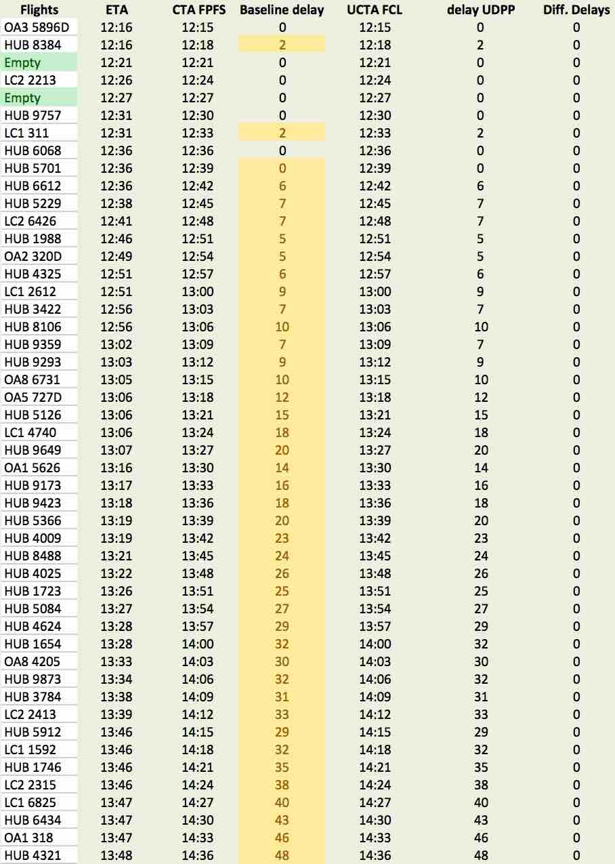 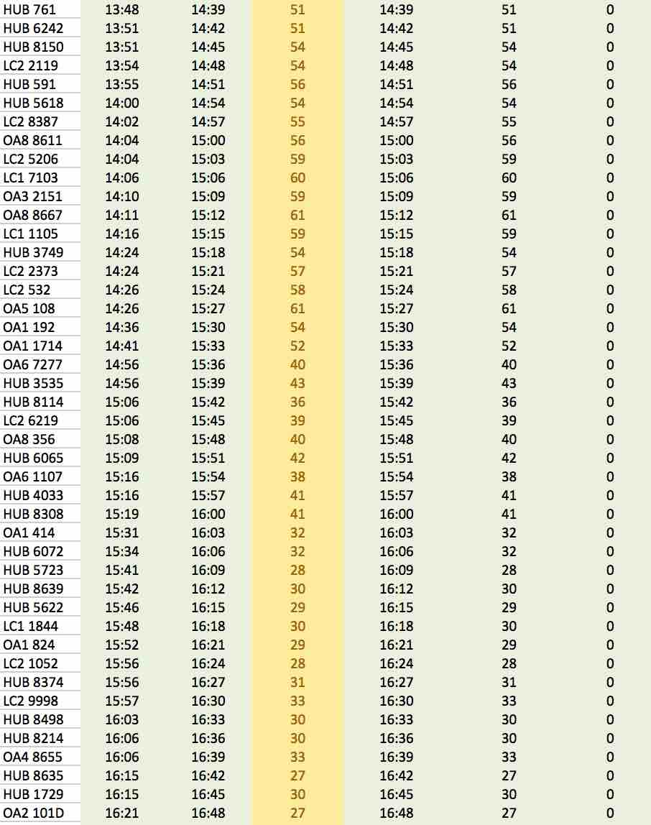

Figure 46: Schedule list with ETAs, CTAs and calculated delays



Figure 47: Ki and delay per flight

Figure 47 shows the evolution of the delay in the UDPP measure, which is directly correlated with the number of positions, *ki*, that a flight *i* is far from its original position in the sequence (delay is proportional to the number of positions and the size in time of each position in the sequence).

Table 13 shows the distribution of flights and delay per Airspace User. Note that delay is distributed randomly but as a direct proportion of the share of flights. A certain degree of concentration of some flights has been identified after analysing the flight positions, especially for the user HUB and LC2. In this particular case, HUB has many of its flights in positions with low delay and LC2 has the flights concentrated in positions subject to relatively long delay.

Note that some AUs have three or less flights in the sequence; therefore they can be considered as LVUCs.

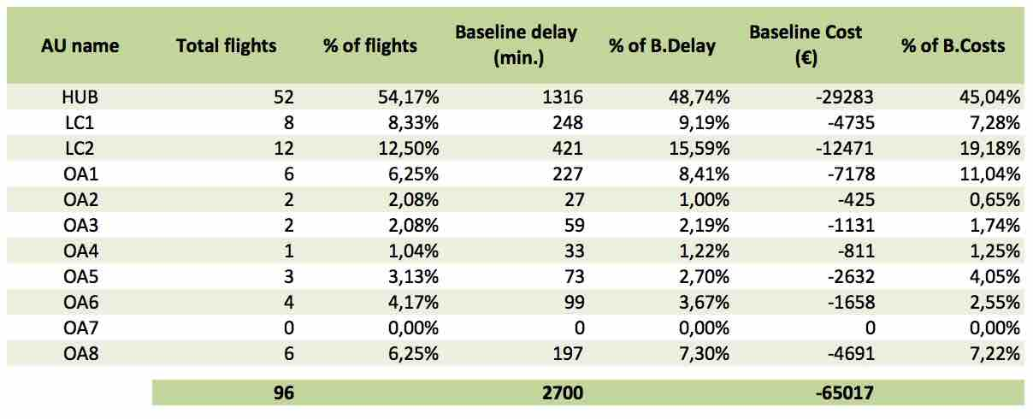

Table 13: Distribution of flights and delay per AU

### Description of the cost model and parameters assumed

It is fundamental to assess the potential benefits or impact of the UDPP mechanism on the AUs, not only in terms of delay but also in terms of costs. It is very difficult at this stage of research maturity to have a precise cost model that can represent to all the AUs in their daily operations. For this reason, a simplified cost model has been taken into account in the simulations. The costs of delay for flights has been modelled with a quadratic function as follows:



Each flight has been randomly parameterised with different sensitivities to delay (a.k.a., elasticity), i.e., with different . The assignation of epsilons/elasticities for each flight has been done randomly following a uniform probabilistic distribution bounded within the following range: . All the flights had the same probabilities to get any value of elasticity within such range. In practice, it means that all the flights were assigned costs as a function of their delay within the maximum and minimum ranges illustrated in Table 14.

|  |  |  |
| --- | --- | --- |
| **Minutes of delay** | **Low cost flight**  **()** | **High cost flight**  **()** |
| 1st minute | 0.25€ | 1€ |
| 10 minutes | 25€ | 100€ |
| 20 minutes | 100€ | 400€ |
| 30 minutes | 225€ | 900€ |
| 40 minutes | 400€ | 1600€ |
| 50 minutes | 625€ | 2500€ |
| 60 minutes | 900€ | 3600€ |
| 70 minutes | 1225€ | 4900€ |

Table 14: Cost thresholds examples assumed in the simulations

Such approximation of AUs costs is not fully representative of the high level of complexity of the actual cost structures (e.g., different types and sizes of knock-on delay impacts). However, the approach is considered valid at this maturity level to observe the potential benefits and impacts of the FCL mechanism in the presence of flights and AUs with heterogeneous cost curves. The purpose is to early assess the potential feasibility of the FCL concept, to enable the observation of potential emergent dynamics, and to start quantifying the potential benefits of flexibility for LVUCs and for all AUs.

Table 13 shows the baseline costs per AU. Note that since the elasticities were randomly assigned to flights it was already expected that AUs have a similar proportion of costs than delay.

### Case study 1: All the AUs using the FCL system

The AUs showed interest on exploring the possibility of using FCL for all the AUs, i.e., not only for LVUCs. This case study explores such idea.

Figure 48 shows the requested optimal delay changes (*taus*) calculated with UDOM, as well as the impact of the delay change on each flight. Note that it has been assumed that the UDPP measure starts with flight LC1 2612, a flight that has 9 minutes of delay. Therefore, the AUs cannot use UDPP to change the delay of those flights out of the UDPP measure.

Table 15 shows the aggregated impact on the costs per AU. Note that in relative terms all the AUs can optimise their costs in similar proportions, and is worthy to point out that the AU with more potential for cost reduction has only 3 flights (is an LVUC). The potential for cost reduction in this scenario for the AUs has been found within the range of approximately 7% up to 36% (average cost reduction of around 17%). The potential for cost reduction depends on the cost structure of the flights in the UDPP measure, and on the amount of delay allocated by the baseline sequence to each of the flights. Also it must be observed that some AUs cannot optimise. Note that OA2 and OA3 have indeed just one of their flights in the UDPP measure (the others are out of the UDPP measure), thus they cannot exchange delay between their flights. The use of credits with validity over the time could be used for giving flexibility to those AUs.

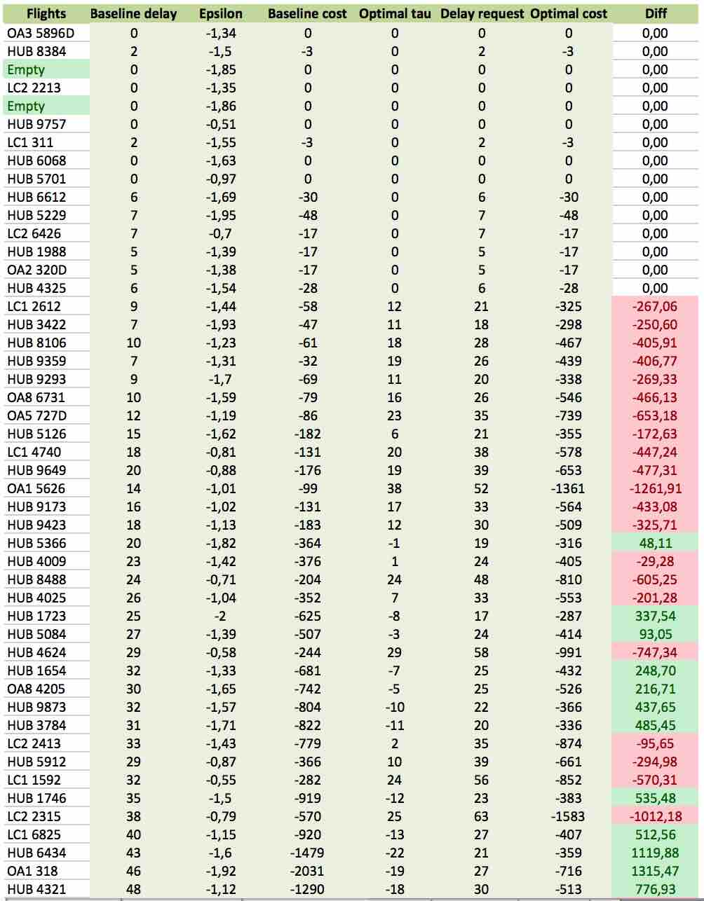 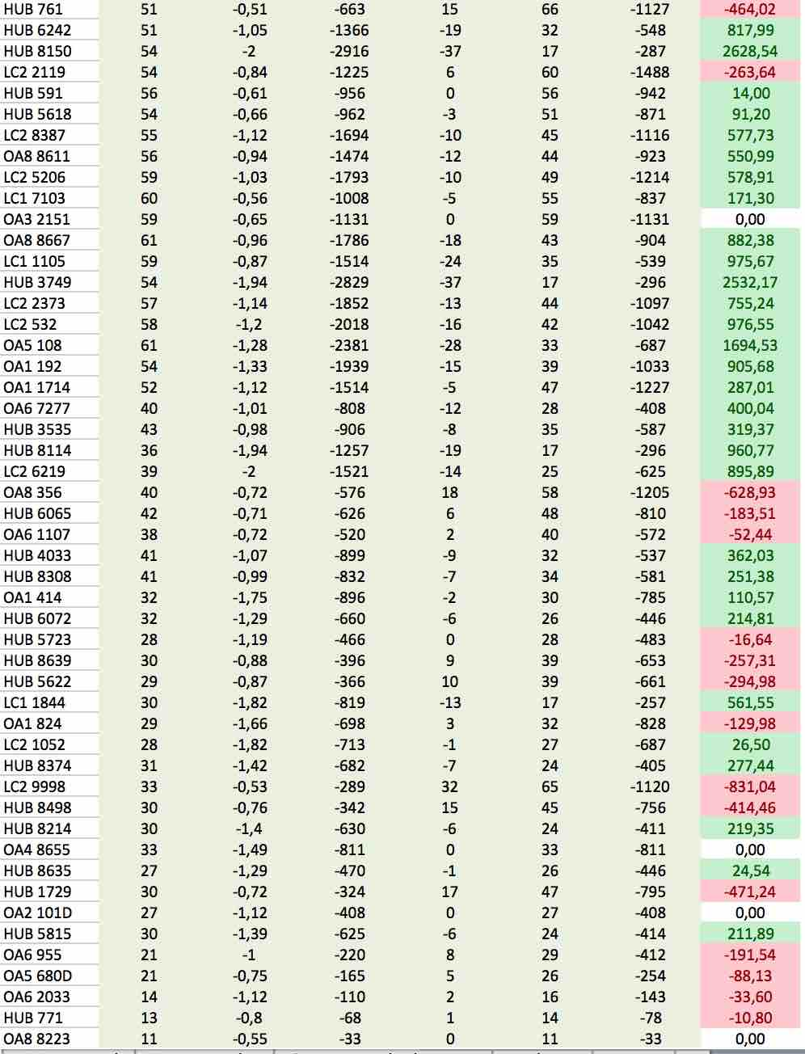

Figure 48: Schedule list with delay, costs and optimal delay requested per flight (case study 1)

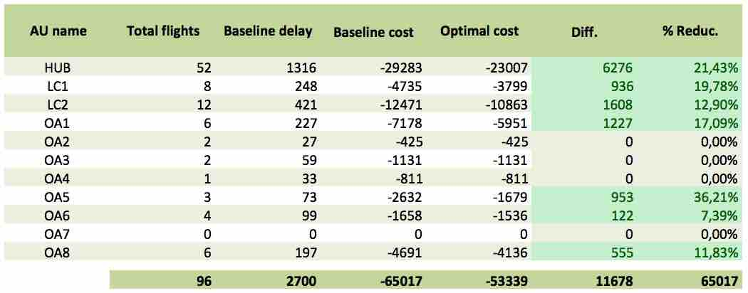

Table 15: Potential cost reductions per AU using UDOM (case study 1)

The difficult part of implementing the optimal solutions calculated by UDOM is the interference between the different solutions, which generate emergent complex dynamics that are still not well understood. See in Figure 49 which are the slots demanded by the AUs to optimise their own costs. It can be observed in the figure that the demand is more or less evenly distributed, at least apparently. However, due to the need to allocate one flight to each available sequence position, the flights have been sorted by requested CTA and then they have been compressed to avoid empty slots and optimise capacity.

Figure 50 is an evidence of those emergent complex dynamics, and shows at each sequence position, the difference between the allocated position and the one requested. In general, less delay than the one requested (negative values in the chart) will have less impact on AUs. In the middle of the sequence there are some flights that they wanted less delay and now they are going to be placed back again with more delay than requested. Therefore, due to the incompatibilities of the many AUs requests, some flights are getting less delay (and less cost) and some more delay (more cost). Table 16 shows the total effect in the total cost supported by the AUs, while Table 17 shows the new distribution of delay per AU. It can be noted that some AUs are worst-off after trying to optimise their costs through the FCL mechanism.

**Conclusion:** On the light of these results, it seems quite unlikely that all the AUs can use FCL in its current form. With the current system rules, and due to the complex interactions and emergent dynamics between the different AUs prioritisations, it cannot be guaranteed that the resulting FCL sequence will have a positive or neutral impact on the AUs costs. Further research could be done, however, to investigate new strategies that may find good solutions with positive cost reduction for all the AUs.

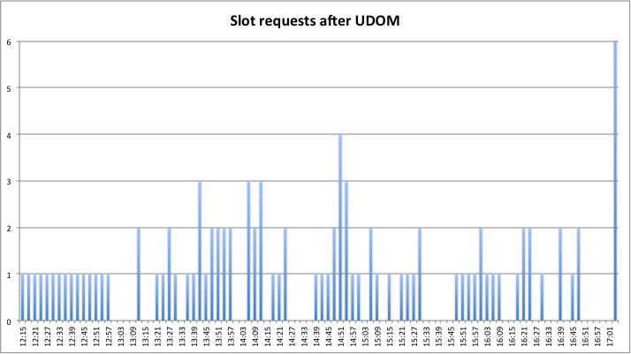

Figure 49: Slots requested by AUs after using UDOM (case study 1)



Figure 50: Deviation of slots requested after compression (case study 1)

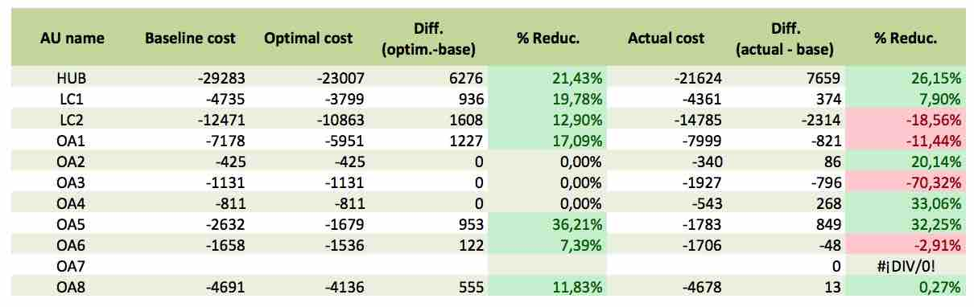

Table 16: Effect of sequence compression on the AUs actual costs (case study 1)

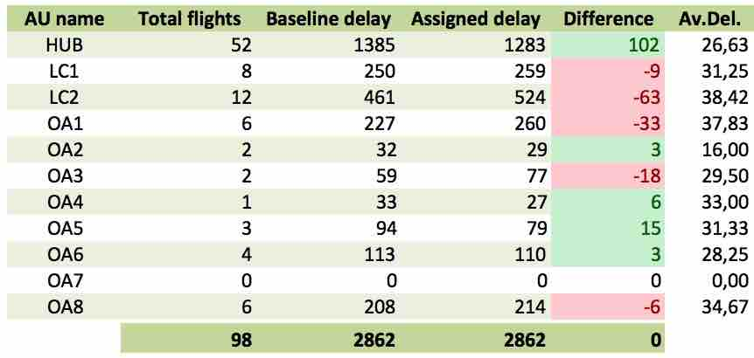

Table 17: Effect of sequence compression on the distribution of delay (case study 1)

### Case study 2: LVUCs with up to 3 flights in the UDPP measure (single UDPP measure optimisation)

In this case study the purpose is to assess the benefits of enabling FLC mechanism only for LVUCs that have up to three flights. The impact to others is also assessed. As shown in Figure 51, only OA2, OA3, O4 and OA5 are LVUCs in this UDPP measure scenario. Note that OA3 and OA4 have 1 flight each in the UDPP measure (OA3 has another flight, but is placed before the UDPP measure), OA2 has 2 flights and OA5 has 3 flights. In the figure they can be found highlighted with different colours. The optimal delay requests found with UDOM for those AUs can be also found in the figure, together with the cost variation for those flights.

In this case study only optimisation within the UDPP measure is allowed, i.e., AUs cannot optimise their delay throughout multiple UDPP measures. Note that LVUCs with one single flight can do nothing in this case to minimise the impact of baseline delay.

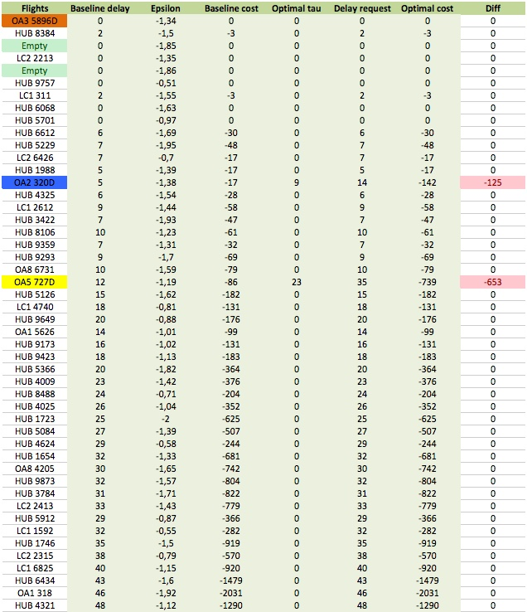 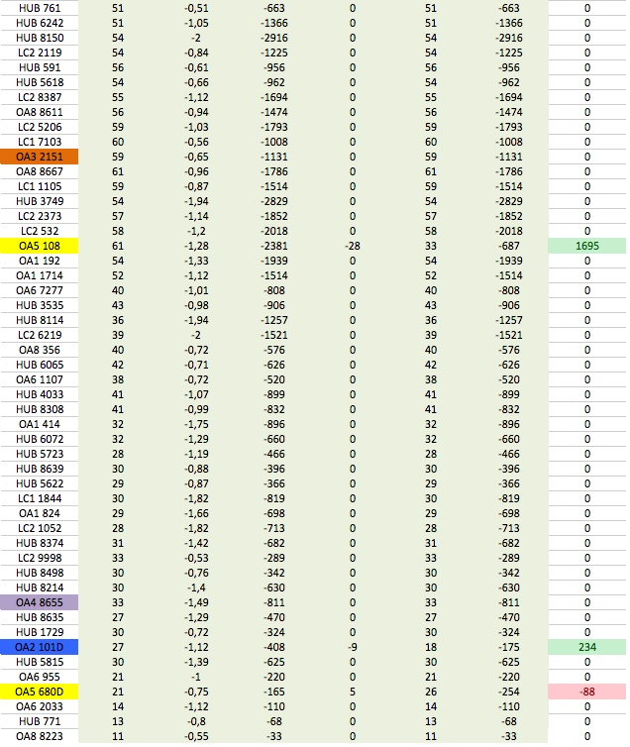

Figure 51: Schedule list with delay, costs and optimal delay requested per flight (case study 2)

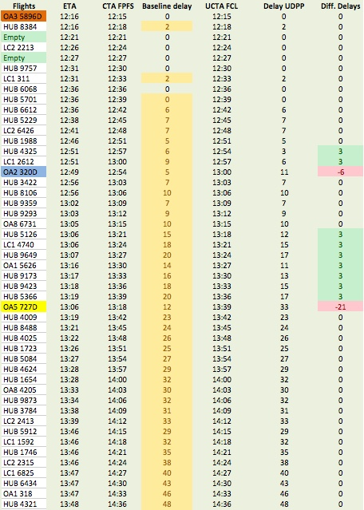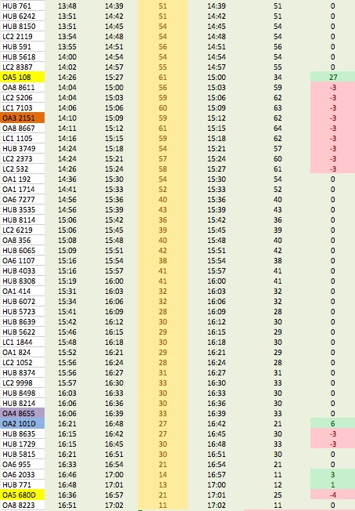

Figure 52: Impact of LVUC decision-making on the sequence and on the delay of flights (case study 2)

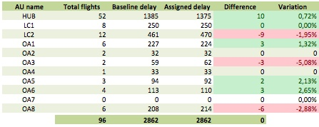

Table 18: Effect of sequence compression on the distribution of delay (case study 2)

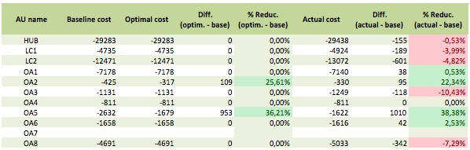

Table 19: Effect of sequence compression on the AUs actual costs (case study 2)

Figure 52 shows the changes in the sequence after the implementation of the LVUCs requests. It can be observed that the maximum impact on individual flights of other AUs has been of 3 minutes (the size of one sequence position).

Table 18 shows the aggregated impact on the delay of the different AUs, which on the light of the figures it can be considered as negligible impact. Note as well that OA2 and OA5 have in practice the same delay as the baseline.

In terms of costs Table 19 shows that OA2 and OA5 could optimise their costs close to what they expected during the optimisation process (UDOM), i.e., a 22.34% of cost reduction for OA2 (who optimised for a 25.61% cost reduction) and a 38.38% cost reduction for OA6 (who aimed at reducing the cost in 36.21%).

Regarding the impact on the rest of the AUs, some relatively small variations can be observed. It must be pointed out that variation of 1-2% of cost could be considered as very huge impacts in reality, however to interpret the results of this simulation exercises it must be reminded that flights typically operate with some tolerances that makes the flight costs to be typically not so sensitive to an extra minute of delay (the quadratic cost structure is probably not representing well the impact to others). In addition, it is assumed that the AUs that are not LVUCs may participate in FDR/SFP features of UDPP, thus optimising their costs and most likely compensating the relatively small impacts from LVUCs.

**Conclusion:** The FCL feature seems to be a good mechanism to give access for LVUCs with more than 1 flight in a UDPP measure. For those LVUCs with 1 flight the access to UDPP through multiple UDPP measures might be necessary to guarantee access and equity of UDPPs. For a reduced number of LVUCs using the FCL the expected impact to other AUs is considered negligible (to be confirmed with AUs).

### Case study 3: LVUCs with up to 3 flights in the UDPP measure (multiple UDPP measure optimisation)

To illustrate the impact of LVUCs optimising over the time (multiple UDPP measures) let us consider that the OA3 and OA4 can reduce the delay of their flights because they did efforts in other UDPP measures (i.e., they increase their delay, thus reducing the delay to flights of other AUs). In the paper of Appendix A the reader can find how the UDOM can be adapted to optimise the costs of operations by managing delay over the time across multiple UDPP measure.

For the purpose of this case study, let us assume that in the same situation as shown in previous case study 2, the LVUCs OA3 and OA4 want to reduce the delay of their flights in 18 minutes each (6 sequence positions in this UDPP measure scenario). It is assumed that proportional efforts were done by such AUs in the past to have the right for reducing their delay in this occasion.

Figure 53 shows the new sequence situation after the implementation of all the LVUCs requests. It can be noted that in this case a maximum delay impact of 6 minutes has been found in some flights (the flight of OA3 and the flight OA5 108 overcome the same three flights, thus generating an impact of two sequence positions, i.e., 6 minutes in this UDPP measure).

Table 20 show similar figures as in case study 2 for delay and cost impacts. The impact on delay caused by LVUCs using FCL could be considered negligible, whereas the impact to other in terms of costs is not conclusive due to the simplifications done in the cost curves of flights. OA2 and OA5 could still optimise their costs in the same order as calculated by UDOM. OA3 and OA4 are assumed to reduce their total –over the time– costs in the same order as OA2 and OA5 (information of costs in past UDPP measures is needed to conclude on the overall cost reduction for OA3 and OA4).

Conclusion: **The impact of LVUCs (up to 3 flights in a UDPP measure) using FCL with optimisation over multiple UDPP measures has been found negligible in contrast to the benefits it can potentially bring. According to the results of the statistical analysis** (Table 12) most of the AUs are LVUCs quite often, therefore the AUs impacted in this given UDPP measure scenario can potentially be benefited from the FCLs feature in other UDPP measures (besides the fact that in the given UDPP measure scenario they could use the FDR/SFP features, that shall compensate the small impact generated by LVUCs. The statistical characterisation of UDPP measures also showed that this UDPP measure scenario used in the simulations is not very far from the typical UDPP measure in terms of duration, severity and number of AUs and LVUCs affected; therefore, it is supposed a certain degree of extrapolation of the results to other UDPP measure situations.

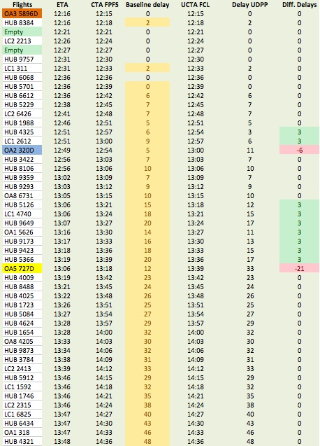 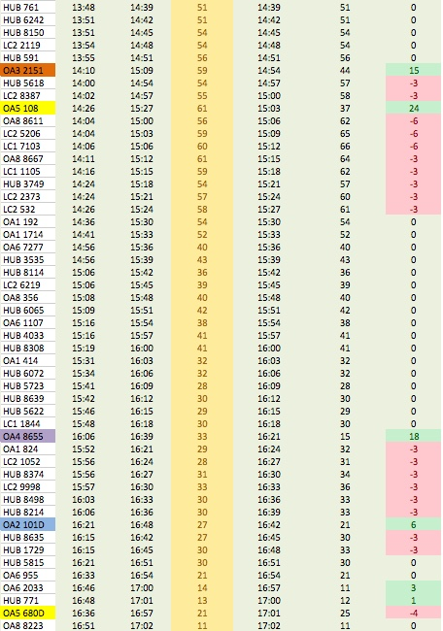

Figure 53: Impact of LVUC decision-making on the sequence and on the delay of flights (case study 3)

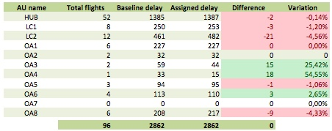

Table 20: Effect of sequence compression on the distribution of delay (case study 3)

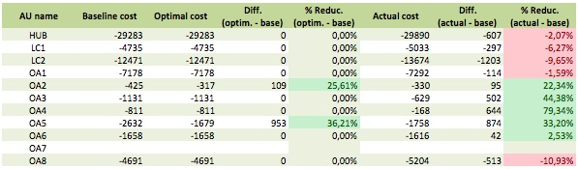

Table 21: Effect of sequence compression on the AUs actual costs (case study 3)

### Case study 4: LVUCs with up to 4 flights in the UDPP measure (multiple UDPP measure optimisation)

In this case study the definition of LVUC is changed, allowing AUs with up to 4 flights to be considered as LVUC and therefore be able to participate in FCL. In this case the slots requests of OA6 has been added to the previous results shown in case study 3 (incremental approach). The following figures show the impact on the other AUs in terms of delay and cost. In this case the impact has only roughly varied for OA1, which in terms of delay has only received 6 minutes more of extra delay. Again no single flight was impacted with more than 6 minutes of extra delay. However, it must be pointed out that the optimal delay exchange calculated by UDOM for OA6 only involved the exchange of delay between two of the OA6’s flights, which means that in practice the OA6 behaved as an LVUC with two flights.

**Conclusion:** Is not conclusive if the definition of LVUC can be extended to AUs having up to four flights in a UDPP measure. Further research is needed.

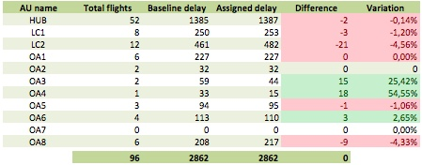

Table 22: Effect of sequence compression on the distribution of delay (case study 4)

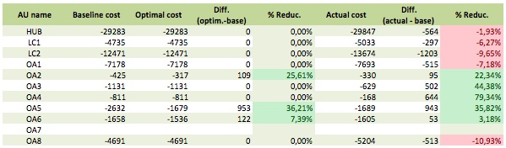

Table 23: Effect of sequence compression on the AUs actual costs (case study 4)

### Case study 5: All AUs with 6 flights or less can use FCL but only for prioritising up to 3 flights (multiple UDPP measure optimisation)

In this case study the number of LVUCs available in the scenario is augmented with a double purpose: a) to check a potential new FCL rule that could allow AUs with up to 6 flights to use FCL to protect up to 3 flights; and b) to observe what is the effect in equity of augmenting the number of LVUCs in a UDPP measure.

Following figures show an impact on delay and costs that in some cases are notably larger than in the case study 3 (4 LVUCs instead of 6). In addition, a maximum impact of time of up to 9 minutes was observed in the sequence.

**Conclusion:** The total number of flights that can use FCL in a UDPP measure must be controlled carefully, because is the number of LVUCs in a UDPP measure is large, then the number of flights using FCL may be large as well, even if each LVUC has only three flights or less in the UDPP measure. Further research is needed to determine which is the maximum number of flights prioritised with FCL in a UDPP measure (possibly related also to how close those flights are in the sequence).

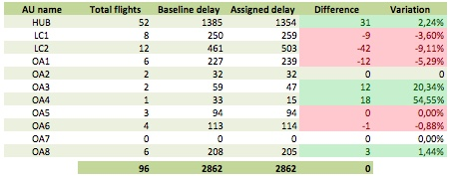

Table 24: Effect of sequence compression on the distribution of delay (case study 5)

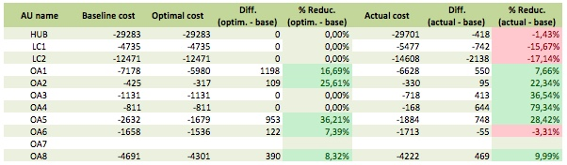

Table 25: Effect of sequence compression on the AUs actual costs (case study 5)

### Case study 6: All AUs with 6 flights or less can use FCL but MNIT = 6 (multiple UDPP measure optimisation)

Solutions that are found inequitable could possibly be balanced in favour of higher levels of equity while the cost efficiency gains are still possible. In this case study all the AUs with 6 flights or less (i.e., from OA1 to OA8) could use FCL for prioritising all of their flights. The maximum negative impact of time (MNIT) allowed was set to 6 minutes (MNIT=6). If any flight is impacted more, the closest flight that took earlier positions in the sequence will be placed in the nearest position after the flights impacted. In this scenario a correction was needed for flight OA5 108, which was placed 3 positions later than requested, thus avoiding big impacts on individual flights.

**Conclusion:** The number of interactions has clearly grown, whereas it is less clear whether the impact could be acceptable from the point of view of equity. New advanced strategies and rules could perhaps be researched to mitigate the impact on LC1 and LC2 while preserving the efficiency. Compared to the case study 5, this case study presents less impact to non-LVUCs, even when there are more flights interacting and generating impact to others. With additional constraints the LVUCs does not have so big cost reductions as in e.g., case study 3, however, they may still have some benefits. Further research is needed to fully understand the complex dynamics of such a complex system and to conclude whether FCL or similar mechanisms could be used by more AUs.

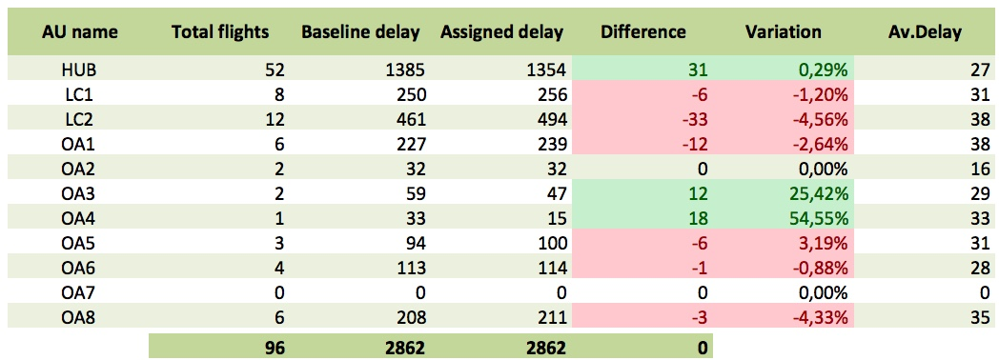

Table 26: Effect of sequence compression on the distribution of delay (case study 6)

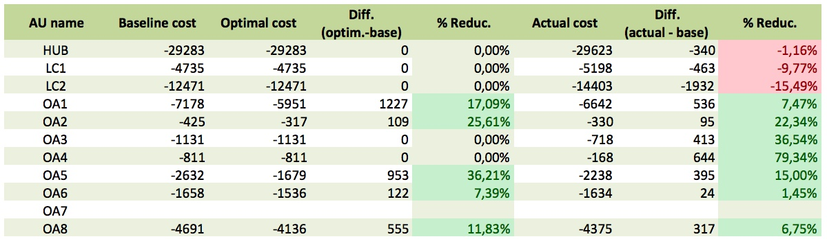

Table 27: Effect of sequence compression on the AUs actual costs (case study 6)

# Limitations of the Research and Identification of Future Work

The body of evidence presented is considered valid for the current level of maturity of the FCL concept. However, for further developments of the concept in higher maturity levels, the following aspects should be sooner or later further developed:

* Mathematical representation of the utility or delay cost functions for flights
* User delay-cost optimisation model (UDOM)
* FCL exchange rate between credits and minutes of delay
* FCL merging rules
* Proof of equity based on fast-time simulations
* Uncertainty and dynamicity of the UDPP measure severity
* Other potential concept improvements and case studies

## Mathematical representation of the utility or delay cost functions for flights

Regarding the mathematical representation of the utility or cost functions, in this research it has been modelled as a continuous quadratic function, as it can be observed in Figure 54. For future research, it could be useful to explore alternative continuous models, e.g., any shape of cost function can be de-composed by Fourier-Legendre transformation and represented as a sum of continuous sinusoidal components. See for instance the Figure 55 in which a discrete function is shown (representing typical cost models in real operations) and its continuous approximation is superposed. The continuous approximation has been found by Fourier-Legendre transformation computing the fundamental frequency with the Fourier-Legendre method (*f0 = 1/30 Hz* in this case), taking the 20 first harmonics (Figure 56), building the sinusoidal signals with their corresponding amplitudes and harmonic frequencies (Figure 57), and adding up such signals to reconstruct the continuous approximation (Figure 55). Note that with more harmonics the approximation will be even closer to the discrete cost curve.

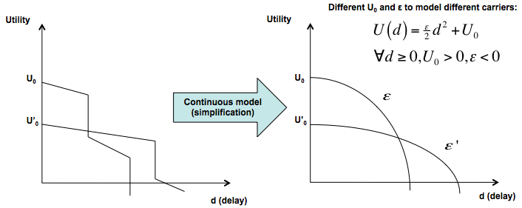

Figure 54: Approximation of the utility function as a continuous quadratic function

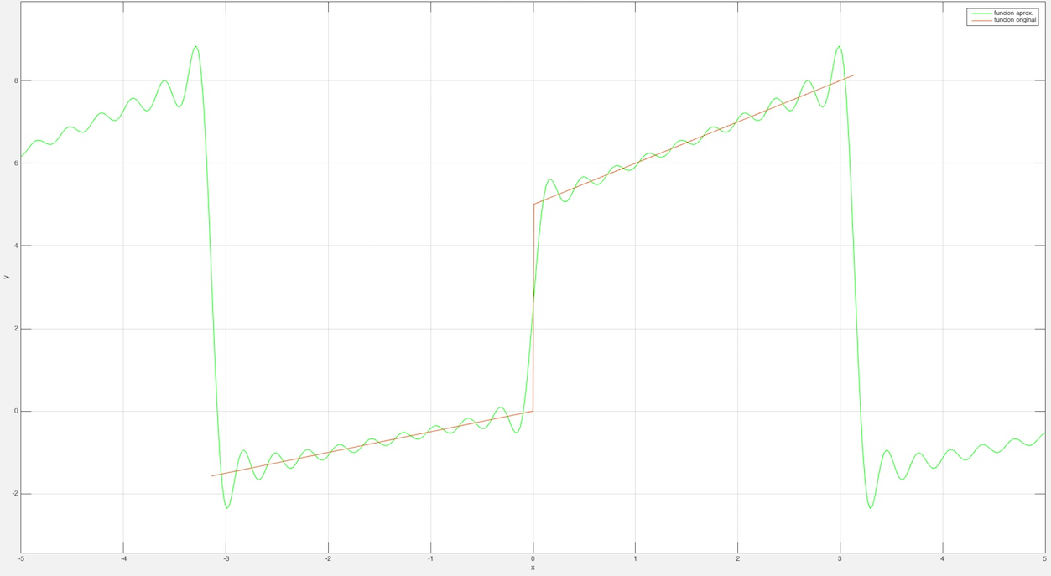

Figure 55: Representation of a –realistic– discrete cost function (red line) and its continuous approximation with 20 harmonics (green line)

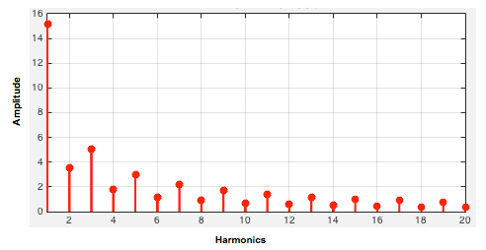

Figure 56: Amplitude of the 20 first harmonics calculated to transform the discrete cost curve

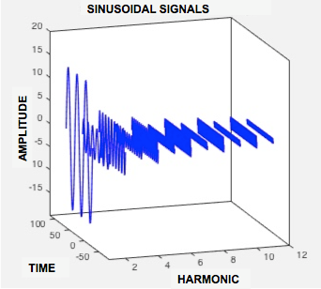

Figure 57: Sinusoidal signals with their corresponding amplitudes and frequencies whose sum can reconstruct the continuous approximation of the cost model

## User delay-cost optimisation model (UDOM)

The UDOM model used in this research is based on the use of the parabolic approximation. In this research this simplified model has been useful to explore some of the fundamental aspects of the FCL, for instance to understand the dominant strategies of the AUs, to observe non-linear relationships between the delay and cost of delay, as well as to be able to perform early fast-time simulations emulating the LVUCs optimised decision-making. However, if the cost model is updated towards a more realistic representation, then the simplified UDOM presented in this research needs to be updated as well, accordingly to the new type of cost models. Among the foreseen options for further research, there is the possibility to model the cost curves as non-smooth functions (with shifts), and therefore a new discrete optimisation model should be developed (typically less efficient and potentially non-feasible for relatively large problems), or well to build an advanced smooth approximation function as shown above and use advanced non-linear optimisation methods. Some powerful mathematical approaches might be found in the field *spectral methods.*

## FCL exchange rate between credits and minutes of delay

Another potential improvement identified, also related with the FCL rules, is the possibility to apply a different exchange rate between credits and minutes of delay. In this research, 1 DC = 1 minute of delay, however, the optimisation models could be updated with a exchange rate that could depend on the position in the sequence of a flight under optimisation. For instance, in positions with higher delay it is expected that more AUs would like to reduce their delay, therefore reducing one minute of delay should possibly be more expensive than in positions in which the delay is lower. Correspondingly, increasing a minute of delay in positions with low delay should be rewarded with less credits that in positions in which the delay is relatively larger. Note that the simplified UDOM could be adapted to that dynamic exchange rate if new constraints are added to the model. This would avoid unfair exchange of delay between flights that have small delay in favour of the ones with large delay.

## FCL merging rules

Another aspect of this research that has been found as affecting largely to the results is the FCL merging rules, i.e., the methodology and principles applied during the combination of the AU’s UDPP requests. It is believed that if this merging problem is further studied new interesting and relevant knowledge could be found regarding the possibility to extend the use of FCL to non-LVUCs AUs (i.e., to extend the possibility to exchange sequence positions among all the AUs and over the time), which could provide much more flexibility and consequently a better ATM quality of service for all the AUs.

## Proof of equity based on fast-time simulations

Also, an agent based simulation platform (see Figure 58) should be developed (or configured) as soon as the concept reaches higher maturity levels to facilitate the analysis of several UDPP features being used in parallel by different AUs, and possibly at different airports, to proof the equity over time, the potential network effects, and the compatibility/feasibility of the de-centralised cooperative decision-making approach.

Finally, to proof equity over the time in a robust and confident way, a large set of realistic scenarios over a large period (e.g., two years), should be explored to develop the required evidence. However, generating a set of realistic scenarios that can represent the situation of all the AUs during congested situations, including the complex dynamics and relationships between fleet management and costs, is a task vastly difficult that requires a lot of efforts. The data obtained from DDR2 could be a starting point, but the preparation of such data as input scenarios for the UDPP simulator is neither trivial nor direct. This will be proposed therefore as key point of a Validation Strategy.



Figure 58: Simulation platform architecture

## Uncertainty and dynamicity of the UDPP measure severity

For the sake of simplicity the uncertainty and dynamicity of the UDPP measure severities have not been considered. However, this aspect is of vital importance for any UDPP feature (e.g., what happen with the prioritisations made by AUs if the capacity constrained situation gets more constraining?) and therefore should be addressed at some point in the future.

## Other potential concept improvements and case studies

The following features and rules could be explored in future research:

* Explore how the **'slot overload'** concept accepted today in operations could be used occasionally to enable flight prioritisations that otherwise could not be possible (e.g., due to MNIT reached for flights in front one LVUC trying to reduce his delay).
* Explore the idea of allocating **'NM slots' (empty positions) at the beginning of the UDPP measure and/or every certain 'x' number of positions**. Such positions would belong to the DCB and the baseline FPFS sequence would be applied to all the flights while respecting the slots that DCB reserved. The purpose of these slots would be to use them in case that some AUs need to protect and no feasible positions are available (e.g., flights in front have reached their MNIT). In case that the empty slots are not used, the DCB could apply compression in the sequence, thus reducing the delay for every flight after such empty positions.

In addition to FCL, **LVUCs could still have access to FDR/SFP features by grouping together in a voluntarily basis and operating as a single operator through a virtual flight operation centre (V-FOC)**. Such approach would respect equity out of the V-FOC (i.e., LVUCs could exchange their own slots without generating impact to others), but two major questions should be addressed in future research to guarantee that the access to LVUCs through V-FOCs is effective in practice: a) is such mechanism flexible enough when the different LVUCs in a V-FOC all want to reduce their delay?; and b) how the equity can be preserved within the VFOC over the time? Such last question is an internal private aspect of the AUs grouping in a V-FOC, but if a pragmatic way of coordination for AUs in a V-FOC is not foreseen, the concept of V-FOC could not work in practice and thus the actual access supposedly given to LVUCs would be not effective.

# Conclusions and Recommendations

## Conclusions

In this research the following conclusions[8] about Flexible Credits for LVUCs (FCL) have been reached:

1. The FCL concept can be considered **partial V1**, although the concept might still be at V0 maturity in some parts.
2. FCL mechanism has shown good properties to **give effective access for LVUCs** to UDPP. In particular it has been found that:
   1. An LVUC can find for each of his flights the **optimal amount of delay** minutes that should be increased or decreased in order to minimise his total costs.
   2. An LVUC can obtain **delay credits** by accepting extra delay (amount of extra delay controlled/decided by the LVUC) and use the credits in the same UDPP measure (if the LVUC has more than one flight) or save the credits and use them in future UDPP measures (i.e., LVUCs are able to optimise their operations over the time).
   3. The **FCL rules are simple** and the level of coordination required is very efficient, so the LVUCs and the rest of the AUs can concentrate on optimising their own operations.
   4. Early evidence showed that with the FCL baseline rules and principles, **equity could be preserved over the time**. The number of flights being prioritised with FCL in a UDPP measure and the maximum negative impact allowed per flight are key parameters to be defined to control de equity.
3. FCL has been thought to **coexist with other UDPP features such as FDR or SFP**, among others, in a way that every AU can get the same levels of Quality of Service (QoS) from the ATM, i.e., efficiency, predictability, and flexibility. FCL can fulfil the need for giving access to all the AUs (Access & Equity KPA). Nevertheless, additional research is required to study equity, fairness and efficiency in the cases where the target positions requested by LVUCs that use FCL could enter in competition with the requests of other AUs that may use other UDPP features.
4. A **robust proof of equity over the time is estimated to be a costly and complex task** (e.g., the generation of representative UDPP measure scenarios), which might be necessary to further develop the access for LVUC at higher the maturity stages of the concept cycle. Further research is therefore required to fine-tune the FCL mechanism and rules, as well as to prove equity over the time in a robust way.
5. **Realistic cost function should be agreed with AUs** to approximate the cost of delay of flights of the baseline delay, or the marginal cost –higher or lower– generated as a consequence of the AUs own decisions, or other AUs’ decisions.
6. **Significant cost reductions and more stable schedules are expected** for AUs using FCL (using simplified quadratic cost curve approximations typical values of 20%-30% cost reductions were observed; even larger cost reductions are expected if realistic non-smooth cost curves were used, due to the significantly different elasticities of cost curves before and after the operational margins of a same flight).
7. **All AUs are often LVUCs** in the 85% of the UDPP measures where some of their flights are affected. All AUs could be potentially benefited directly from participating in FCL in UDPP measures in which they could be considered as LVUCs. Different rules could be applied for AUs that are always LVUCs (e.g., a Business Aviation company with only one or two aircraft).

## Recommendations

Proving the equity is something complex for advanced concepts such as FCL, where some AUs can take the sequence positions of other AUs and compensate them, directly or indirectly, in the same or in other UDPP measures over the time. Even if a certain degree of inequity is allowed (i.e., MNIT per flight) and the number of flights using FCL in a UDPP measure is limited, a robust proof of equity over the time is not trivial to generate. See in the paper in [38] about the discussion about flexibility vs equity. Further research must be therefore conducted in such direction. The recommended steps are:

1. **FDR/SFP should be used in a UDPP measure instead of FCL for AUs that are non-LVUCs,** since FDR/SFP features can guarantee full equity over the time ('equity' understood as no negative impact to others).
2. **FCL could be recommended as a mechanism to give access for LVUCs to UDPP**. FCL can provide high flexibility to LVUCs and according to the evidence shown in this document, the equity could be controlled by fine-tuning the set of rules that limit the number of flights in a UDPP measure and the maximum negative time impact allowed per flight (MNIT).
3. All the AUs –even the largest airlines– are often LVUCs in many regulations that occur every day. **The possibility to include all the AUs –irrespective to the number of flights operated per day– when they are LVUCs in a UDPP measure is recommended**, since it may contribute to reduce the cost for all the AUs, and possibly increase the predictability and robustness of fleet schedules (e.g., for a hub carrier a single flight delayed in a remote/non-hub airport could have a knock-on impact on the hub connections and cause disruption on the full-day operations). **Special rules may apply for AUs that are always LVUCs**, e.g., Business Aviation.
4. The number of flights that determines whether an AU can be considered an LVUC (and thus have access to FCL) is still not clearly determined. However, according to the evidence generated in this research, **3 flights could be recommended as a starting point to determine whether an AU is an LVUC in a UDPP measure.** Such value could potentially be increased in the future if advanced FCL rules are further developed to control the equity aspects.
5. **Further research is needed to determine the MNIT parameter and the number of flights that can use FCL in a UDPP measure**. An early recommendation for these values is: **MNIT=6** and a **10% of flights to be allowed for using FCL in a UDPP measure**. According to the statistical evidence, such parameterisation could introduce enough flexibility for LVUCs in typical UDPP measures, while the impact to others is expected to be negligible (and most likely compensated by the situations in which the impacted AUs are LVUCs in other UDPP measures).
6. In addition to FCL, **LVUCs could still have access to FDR/SFP features by grouping together in a voluntarily basis and operating as a single operator through a virtual flight operation centre (V-FOC)**. Such approach would respect equity out of the V-FOC (i.e., LVUCs could exchange their own slots without generating impact to others), but two major questions should be addressed in future research to guarantee that the access to LVUCs through V-FOCs is effective in practice: a) is such mechanism flexible enough when the different LVUCs in a V-FOC all want to reduce their delay?; and b) how the equity can be preserved within the VFOC over the time? Such last question is an internal private aspect of the AUs grouping in a V-FOC, but if a pragmatic way of coordination for AUs in a V-FOC is not foreseen, the concept of V-FOC could not work in practice and thus the actual access supposedly given to LVUCs would be not effective.
7. Further research should **study in detail the integration/complementarity of FCL and FDR/SFP**, in particular **to identify potential incompatibilities** (e.g., should MNIT be allowed when a certain flight has been protected by a non-LVUC?) and how to rule such cases to reach a good trade-off between flexibility, equity and fairness.
8. To enhance equity and fairness **in FCL a different 'value' should be assigned to the minutes of delay given or taken to others** by the LVUCs: the level of delay at the original and requested sequence positions of their flights should be taken into consideration, since the marginal cost of allocating one minute of extra delay to flight with large delay may be higher than for flights with low level of delay. In practice, it means that **reducing delay in sequence positions where the delay is high would require more efforts from flights that are increasing their delay in positions in the sequence where the delay is low**. The same idea can be applied to exchange credits **across different UDPP measures**.
9. To generate further evidence for the FCL and UDPP business cases **the cost model and optimisation model used in this research should be updated** towards more realistic flight cost structures.
10. To generate a robust proof of equity over the time, **more effort must be dedicated to develop validation scenarios** (more difficult to demonstrate equity in the long-term). To build the scenarios, keep building them with the help of **DDR2**, or try **commercial databases (obtained via ADS-B tracks) such as FlightAware or FlightRadar24**. **Rotation information** is not today in the DDR2, and it is important to provide in the future strong evidence about the reactionary delays, the impact of delay on AUs operations, and to build more advanced models.
11. The following features and rules could be explored in future research:
    1. Explore how the **'slot overload'** concept accepted today in operations could be used occasionally to enable flight prioritisations that otherwise could not be possible (e.g., due to MNIT reached for flights in front one LVUC trying to reduce his delay).
    2. Explore the idea of allocating **‘NM slots’ (empty positions) at the beginning of the UDPP measure and/or every certain 'x' number of positions**. Such positions would belong to the DCB and the baseline FPFS sequence would be applied to all the flights while respecting the slots that DCB reserved. The purpose of these slots would be to use them in case that some AUs need to protect and no feasible positions are available (e.g., flights in front have reached their MNIT). In case that the empty slots are not used, the DCB could apply compression in the sequence, thus reducing the delay for every flight after such empty positions.
12. **New performance indicators are needed to measure flexibility and equity.** DCB/NM should possibly use visible information revealed by the AUs with the request and preferences indications. If the UDPP solutions found are close to the AUs request, then they may be considered **efficient**. DCB may be also interested in measuring **reactionary delay**, in case it could lead to further inefficiencies, traffic unpredictability and capacity problems.

1. *See in Appendix B the statistical evidence that supports such sentence.*
2. *Note that the Access via V-FOC would be not always possible, e.g., if there is only 1 LVUC in the UDPP Measure*
3. The EUROCAE ED-78A has been used as an initial guidance material. ED-78A is useful, but is not an applicable document, because it mostly addresses the V4-V5 phases, whilst the SESAR R&D programme is focussed on development (V1-V2-V3, and because of its partial compliance with safety regulatory requirements).
4. Note that this rule applies for LVUCs, which, by definition, are expected to have less flexibility than other AUs. It may occur that in a particular hotspot the only flight available for a suspension could be in positions after the one that is tactically important for the LVUC.
5. To have more control on equity aspects, future research may consider different value of delay depending on the position in the sequence and the level of delay already allocated to such position.
6. *This assumption is consistent with the assumptions behind the compression algorithm detailed in [39].*
7. Recommendation 2, *'the use of flexible credits (ESFP) by all AUs should be explored, i.e., not limited to the role of LVUCs'*, and Recommendation 10, *'The compatibility of parallel and concurrent decision-making processes (i.e., different AUs using ESFP simultaneously) should be further explored, since potential incompatibilities among the concurrent prioritisation decisions could arise'*.
8. See also in Appendix C the conclusions of previous research together with some updating comments from the perspective and knowledge acquired in this new research.